CONTENT BASED TEACHING ConBaT+ MOTION IN THE OCEAN
For the Teacher
Martine KERVRAN
2/7/2011

Table of Contents
Introductory Information 3
The oceans in the world 4
Learner worksheet 1 5
Learner worksheet 2 6
Learner worksheet 3: multilingual ocean! 7
Waves and wind 9
Learner worksheet 1: How can waves be described? 10
Learner worksheet 2: How are waves measured? 11
When the waves grow bigger and bigger… 12
Learner worksheet 1: The Beaufort wind scale 13
Learner worksheet 2: All kinds of storms at sea 15
Learner worksheet 3: Find out about borrowings in the English language 17
Assessment 19
References 21

Introductory Information
AUTHOR: Martine KERVRAN
E-MAIL: Martine.kervran@bretagne.iufm.fr
INSTITUTE: IUFM de Bretagne, France
Target Group:
9-14
Subjects:
Geography & Physical Sciences
Aims:
- Learn about the location and names of the main oceans in the world
- Identify the main causes for water movement in the ocean.
- Explore the relationships between wind and ocean waves.
- Learn about storms at sea
Key Competencies regarding:
Communication in language(s):
- improve reading competencies in English as a foreign language
- learn English vocabulary related to the topic of oceans and ocean water movement
- learn about the etymology of some English words
- learn about borrowings and exchanges between languages
Learning to learn:
- Look for information and share it with others
Digital competences:
- looking for information on the Internet and being able to sort it out
Social and civic competences:
- Cooperate with peers

Timing of the overall activities:
- Approximately 6 hours

The oceans in the world
Notes for the teacher: This first set of tasks aims at introducing the topic by learning the names of the five oceans and localizing them.
- Learner worksheet 1:
  - discuss the contents of the chart (worksheet 1.1)with the whole class
  - ask the pupils to complete the chart individually
  - discuss the question of worksheet 1.2 collectively and ask the pupils to answer it individually
- Learner worksheet 2 is to be done individually and self-corrected
- Hand out learner worksheet 3
  - ask the pupils to fill in the chart and answer the questions individually
  - discuss the questions collectively and ask the pupils to complete the answers
Timing: 90 minutes
Material required: worksheets 1, 2, 3
Grouping :  ; ;
Focus on content: localisation of the five oceans
Focus on language(S): names of the oceans; name of the continents; geographical terminology; etymology of the word ocean; language families

Learner worksheet 1
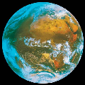
- Fill in the chart below after discussing the items with your friends and your teacher (use the language you know best / your teacher will help you if necessary)
What we know about the ocean | What we want to Learn  About the ocean
-  -  - (..) | -  -  - (...)
- Answer the following question after discussing it with your friends and your teacher (use the language you know best/ your teacher will help you if necessary)
Why does the water of the sea move?
…………………………………………………………………
………………………………………………………………….

Learner worksheet 2
Grouping:
- Read the definitions and label the map
Oceans cover nearly 71% of the Earth's surface.
The Pacific Ocean is the largest ocean and borders the five continents.
The Atlantic Ocean’s neighbouring seas include the Mediterranean Sea, the North Sea and the Baltic Sea.
The Arctic Ocean is the smallest ocean. It surrounds the North Pole. It is frozen all the time, except at its edges.
The Southern Ocean is where you'll find Antarctica and the South Pole.
The Indian Ocean borders areas from the southern hemisphere.

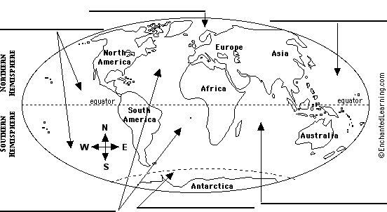
- Check your answers and learn more about the five oceans by following this link:
http://www.gdrc.org/oceans/world-oceans.html

Learner worksheet 3: multilingual ocean!
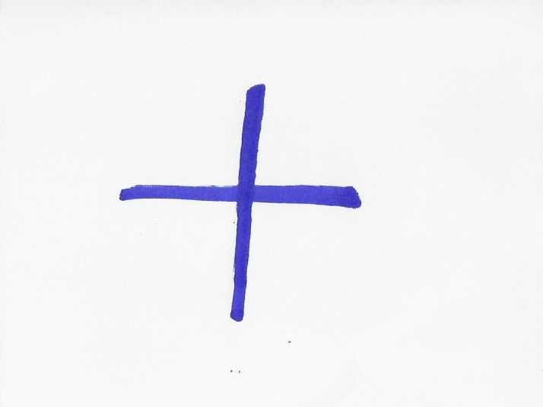
Look at the translations of the world ocean in a few different languages and try to answer these questions
Language | The word ocean
German | ozean
French | océan
Italian | oceano
Russian | океан
Danish | ocean
Dutch | oceaan
Spanish | océano
Portuguese | oceano
Swedish | ocean
… | …
… | …
Then discuss them with the whole class (use the language you know best/ your classmates and teacher will help you if necessary)
What do you notice?
…………………………………………………………………………..
Can you guess why?
…………………………………………………………………………..
Can you write the word ocean in any other language(s)? If so, add it to the list above.
Answer sheet (learner worksheet 3): multilingual ocean
The word ocean looks the same in many languages because it comes from the ancient Greek word Ωκεανός, Okeanos (Oceanus). Oceanus was believed to be the world-ocean in classical antiquity, which the ancient Romans and Greeks considered to be an enormous river encircling the world. This world-ocean was personified as a Titan, a son of Uranus (the Sky) and Gaia (the Earth).

Waves and wind
Notes for the teacher:
Learner worksheet 1: the correction of part 2 is made through collective agreement. To confirm the answers, the pupils can be asked to look up the words in a dictionary
Learner worksheet 2: the work is basically individual but pupils can help each other. The teacher can give complementary explanations about the diagram
Timing: 2 hours
Material required: worksheets1&2;
Resources: photographs, pictures or paintings of waves
Focus on content: (physical sciences): formation and measurement of waves
Focus on language: vocabulary of wave components (crest; troughs; foam…)

Learner worksheet 1: How can waves be described?
- Bring photographs, pictures or paintings about waves to class
- Share them with the class and describe them
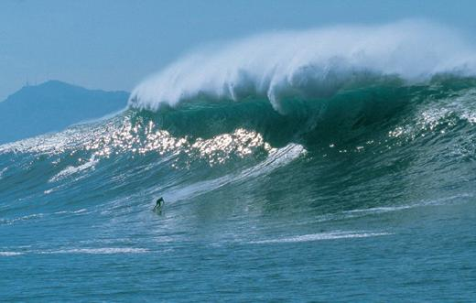
- Match each word to its definition
Duration | bottom of a wave
Trough | length of time
Crest | distance over which the wind blows
Fetch | top of a wave

Learner worksheet 2: How are waves measured?
- Look at the diagram and fill in the blanks in the text with words from the list below
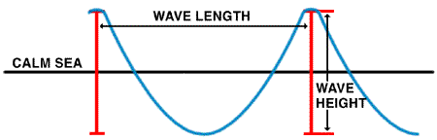
Wave model from www.ndbc.noaa.gov/educate/educate.shtml
The water in the ocean is always ----. Waves are one movement of the ocean----.
They are caused by the----. The ----of these waves depends on wind----, on the ---- of the wind and on the----. It is measured from the wave ----to the wave----. The wave -----is defined as the horizontal distance between two successive----.
Water; moving; height; waves; length; crest ; troughs; wind ; duration; fetch; speed
Answer sheet
The water in the ocean is always moving. Waves are one movement of the ocean water. They are caused by the wind. The height of these waves depends on wind speed, on the duration of the wind and on the fetch. It is measured from the wave crest to the wave trough. The wave length is defined as the horizontal distance between two successive waves.
- - Create your own ocean wave!
Follow this link and discover the wave machine…
http://www.pbs.org/wnet/savageseas/multimedia/wavemachine.html

When the waves grow bigger and bigger…
Notes for the teacher:
Learner worksheet 1 : additional information about Beaufort and his scale can be given to the pupils, if the teacher finds it necessary.
Learner worksheets 2 and 3 : the correction can be done collectively. The teacher can give all the information needed to the understanding of the process of word exchanges between languages. The interest of etymology to better understand concepts (here: physical phenomena and geographical terminology) should be underlined.
Timing: 90 minutes
Material required: worksheets 1, 2, 3
Focus on content: (physical sciences): wind as the main cause for storms; the Beaufort wind scale
Focus on language/s: storms words and their etymology; borrowings
Language skill: reading comprehension

Learner worksheet 1: The Beaufort wind scale
In 1805, British admiral Francis Beaufort devised a descriptive wind scale to standardize wind reports. The Beaufort wind scale is still used today.
- Look at the chart below and read it carefully
Beaufort scale number | Descriptive term | Wind speed km/h | Description of the sea | Description of the land
0 | Calm | 0 | Sea like a mirror.
1-3 | Light winds | 19 km/h or less | Small wavelets
4 | Moderate winds | 20 - 29 km/h | Small waves
5 | Fresh winds | 30 - 39 km/h | Moderate waves
6 | Strong winds | 40 - 50 km/h | Large waves
7 | Near gale | 51 - 62 km/h | Sea heaps up and white foam
8 | Gale | 63 - 75 km/h | Moderately high waves of greater length
9 | Strong gale | 76 - 87 km/h | High waves; spray may affect visibility.
10 | Storm | 88 - 102 km/h | Very high waves ; the surface of the sea takes on a white appearance with visibility affected.
11 | Violent storm | 103 -117 km/h | Exceptionally high waves; the sea is completely covered with long white patches of foam.
12+ | Hurricane | 118 km/h or more | The air is filled with foam .The sea is completely white; visibility is very seriously affected
- In pairs, cut out the drawings and stick them in the right place in the above chart to describe the land at each stage.
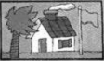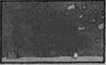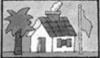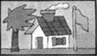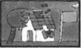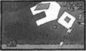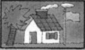
Answer sheet :

Learner worksheet 2: All kinds of storms at sea
There are various kinds of storms at sea that are given different names. Those names depend on the region of the world where those phenomena generally occur.
- Link each English word to the original word you think it comes from.
English word | original word
Hurricane | Kyklōma
Typhoon | 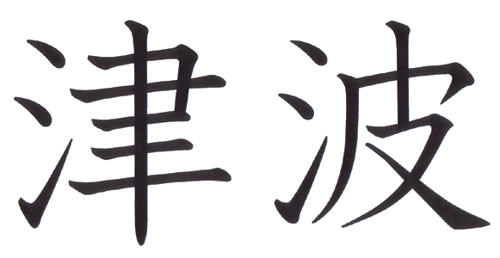
Tsunami | Huracan
Cyclone | 台 风
- Try to find out what is the name of each of those languages
The word hurricane comes from……
The word typhoon comes from…….
The word tsunami comes from…….
The word cyclone comes from……..
Answer sheet:
The word hurricane comes from Spanish
The word typhoon comes from Chinese
The word tsunami comes from Japanese
The word cyclone comes from Greek
The word hurricane came to English from the Spanish word hurican. Spanish explorers and conquerers took the word from the Taino word, meaning storm. Taino is an extinct language from the Bahamas.
The word typhoon comes from the Chinese word台 风(tai-fung) which means “ great wind”.
The word tsunami comes from the japanese word , meaning “port” (tsu)
The word cyclone comes from modifications of the Greek word kyklōma which means wheel and is derived from kyklos, meaning circle.
- Look for a definition of each term in a dictionary and write it down:
Hurricane: ------------------------------------------------------------------------------------------
Typhoon: -------------------------------------------------------------------------------------------
Tsunami: -------------------------------------------------------------------------------------------
Cyclone: --------------------------------------------------------------------------------------------
Answer sheet:
Hurricane: A tropical cyclone with winds that have reached a constant speed of 74 miles per hour or more.
Typhoon: A tropical cyclone occurring in the western Pacific or Indian oceans
Tsunami: A huge ocean wave that can travel at speeds up to 600 mi/hr (965 km/hr), hundreds of miles over open sea before it hits land.
Cyclone: An atmospheric circulation system in which the sense of rotation of the wind about the local vertical is the same as that of the Earth's rotation
- Look for more information about those phenomena on the Internet
Read the information on those web pages and write a very short summary of the contents
Cyclones http://ww2010.atmos.uiuc.edu/(Gh)/guides/mtr/cyc/def.rxml
Hurricanes: http://ww2010.atmos.uiuc.edu/(Gh)/guides/mtr/hurr/def.rxml
Typhoons: http://library.thinkquest.org/03oct/00477/NatDisasterPages/jeb.webpages/Typhoon/typhoon_definition.htm
Tsunamis: http://www.pbs.org/wnet/savageseas/neptune-side-tsunamis.html

Learner worksheet 3: Find out about borrowings in the English language
- The words hurricane, typhoon and tsunami were borrowed to other languages. Can you guess why?
- Those other words from the geographical domain are also loan words.Look for their meaning in a dictionary and try to guess which langauge they were borrowed from
avalanche : ----------------
canyon : -------------------
fjord : ----------------------
geyser : --------------------
golf : -----------------------
iceberg : -------------------
jungle : --------------------

Answer sheet:
Avalanche : Switzerland Romansh
Canyon : Spanish
Fjord : Norwegian
Geyser : Icelandic
Golf : Gaelic
Iceberg : Dutch
Jungle : Hindi
- Can you think of any other English words that were borrowed to other language?
Which language were they borrowed to? Make a list with your teacher and try to classify them according to the language they come from or the domain (food; clothes; animals ...) they belong to
More loan words and their origin:
http://www.krysstal.com/borrow.html
http://efl.htmlplanet.com/words_from_otherlingos.htm
The history of borrowings in the English language
http://www.ruf.rice.edu/~kemmer/Words04/structure/borrowed.html

Assessment
Note for the teacher: The information for the scrapbook should be collected all along the module and arranged at the end.
- Discuss with your friends and your teacher and fill in the chart below
What we have learnt

- Have a look at what you had written in the chart “what we know / what we want to learn” at the beginning of the module and discuss what you have learnt and what else you would like to know about the oceans
- Make your own multilingual ocean scrapbook
- Collect information and documents about waves and other information about the motion of the ocean from this module, classbooks, websites, magazines or books.
- Make sure the documents
  - come from various sources,
  - include various types of information (texts, pictures, drawing, paintings, photographs, stories…),
  - are written in different languages.
- Choose the most interesting ones, put them together, arrange them into chapters and make them into a nice file or book.
- Share your ocean scrapbook with your classmates and your teacher.

References
A few websites about the ocean:
Oceanlink: http://oceanlink.island.net/
Links to a glossary, ocean facts, career information, and more.
OceanPortal: http://ocean.si.edu/
“OceanPortal is a high-level directory of Ocean Data and Information related web sites.”
Ocean Planet, Smithsonian: http://seawifs.gsfc.nasa.gov/ocean_planet.html
A virtual tour of the Ocean Planet exhibit at the Smithsonian’s Museum of Natural History.
Oceanic Information Center: http://www.oceanic.udel.edu/
Resources on oceanographic experiments, research projects, databases, etc.

