CONTENT BASED TEACHING ConBaT+ Parasites (parasitism)
For the Teacher
Anu Parts & Mare Kallas
2/7/2011

Parasites (parasitism)
Table of Contents
Introductory Information 3
1. Parasites 5
Worksheet 1: Diversity of parasites 6
2. Parasites around the world 8
Worksheet 1 9
3. News and poems 10
Worksheet 1 11
Assessment 15
References 15

Introductory Information
AUTHOR: Anu Parts & Mare Kallas
E-MAIL: anu.parts@gmail.com
INSTITUTE: Tallinn English College, Estonia
Target Group:
13-15
Subjects:
- Biology, art, geography
Aims:
- know the concepts connected with parasitism
- understand the role of parasites in ecosystem
- know the importance of hygiene
- develop manual skills (drawing, folding)
- enlarge understanding of poetry
- become knowledgeable citizens who can distinguish his role in being healthy
Key Competencies regarding:
Communication in language(s):
- development of the ability to express and interpret concepts, thoughts, feelings, facts and opinions in both oral and written form
- communication in the mother tongue
- mediation and intercultural understanding
Learning to learn:
- development of the ability to pursue and organise one's own learning, either individually or in groups, in accordance with one's own needs
- awareness of methods and opportunities
- organise information
Digital competences:
- development of basic skills in information and communication technology (ICT)
Social and civic competences:
- development of personal, interpersonal and intercultural competence and all forms of behaviour that equip individuals to participate in an effective and constructive way in social and working life
- ability to turn ideas into action. This involves creativity, innovation and risk-taking, as well as the ability to plan and manage projects in order to achieve objectives. The individual is aware of the context of their work and is able to seize opportunities when they arise
- enlarge understanding of codes of conduct and customs in the different environments in which individuals operate

Timing of the overall activities:
- 3 x 45 minutes

Resources and materials needed
- Computer (access to internet)

1. Parasites
Timing: 45 min
Material required:
- Computer (access to internet)
- paper, pencils
Grouping: 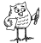 -
Focus on content:
- parasites, biology
Focus on language(S):
- Pronouncing words in different languages and using the languages of the class

Worksheet 1: Diversity of parasites

- Search the Internet and make a list/compile a mini- dictionary of parasitic organism in alphabetical order. You can use English and add other language you know. Try to find a parasite for each letter. Provide one sentence to define or characterize each parasite. Make your parasite ABC more attractive by adding illustrations.
http://www.healingdaily.com/colon-kidney-detoxification/what-are-parasites.htm
For example:
A | Ascariasis (roundworms) | Spread mainly in tropical regions, also in areas of poor hygiene
B | Body louse | Transmitter of epidemic typhus
C | ….
D
- Watch the videos and organise information http://video.google.com/videosearch?hl=et&q=parasites&lr=&um=1&ie=UTF-8&ei=b_yjSYHzL4OB_gafm-iMBQ&sa=X&oi=video_result_group&resnum=4&ct=title#
Parasite | Way of infection | Damaged organs | Symptoms
Give two conclusions from the table:
..............................................................................................................................................................................................................................................................
- Parasites can be divided into two groups exo- and endoparasites. What's the meaning of these prefixes? Using analogy, try to compose a definition of the prefix.
Exo -
Endo-
To add more examples, go to Natural History Museum homepage and visit collections of invertebrates. Work in pairs.
Exoparasites | are organisms  who live  ……………………………………………………………….  and their role is ……………………………………………………….
Exoparasites | examples
Endoparasites | …………………………………………………………………………  …………………………………………………………………………  …………………………………………………………………………
Endoparasites | examples

2. Parasites around the world
Timing: 45 min
Material required:
- Computer (access to internet)
- paper, pencils
Grouping: - -
Focus on content:
- parasites, biology, geography

Worksheet 1
- Writing task: Study the prevalence, life cycle, diagnosis etc of head louse (Pediculus humanus)
- Describe your day as a parasite.
- Describe an adventure as a parasite
- This is how I died.
- Work in pairs. Spot the prevalence areas of 1-5 parasites in the world map. Define the symbols (colours) to each other.

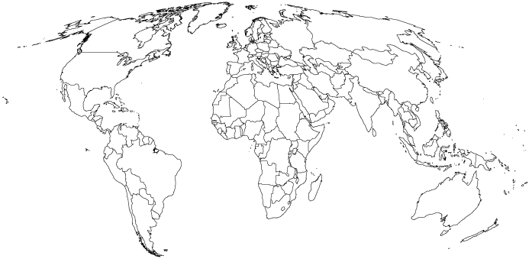
- Classroom discussion
Some people are called “parasites”. They live off others and give nothing in return. Find some examples from your society, justify your opinion. What needs to be done in order to get rid of them/to change them? Present your ideas in the class.
- Interview
The problem of parasites is not just limited to so called third-world countries. We are just as much at risk as anyone else. Visit a pharmacy and interview the pharmacist about the most common parasites in humans currently. Ask about the ways to get rid of them. Write a report on the results or get ready for a classroom presentation.
Prepare your questions to the pharmacist in advance. You can ask help from your teacher.

3. News and poems
Timing: 45 min
Material required:
Computer (access to internet), paper, pencils
Grouping:
Focus on content:
- parasites, biology
Focus on language(S):
- Pronouncing words in different languages and using the languages of the class

Worksheet 1
- A newsletter
Search the Internet and find any up to date news about parasites in the world. Make a short summary. In groups compile The Parasite News, include pictures, comics etc. Any satire or comedy spoof writing are also accepted. If you need inspiration, see the article below:
http://www.thespoof.com/news/spoof.cfm?headline=s5i53412
- Write a haiku or poem about parasites. Use your mother tongue and any other foreign language(s) you know.
- Design your book (blog) of parasites.
Some ideas for the design of your book:
- Make a tapeworm-shaped folded book of poetry, add illustrations.
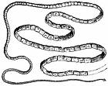

- You can fold the book according to these instructions.
- Take a sheet of paper.
- Fold it to half on both directions. Look at the drawing.
- Open the paper and fold it in half
- Take scissors and cut until the line
cut until the next line | stop here
- Open the paper and fold it by the longitudinal line. Press it gently and you can see the little book formation. Be creative.
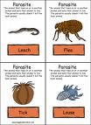 | Parasite poetry  2009

Assessment
- Knowledge dimension (correct concept use)
- Reasoning dimension (information selection; critical analyse of the videos; quality of the conclusions)
- Communicational dimension (discussion of conclusions).
- Writing skills

References
- http://www.healingdaily.com/colon-kidney-detoxification/what-are-parasites.htm
- http://video.google.com/videosearch?hl=et&q=parasites&lr=&um=1&ie=UTF-8&ei=b_yjSYHzL4OB_gafm-iMBQ&sa=X&oi=video_result_group&resnum=4&ct=title#
- http://www.healingdaily.com/colon-kidney-detoxification/what-are-parasites.htm
- http://workforce.cup.edu/Buckelew/Life%20Cycles.htm

