CONTENT BASED TEACHING ConBaT+ Trees: Linguistic and Cultural Aspects
For the Teacher
Christoph SUTER
1/26/2011

Title of the unit: Trees: Linguistic and Cultural Aspects
Table of Contents
Introductory Information 3
Title of task 1: Labelling parts of a tree; figurative senses of parts of a tree 5
Worksheet 1 6
Worksheet 2 8
Title of task 2: Connotations of trees in English and in learners‘ L1 10
Worksheet 3 11
Title of task 3: The forestal nutrient cycle in different climates 13
Worksheet 4 14
Title of task 4: The Baobab Tree: exploring the multiple functions of a tree in an ecologic system 16
Worksheet 5 17
References/ References/ Referencias 18

Introductory Information
AUTHOR: Christoph SUTER
E-MAIL: christoph.suter@phzh.ch
INSTITUTE: Pädagogische Hochschule Zürich, Switzerland
Target Group:
- 12-16
Subjects:
- English,
- Geography,
- Biology
Aims:
- to label common parts of trees on different types of trees in English
- to learn about connotations and collocations of the word tree and of a specific tree in English
- to research connotations and collocations of trees in learners‘ L1 and compare and present findings in class
- to learn about the specific distribution of nutrients in tropical rainforests and in central European forests
- to understand the multiple functions of a tree in an ecologic system through the example of the baobab tree
Key Competencies regarding:
Communication in language(s):
Communication in L1
- Learners communicate with three members of their family about additional meanings of trees in general, certain trees or parts of trees.
- L1 is considered and appreciated for work in school.
Communication in FL(s)
- Learners acquire topic vocabulary and interact with peers in FL
- The matematical term root is mentioned in materials. Activities provide starting points for further work on the functions of the parts of a tree as well as their structures.
Learning to learn:
Learners research the information regarding their L1 in their social network. In this way they learn to see their surrounding as a resource for learning.
Digital competences:
- Learners might use an online dictionary for their work, e.g. http://www.macmillandictionary.com/
- Learners work with online resources
Social and civic competences:
- Learners work in pairs, groups, and in class in order to develop interactive skills.
- Learners identify and contact speakers of their L1 who they think might be able to answer their questions. They document the answers and present them to classmates.
- Learners develop an understanding of differing connotations of similar items in different cultures.
Timing of the overall activities:
160’
Resources and materials needed
Worksheets 1, 2, 3, 4

Title of task 1: Labelling parts of a tree; figurative senses of parts of a tree
Notes for the teacher:
- Learners label different trees with these terms: roots, trunk, crown, branches, leaves.
- Learners find different uses of these terms with the aid of a monolingual dictionary.
- Learners say what parts of a tree are called in their L1 and what other uses of these terms exist.
According to your class‘ needs, either start with projecting a picture of a tree and talking about it, using the terms roots, trunk, crown, branches, leaves, or ask learners to tackle Worksheet 1 in pairs straight away
Timing 40’
Material required: Worksheets 1&2

Grouping: / /
Focus on content:
Parts of a tree: roots, trunk, crown, branches, leaves
Figurative meanings
Focus on language:
botanical terms
other uses of these terms in English (e.g. crown)
parts of a tree in learners‘ L1 and their figurative uses
Learner worksheets

Worksheet 1

/
1 Label the pictures with these terms: roots, trunk, crown, branches, leaves.
Rhizophora mangle (red mangrove) forest, Caeté estuary, Bragança, Pará, Brazil (http://de.wikipedia.org/w/index.php?title=Datei:Rhizophora-forest.jpg&filetimestamp=20060613214853)
Norway Spruce (http://en.wikipedia.org/wiki/File:Picea_abies.jpg)
Oak (http://upload.wikimedia.org/wikipedia/commons/d/df/Ljusterö_Bössarviken_01.jpg)

Bonsai: Dwarf Japanese Juniper (http://upload.wikimedia.org/wikipedia/commons/2/2d/Dwarf_Japanese_Juniper%2C_1975-2007.jpg)


Worksheet 2
 Parts of a tree can also be used in a figurative sense in English. Look at these definitions going with the words root, trunk, branch, leaf, crown. Write the appropriate word next to its definition. Check with a partner.

- a large strong box with a lid used for storing things or for carrying them when you travel. __________
- a sheet of paper, especially in a book. __________
- a circular decoration that a king or queen wears on their head as a symbol of power, often decorated with jewels. __________
- the __________ of a number is another number that, when multiplied by itself a particular number of times, equals that number.
- a shop or office representing a large company or organization in a particular area. __________
2 With your partner, use a monolingual dictionary (on paper or online) to make a list of other uses of these words in English.
In class, read out uses of trunk - leaf - crown - root - branch and find out which part of the tree the definition is alluding to.
What are parts of a tree called in your language? Ask members of your family or other people sharing your first language. Make a list, and collect other uses of these words.
Write two or three figurative uses of parts of a tree used in your first language in English. Ask a classmate to point to the appropriate part of the tree on the picture.
Assessment
Learners check their findings with the solution of the worksheet

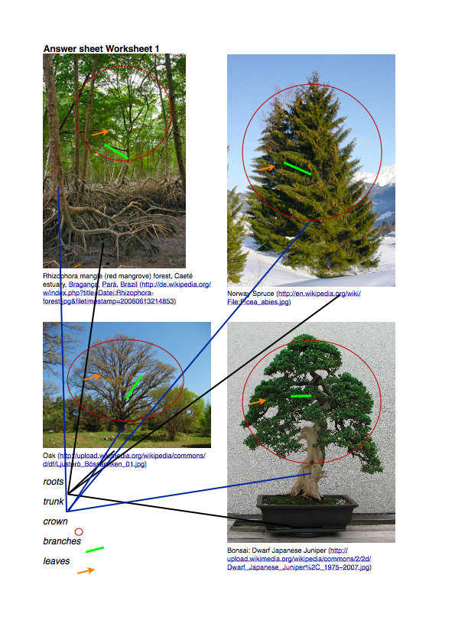
Answers Worksheet 2: trunk - leaf - crown - root - branch

Title of task 2: Connotations of trees in English and in learners‘ L1
Notes for the teacher:
Learners examine the connotations the word tree is carrying in English and explore connotations of the word tree or of specific trees in their first language.
Option: Learners bring a picture they like of a tree to the classroom and explain what they like about the picture.
Timing: 50’
Material required: Worksheet 3, poster sheets, pens
Grouping: /
Focus on content:
- Cultural connotations of trees
Focus on language:
Figurative use of language

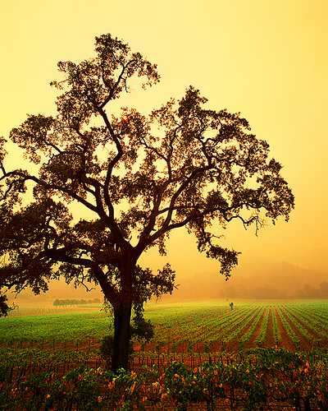
Worksheet 3
What does a tree make you think of? Look at the picture and collect 5 to 10 words that you link to the word tree.
http://farm1.static.flickr.com/233/445631386_b4ea2896fc.jpg?v=1234922551
2 In English, the word tree makes people think of the countryside, greenness, strength and longevity. Others may think of leafless trees connoting winter and hardship. Moreover, specific trees might make people think of certain things, the word oak, for instance, is often used in connection with words such as solid, royal, old.
What are speakers of your first language thinking of in connection with trees? Are there any specific trees in your first language‘s culture that are used in connection with other words? Ask these questions to three people of your family. Take notes of their answers and bring them to class (the notes, not the people ;-) ).

Go to http://www.logosdictionary.org and type the name of a tree in your first language, then click on search. How many translations are being offered for your tree? Are some of them similar to the name in your first language? Try other trees. What can you find out?
() Compare your findings in groups. In your group, design a poster with the outline of a tree and the information that you have collected.
Assessment
Quality of information posters

Title of task 3: The forestal nutrient cycle in different climates
Notes for the teacher:
Learners compare forestal systems in differing climates.
Option: Learners present their findings to the class in the form of a role play, e.g. one learner is playing a person saying I am a little girl living nearby and the baobab is good for me because I like to hide in the baobab tree.
If you would like to extend the topic of benefits of trees, see also http://www.treesaregood.com/treecare/tree_benefits.aspx
Timing 30’
Material required: Worksheet 4
Grouping: / /
Focus on content:
Forestal nutrient cycles
Risks of cutting down tropical forests
Focus on language:
Percentage
Comparing

Worksheet 4
Work with a partner. Look at the pictures. Compare the two systems. Use the language support.
Percentage of nutrient substance …

… in the tropical rainforest
… in a central European forest

45 % in living plants
5% in a layer of decomposing substance
50% in the soil

90% in living plants
3% in a layer of decomposing substance
7% in the soil

Language support
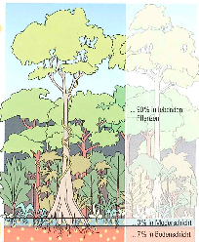
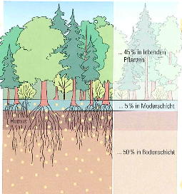
While in the rainforest there‘s … % of … in …, in a central European forest, there‘s …%.
In … there‘s only … % in …, but in … there‘s … % in….
There‘s twice as much nutrient substance … in … than in …
If you take away the living plants in a … forest, you take away … % of the nutrient substance.

() The problem with cutting down tropical rainforest is that it isn‘t able to recover. Can you imagine why? Why is central European forest able to recover? Discuss in groups, then report to the class.

Assessment
Learners give reasons why tropical forest cannot recover from being cut down.
Answers to Worksheet 4
Suggested answers
While in the rainforest there‘s 90 % of the nutrient substance in the living plants, in a central European forest, there‘s 45%.
In the rainforest there‘s only 5 % nutrient substance in the soil, but in a Central European forest there‘s 50 % in the soil.
There‘s twice as much nutrient substance living plants in rainforest than in a Central European forest
If you take away the living plants in a tropical forest, you take away 90 % of the nutrient substance.

Title of task 4: The Baobab Tree: exploring the multiple functions of a tree in an ecologic system
Notes for the teacher
Learners research the manifold benefits of the baobab tree for humans and animals. They collect and sort the different aspects involved and create a poster displaying their findings.
Timing 40’
Material required: Internet access, poster sheets, pens
Grouping: (individual) or (pairs) or (small group) or (whole class)
Focus on content:
A tree as a resource for life around it.
Different benefits of the baobab tree.
Focus on language:
Processing authentic text.
Writing short descriptions.

Worksheet 5
Brainstorm what a tree is good for : What benefits can you think of, for humans or animals ? Make a list and exchange ideas in class.
You are going to learn about a characteristic tree in the African savannah landscape. This tree is used in many ways by animals and humans. Its name is the baobab tree. Research the internet to find out about this tree. You may start with one of these web sites : http://www.baobab-solutions.com/the_baobab.htm
http://www.yozuna.com/baobab
Imagine specific people and animals living near a baobab tree. On sheets of paper write down the description of a person or the name of an animal and its profit from the baobab tree, e.g. Cheetah – Enjoys the shade under the baobab when it’s hot. / Little girls – Like to play hide and seek in and around the baobab.
Arrange your sheets of paper on a poster with a picture of a baobab tree.
Read and compare your posters in class.

Assessment
- Quality of posters

References/ References/ Referencias
Illustrations Activity 1: Wikipedia, see worksheet for url.
Illustration Activity 2: flickr.com, see worksheet for url.
Connotations Activity 2: http://www.arts.gla.ac.uk/SESLL/EngLang/LILT/connotn.htm
Collocations Activity 2: Corpus research with the Cobuild Corpus.
Illustrations Activity 3: Lehrmittelverlag des Kantons Zürich: Die Erde (copyright?)

http://www.baobab-solutions.com/the_baobab.htm
http://www.yozuna.com/baobab

