2. Europe

Worksheet 2
In which European countries are these languages official languages? Try this for 6 languages.
Language: _______________  Countries: ____________________  ____________________ | Language: _______________  Countries: ____________________  ____________________ | Language: _______________  Countries: ____________________  ____________________
Language: _______________  Countries: ____________________  ____________________ | Language: _______________  Countries: ____________________  ____________________ | Language: _______________  Countries: ____________________  ____________________
Can you find these countries on the map of Europe?
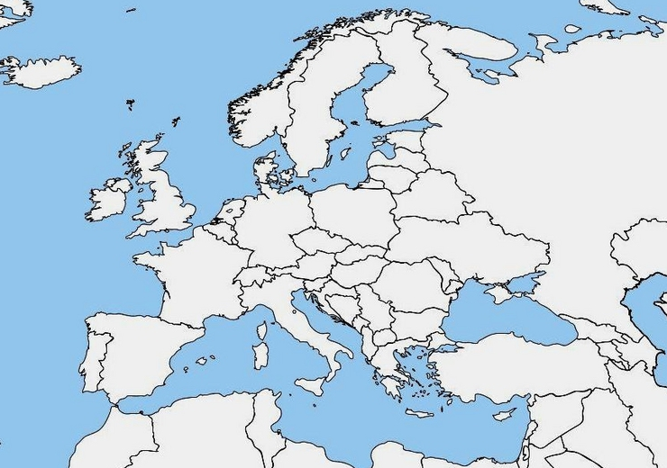
Afterwards you can check the atlas to see if you were right.
Answer sheet:
Dutch: Belgium, The Netherlands | French: France, Belgium, Luxemburg, Switzerland, Italy | Polish: Poland
German: Belgium, Germany, Switzerland, Austria, Luxemburg, Liechtenstein | Italian: Italy, Switzerland | Croatian: Croatia, Bosnia, Herzegovina, Austria, Italy, Serbia
English: England, Ireland | Spanish: Spain
Danish: Denmark | Romanian: Romania
Swedish: Sweden | Portuguese: Portugal
Norwegian: Norway

