1. A delicious ingredient

Worksheet 1
Which ingredient do you recognise below? _____________________________
Which languages do you recognise? Write the language next to the word.
- čokolada ……………………………….
- czekolada ……………………………….
- ciocolată ……………………………….
- cioccolato ……………………………….
- sjokolade ……………………………….
- chocolate ……………………………….
- schokolade ……………………………….
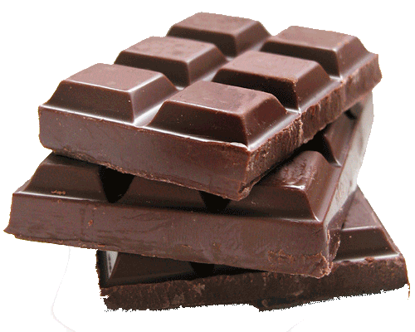
- choklad ……………………………….
- chocolade ……………………………….
- chocolat ……………………………….
Which languages are similar? _______________________________________
_______________________________________________________________
Have you any idea why that is so? ___________________________________
_______________________________________________________________
Answer sheets:
Čokolada = Croatian
Czekolada = Polish
Ciocolată = Romanian
Cioccolato = Italian
Sjokolade = Norwegian
Chocolate = English, Portuguese, Spanish
Schokolade = German
Choklad = Swedish
Chocolade = Dutch, Danish
Chocolat = French
The following words resemble each other because they belong to the same language family. In special needs schools this doesn’t have to be discussed in class. The students can discover that these countries are geographically related.
Germanic languages | Romanesque languages | Slavic languages
Chocolade (Dutch) | Chocolat (French) | Czekolada (Polish)
Schokolade (German) | Cioccolato (Italian) | Čokolada (Croatian)
Chocolate (English) | Chocolate (Spanish)
Chocolade (Danish) | Ciocolată (Romanian)
Choklad (Swedish) | Chocolate (Portuguese)
Sjokolade (Norwegian)

