When the waves grow bigger and bigger…

Learner worksheet 2: All kinds of storms at sea
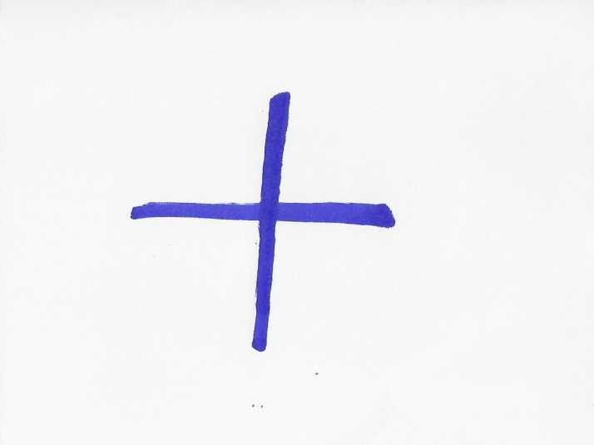 There are various kinds of storms at sea that are given different names. Those names depend on the region of the world where those phenomena generally occur.
- Link each English word to the original word you think it comes from.
English word | original word
Hurricane | Kyklōma
Typhoon | 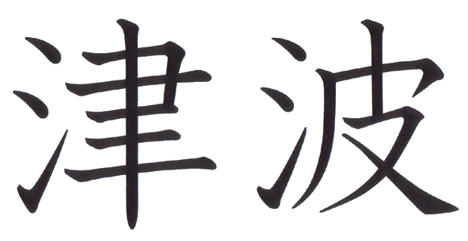
Tsunami | Huracan
Cyclone | 台 风
- Try to find out what is the name of each of those languages
The word hurricane comes from……
The word typhoon comes from…….
The word tsunami comes from…….
The word cyclone comes from……..
Answer sheet:
The word hurricane comes from Spanish
The word typhoon comes from Chinese
The word tsunami comes from Japanese
The word cyclone comes from Greek
The word hurricane came to English from the Spanish word hurican. Spanish explorers and conquerers took the word from the Taino word, meaning storm. Taino is an extinct language from the Bahamas.
The word typhoon comes from the Chinese word台 风(tai-fung) which means “ great wind”.
The word tsunami comes from the japanese word , meaning “port” (tsu)
The word cyclone comes from modifications of the Greek word kyklōma which means wheel and is derived from kyklos, meaning circle.
- Look for a definition of each term in a dictionary and write it down:
Hurricane: ------------------------------------------------------------------------------------------
Typhoon: -------------------------------------------------------------------------------------------
Tsunami: -------------------------------------------------------------------------------------------
Cyclone: --------------------------------------------------------------------------------------------
Answer sheet:
Hurricane: A tropical cyclone with winds that have reached a constant speed of 74 miles per hour or more.
Typhoon: A tropical cyclone occurring in the western Pacific or Indian oceans
Tsunami: A huge ocean wave that can travel at speeds up to 600 mi/hr (965 km/hr), hundreds of miles over open sea before it hits land.
Cyclone: An atmospheric circulation system in which the sense of rotation of the wind about the local vertical is the same as that of the Earth's rotation
- Look for more information about those phenomena on the Internet
Read the information on those web pages and write a very short summary of the contents
Cyclones http://ww2010.atmos.uiuc.edu/(Gh)/guides/mtr/cyc/def.rxml
Hurricanes: http://ww2010.atmos.uiuc.edu/(Gh)/guides/mtr/hurr/def.rxml
Typhoons: http://library.thinkquest.org/03oct/00477/NatDisasterPages/jeb.webpages/Typhoon/typhoon_definition.htm
Tsunamis: http://www.pbs.org/wnet/savageseas/neptune-side-tsunamis.html

