Waves and wind

Learner worksheet 2: How are waves measured?
- Look at the diagram and fill in the blanks in the text with words from the list below
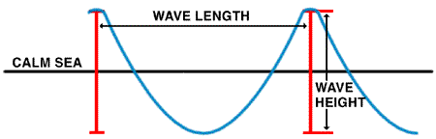
Wave model from www.ndbc.noaa.gov/educate/educate.shtml
The water in the ocean is always ----. Waves are one movement of the ocean----.
They are caused by the----. The ----of these waves depends on wind----, on the ---- of the wind and on the----. It is measured from the wave ----to the wave----. The wave -----is defined as the horizontal distance between two successive----.
Water; moving; height; waves; length; crest ; troughs; wind ; duration; fetch; speed
Answer sheet
The water in the ocean is always moving. Waves are one movement of the ocean water. They are caused by the wind. The height of these waves depends on wind speed, on the duration of the wind and on the fetch. It is measured from the wave crest to the wave trough. The wave length is defined as the horizontal distance between two successive waves.
- - Create your own ocean wave!
Follow this link and discover the wave machine…
http://www.pbs.org/wnet/savageseas/multimedia/wavemachine.html

