The oceans in the world

Learner worksheet 3: multilingual ocean!
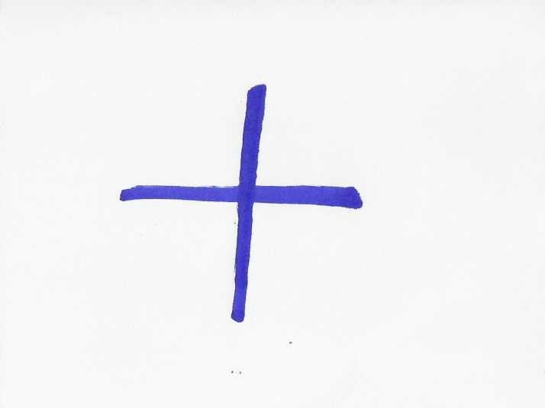
Look at the translations of the world ocean in a few different languages and try to answer these questions
Language | The word ocean
German | ozean
French | océan
Italian | oceano
Russian | океан
Danish | ocean
Dutch | oceaan
Spanish | océano
Portuguese | oceano
Swedish | ocean
… | …
… | …
Then discuss them with the whole class (use the language you know best/ your classmates and teacher will help you if necessary)
What do you notice?
…………………………………………………………………………..
Can you guess why?
…………………………………………………………………………..
Can you write the word ocean in any other language(s)? If so, add it to the list above.
Answer sheet (learner worksheet 3): multilingual ocean
The word ocean looks the same in many languages because it comes from the ancient Greek word Ωκεανός, Okeanos (Oceanus). Oceanus was believed to be the world-ocean in classical antiquity, which the ancient Romans and Greeks considered to be an enormous river encircling the world. This world-ocean was personified as a Titan, a son of Uranus (the Sky) and Gaia (the Earth).

