Assessment
Note for the teacher: The information for the scrapbook should be collected all along the module and arranged at the end.
- Discuss with your friends and your teacher and fill in the chart below
What we have learnt

- Have a look at what you had written in the chart “what we know / what we want to learn” at the beginning of the module and discuss what you have learnt and what else you would like to know about the oceans
- Make your own multilingual ocean scrapbook
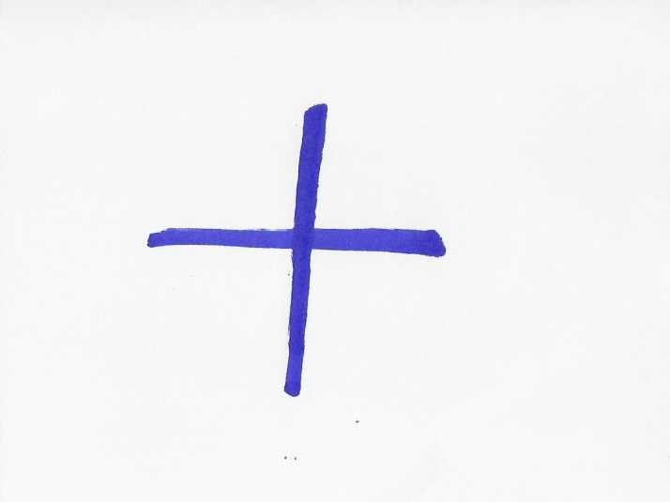
- Collect information and documents about waves and other information about the motion of the ocean from this module, classbooks, websites, magazines or books.
- Make sure the documents
  - come from various sources,
  - include various types of information (texts, pictures, drawing, paintings, photographs, stories…),
  - are written in different languages.
- Choose the most interesting ones, put them together, arrange them into chapters and make them into a nice file or book.
- Share your ocean scrapbook with your classmates and your teacher.

