worksheet 1: From the history of mathematics
Timing: 10 minutes
Grouping: 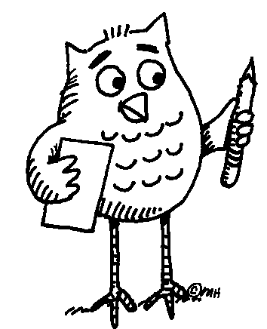 ( ... ) Learners work in pairs. Later they compare their results with the others in class.



Worksheet 1: FROM THE HISTORY OF MATHEMATICS

Task 1: Read the paragraph using the dictionary to clarify the meaning of unknown words or phrases.
Understanding mathematics has always meant asking a lot of questions. Sometimes, in order to find the right answers we find it useful to look back and learn from history. Mathematical knowledge of today has a long tradition; all the different cultures in different periods of history have contributed to its development. Due to the lack of contact, however, each of the early civilizations developed its own specific number system. This process was often closely related to body parts, an approach common to different parts of the world. For example, the sizes of dishes in many countries were usually based on the average size of hands and feet. Whereas European mathematics later turned away from concrete things and became abstract, the concept of mathematics elsewhere, outside the European influence, has often remained unchanged. Nowadays, body parts are still used either as an aid to tallying (e.g. fingers and toes) or for counting according to a conventionally defined order, e.g. by the people of Papua New Guinea.
Task 2: Talk to each other in English or your mother tongue. Try to come up with examples of OLD measures of length, capacity, or weight. Share with the rest of the class.
Task 3: Write one example each for a mathematical problem expressed
- in numbers:
- in letters:
- in pictures:
Share with the rest of the class.

Assessment: The aim of all the activities is to motivate learners. Therefore it is advisable to encourage the learners, help them do the task, monitor their work carefully, and show interest in their results. Suggested issues: Are the learners interested in the ideas? Are they busy working/discussing? Do they have ‘positive feelings’ about the activity? - Whereas affective aspects of learning and the engagement of learners can be assessed, there is no need to assess language accuracy and/or the correctness of problem solving. The learners should, however, get acquainted with the correct language forms or solving procedures.
Resources:
In case of interest, more information can be found in the Ethnomathematics Digital Library http://www.ethnomath.org/search/browseResources.asp?type=subject&id=523 http://www.und.nodak.edu/dept/math/history/counting.htm
http://en.wikipedia.org/wiki/History_of_measurement
Notes for the teacher: Worksheet 1
Task 1 - Additional information: (i.e. what the teacher can tell the class in case of interest)
“Archeological evidence shows the earliest symbols were related to groupings of objects (frequent symbolic representations of cattle, fish, farm produce etc. suggesting a connection with barter or trade, or with accounting or early forms of payment or taxation). From this evolved different ways of counting different things: cattle were grouped differently from sheep or fish or cobs of corn; in some cultures trees were counted in a different way from stones, etc. (In many countries eggs are still bought in boxes of six or twelve). However strange this may sound, it is culturally significant.”
Answers (checking the students´ comprehension): To seek answers = search for (look for) answers. Due to the lack of contact … = because (the early civilizations) did not meet. A number system = a way of counting. An aid to tallying = a kind of help in counting, scoring or matching. A conventionally defined order = the order agreed upon by use and custom.
Task 2 - The learners work in pairs first. Later they present examples to the others in class. The teacher should elicit answers in different languages. (An example of an old unit of length in English: 1 league = 3 miles.)
Task 3 - The teacher should monitor what the learners are writing. If necessary, some examples may be presented out loud or written on the board.
References:
Barnes, I. 2009. Dávné civilizace. Computer Press. Translated from the English original: 2007 Classical World. London: Cartographica Press.
Joseph, G.G. The Crest of the Peacock, London: Penguin Books Ltd., 2000.

