7. The Black Sea and the Red Sea

Worksheet 4: “Black” and “Red” are not just colours
Grouping: A.1, A.2, A.3, A.4, A.5 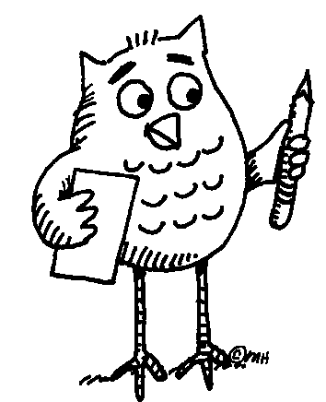 (small group) and A.6 (whole class)
Often, the words “black” and “red” are used to express something more than colours.
- Take a look at the following expressions and together with your partners try to guess where to use “black” “red”, to fill in the gaps. If you need help, you can use an English dictionary or go to http://www.learn-english-today.com/idioms/idiom-categories/colour-idioms.htm
- I was very angry. I saw ___________.
- I owe money to the bank. I am in the ___________.
- My friend has money in her bank account. She is in the _________.
- If our football team gets the title we shall paint the town ____________.
- My uncle does not follow the family tradition. He is the _____________ sheep of the family.
- Colours often carry heavy symbolisms. With regard to the expressions above, which colour would you connect with the words “excitement”, “danger”, “security”, “strong emotions”, “vitality” “bad behaviour”, “action”? Discuss and decide with your partners. Then, write next to each colour the words that you think are connected with that colour:
red:_____________________________________________________________________________________________________________________
___________________________________________________________
___________________________________________________________
black:____________________________________________________________________________________________________________________
___________________________________________________________
___________________________________________________________
- Can you think of other words and symbolisms which are connected with those colours? Add them to the above lists.
- Can you think of any expressions with “red” and “black” in your own mother tongue or other languages that you know? Tell your fellow students. Are they similar to any of the English expressions that were previously mentioned? Discuss if “red” and “black” carry the same symbolisms.
- Are you aware of any other colours that carry symbolisms? Which are those colours and what are their symbolisms? Discuss with your fellow students and write them down. If you happen to notice that there differences in colour symbolisms among the different cultures, you can note that down next to each colour.
____________________________________________________________________________________________________________________________________________________________________________________________________________________________________________________________________________________________________________________________________________________________________________________________________________________________________________________________________________________________________________________________________________________________________________________________________________________________________________________________________________________________________________________________________
- As a class discuss your answers and exchange information.

Answer sheet for A
- I was very angry. I saw ____red_______.
- I owe money to the bank. I am in the ____red_______.
- My friend has money in her bank account. She is in the ____black___.
- If our football team gets the title we shall paint the town ____red________.
- My uncle does not follow the family tradition. He is the _____black________ sheep of the family.

Answer sheet for B
red:____excitement____danger___ vitality ____action _________________
________ strong emotions_____________________________________
black:_____security_______bad behaviour___________________________
___________________________________________________________
___________________________________________________________

Answer sheet for C
(Indicative answers, compatible to the so called Western culture, as colour symbolism may vary among cultures. You can give different answers on the basis of your personal culture).
red:____passion____love___ violence and warfare (blood is red) ________ __________________________________________________________
black:_____death_______mourning_________bad luck (black cat)________
___________________________________________________________

Answer sheet for E:
(Indicative answers, as the answer will depend on the students’ own experiences and background).
Green: ___growth_____ love for nature___________________________
Blue: ___relaxation_____ tranquility______________________________
White: ___purity _____innocence_______________________________

