. Review and Assessment Project
Notes for the teacher
- The assessment is done through a project - the creation of a poster with a world map - in which all the students participate and contribute with what they have learnt or by using their artistic skills to colour the poster.
- Before the class starts working on the project, they may wish to watch the ppt presentation again, as a means of reviewing the information about countries, their location and their capitals.
- Apart from geographical information, the poster will contain information concerning languages and time. So, it would be advisable for the students to have their previous worksheets to refer to and use the information contained in them.
- The teacher could let the students form 3 groups that will undertake the different jobs mentioned in the instructions. It would be good if the students themselves chose the job they would be interested in doing.
- If you wish to make a large photocopy of the blank map in Worksheet 5, you could cut it in pieces and blow up each piece to the same size and then stick the photocopies together, by using sticky tape on the back side.
Duration: 60 minutes
Necessary material:
- A world map or a blown up photocopy of the map in this worksheet
- Pieces of paper
- Colouring pens
- The previous worksheets

Worksheet 1: Reviewing the information on countries and languages
Grouping: 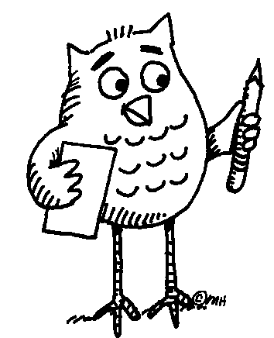 (small group) and (whole class)
Do you think you could all work together and make a poster using a world map, where you would pin pieces of paper with the names of countries and cities in English? You can use a map from your geography lessons where the different countries are already marked or you could use a blown up photocopy of the following map, where you will need to locate the countries and write down their names yourselves. If you wish, you could watch the ppt presentation once more, for help. Work in groups and decide which of the following jobs each group will undertake:
- Mark the strait of Gibraltar, the Black and Red Seas (write the name of the seas in different languages) and any isthmuses or canals that you know.
- Write on pieces of paper the foreign words you have learnt and pin them in the countries that they can be used. If they can be used in many countries, prepare corresponding pieces of paper and pin them on the map. You will find out that you have learnt some quite useful words, that can help you greet people/say thanks/introduce yourself or say something to a very great number of people in our world, on OUR BEAUTIFUL EARTH.
- Draw a sun and a moon on two separate pieces of paper. Put them on your map, to mark where you think it is night and where it is daytime, at the time you are working on your poster. Using the time zones map from Worksheet 4, you can mark what time is at some or all of the countries you will mark on the map.
- After you have finished the poster you can talk about the new things each one of you has learned by participating in this project.
Map from http://vectorya.com/gallery/img65.search.htm
