Raising awareness of Japanese characters (katakana)

Learner Worksheet 2
Material required: The Katakana table. Short history of this syllabic alphabet.
Resources: Document 2, Katakana table
Grouping: 
Let’s study Japanese (a little)
1. Study the Katakana table (Document 2) and call each syllable out loud. Follow the recommended reading direction. Now, can you guess where the first page of a Japanese book is located? And the last page? Do you know other languages that behave in the same manner?
Worksheet 2 answers: Reading the katakana table The first page of a Japanese book is located at the end of a European book. The last page is at the beginning of a European book. Another language that behaves in the same manner is Arabic.
Document 2 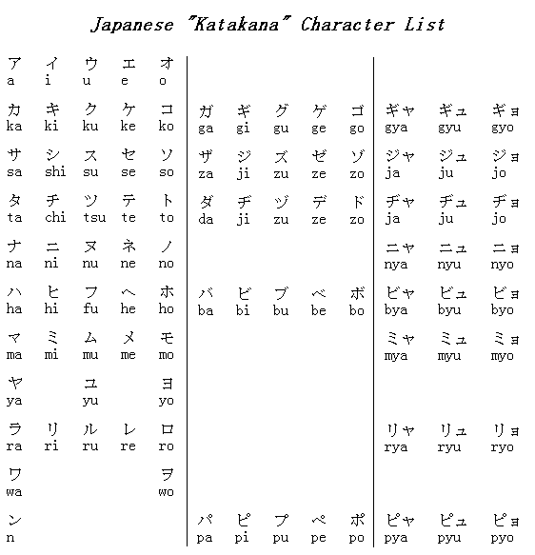
This table is read from right to left or from top to bottom
Only nouns and names can be imported from other languages into Japanese.

