Learner Worksheet 1: Raising awareness of Japanese characters (katakana)
Material required: Japanese calligraphy examples included below. Internet access is optional.
Resources: Document 1, Katakana examples
Grouping: 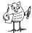and

Focus on content:
Discovering another writing system
Focus on language(S): 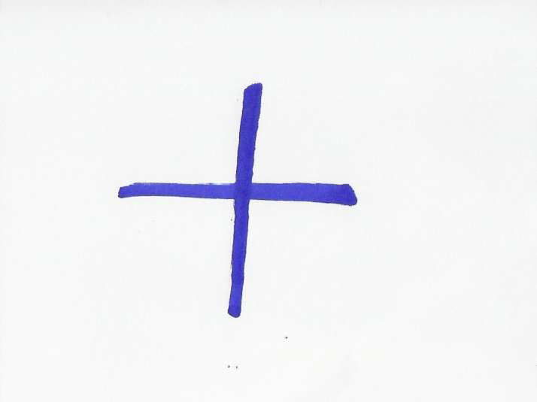
Pronouncing words from other languages
Notes for the teacher:
These tasks can be conducted bilingually. Katakana is syllabic, therefore children must break words into their number of syllables. The sound L is represented by R. There are more signs than those represented in Document 2. These signs can be accessed on the web

Learner worksheet 1 Discovering Japanese calligraphy
- Look at the short film shown on http://markun.cs.shinshu-u.ac.jp/japan/shodou/index-e.html. (The explanations are in English). It shows you how to write Japanese characters. You can also study Document 1 on Japanese calligraphy and/or go back to the site to see an interactive version of the Katakana table.
http://markun.cs.shinshu-u.ac.jp/japan/japan/Katakana1.html
- Practise writing a French/German/Italian or Portuguese noun of your choice in Japanese in Document 1. Can you copy the other nouns that are shown on Document 1?
Can you pronounce these words from other languages (Document 1)?

Document 1:
From Spanish
From Portuguese
パン from "pan" サンバ from "samba"

From German
アルバイト from "Arbeit", which just means "work"
フラメンコ from "flamenco"
サルサ from "salsa" (Portuguese?)
ルンバ from "rumba"
タンゴ from "tango"
From French
バカンス from "vacances"
シネマ from "cinéma"
カフェー from "café"
カフェオレ from "café au lait"
ショコラ from "chocolat"
クロワッサン from "croissant"
エクレア from "éclair"
タルト from "tarte"
ガトー from "gâteau"
From Italian
イタリア from "Italia"
パスタ from "pasta"
スパゲッティ from "spaghetti"
ピッザ from "pizza”
From English:
ジョン
jon John
ジョージ
jōji George
マリー
marī Marie
マイケル
maikeru Michael
ピーター
pītā Peter

