Worksheet 3
- A newsletter
Search the Internet and find any up to date news about parasites in the world. Make a short summary. In groups compile The Parasite News, include pictures, comics etc. Any satire or comedy spoof writing are also accepted. If you need inspiration, see the article below:
http://www.thespoof.com/news/spoof.cfm?headline=s5i53412
-  Write a haiku or poem about parasites. Use your mother tongue and any other foreign language(s) you know.
- Design your book (blog) of parasites.
Some ideas for the design of your book:
- Make a tapeworm-shaped folded book of poetry, add illustrations.
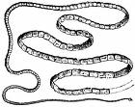

- You can fold the book according to these instructions.
- Take a sheet of paper.
- Fold it to half on both directions. Look at the drawing.
- Open the paper and fold it in half
- Take scissors and cut until the line
cut until the next line | stop here
- Open the paper and fold it by the longitudinal line. Press it gently and you can see the little book formation. Be creative.
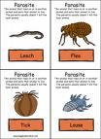 | Parasite poetry  2009

