4. The origin of chocolate
Grouping: 

Worksheet 1
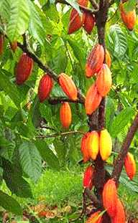
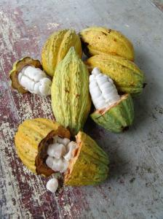
The premier contact of the Western world with Kakao took place in 1528 when the Spanish explorador Fernando Cortez returned from Mexico with Kakao. At that temps cacao was used to make une boisson. The cacaobonen were very duur. Only rich insanlar could payer them. Only in 1900 Kakao became a national drink due to a sharp drop in prix of Kakao. The main ingredient of chocolate is Kakao, made from cacaobonen. They come from the fruta of the Kakaobaum. Kakaobaumen grow in warm and humid tropical ülkeler, surtout in the ülkeler around the équateur. The best-known fournisseurs are Indonesia, Ecuador, Kenia, Ivory Coast... A Kakaobaum has to grow tres tot four jaren and can become quinze metros hoog. Most Kakaobaumen are pruned and become only vier metros hoog. That way it’s easier to pick the Früchte. Every arbre gives about dertig to veertig Früchte par an. The tree has bloemen all year long. Big, hard Früchte grow out of every bloem. After about cinco maanden the Früchte are ripe. After these vijf aylar they can be picked. The ripe fruits are geel. They are about zwanzig Zentimeter long. Every fruta contains about quarante tohumlar. These seeds are the cacaobonen. Kakao is made of these tohumlar. Every year an arbre delivers bir to twee kilo kakao. They open the Früchte with a couteau. They take out the bonen and put them in bins. The bins are covered with big feuilles. After a semaine the bonen are bruin. The bonen are taken out of the bins and put in the Sonne to dry. The bonen are put in big sacs and transported to Europe by Fahrzeug. De sacs are unloaded in the haven of Amsterdam and they take them to the chocolate fabrics by camions. In the fabrics they are converted into chocolate.

Answer the following questions:
Who brought the cacao to Europe? ___________________________________
In which year was that? ____________________________________________
Which country does the cacao come from? _____________________________
Where do cacao trees grow? ________________________________________
______________________________________________________________________________________________________________________________
How much cacao does a cacao tree deliver a year? _____________________
How many seeds does a cacao tree fruit contain? ______________________

