1. A delicious ingredient
Grouping: 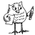

Worksheet 1
Which ingredient do you recognise below? _______________________
Which languages do you recognise? Write the language next to the word.
1. čokolada ……………………………….
2. czekolada ……………………………….
3. ciocolată ……………………………….
4. cioccolato ……………………………….
5. sjokolade ……………………………….
6. chocolate ……………………………….
7. schokolade ……………………………….
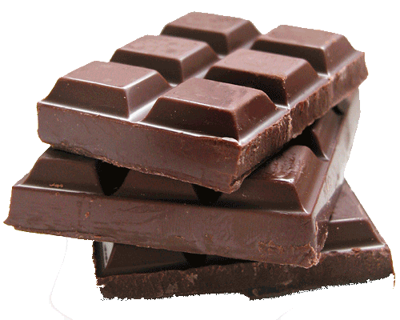
8. choklad ……………………………….
9. chocolade ……………………………….
10. chocolat ……………………………….

Which languages are similar? _______________________________________
______________________________________________________________________________________________________________________________
Have you any idea why that is so? ___________________________________ _______________________________________________________________

