3. Working with nature and scenery in fairy tales in cooperation with Geography, Science and Physical Education
So far we have worked with characters in fairy tales. Now we will continue with the environment which you can come across in the tales.
Grouping:  or or
- Look at the picture of the forest and describe it (Enclosure 1). Is it a scary forest or a nice and calm place to be? Use as many descriptive adjectives as you can. Use as many senses as possible:
- Hearing
- Sight
- Smell
- Taste
- Touch
- What can you do in a forest? Give examples. (Working with verbs)
- Do you have forests like these in the country where you or your parents came from? Describe that nature. Compare it with nature in Sweden. (See Map of Sweden, Topography)
- Design a game, which is based on your fairy tale, which you can play in the forest with the children from the kindergarten.
- Design (Invent) your own sport.
- Bring samples from the forest, such as stones, lava, insects and leaves and so on. (You can do that in Sweden, according to Swedish law.) Do you recognise any environments or/and monsters you have seen in movies? Look at, whatever you have brought, in a microscope. Can you use what you see, in your fairy tale or in your game?
Homework:
Go home and ask your parents to describe or show you pictures of nature in their/your home country. Try to describe it by using the five senses. Write it down in your mother tongue and translate it into English. Draw a picture which you can show the class.

Map of Sweden, Topography

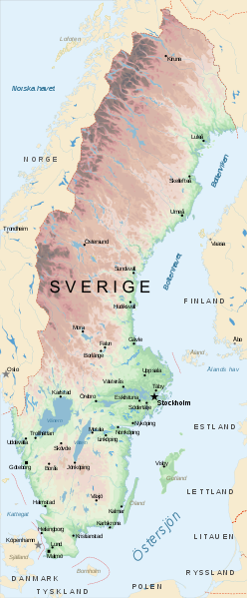
http://commons.wikimedia.org/wiki/File:Map_of_Sweden_Topography_(polar_stereographic)_Sv.svg

Map of the world
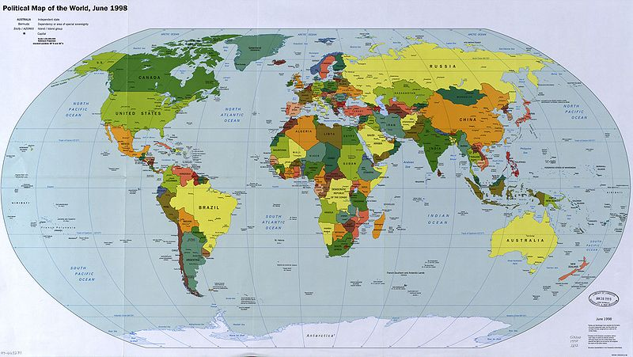
http://commons.wikimedia.org/wiki/File:Map_of_the_world_1998.jpg

