3- When the waves grow bigger and bigger…

Worksheet 2: All kinds of storms at sea
Grouping
There are various kinds of storms at sea that are given different names. Those names depend on the region of the world where those phenomena generally occur.
- Link each English word to the original word you think it comes from.
English word | original word
Hurricane | Kyklōma
Typhoon | 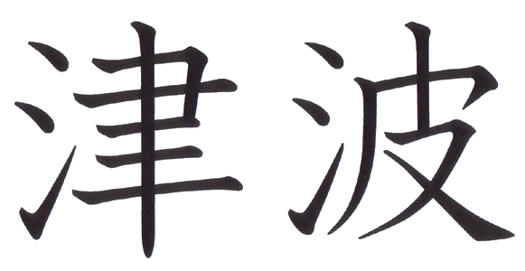
Tsunami | Huracan
Cyclone | 台 风

- Try to find out what is the name of each of those languages
The word hurricane comes from……
The word typhoon comes from…….
The word tsunami comes from…….
The word cyclone comes from……..
- Look for a definition of each term in a dictionary and write it down:
Hurricane: -------------------------------------------------------------------------------------------------
Typhoon: -------------------------------------------------------------------------------------------
Tsunami: -------------------------------------------------------------------------------------------
Cyclone: --------------------------------------------------------------------------------------------

- Look for more information about those phenomena on the Internet
Read the information on those web pages and write a very short summary of the contents
Cyclones http://ww2010.atmos.uiuc.edu/(Gh)/guides/mtr/cyc/def.rxml
Hurricanes : http://ww2010.atmos.uiuc.edu/(Gh)/guides/mtr/hurr/def.rxml
Typhoons: http://library.thinkquest.org/03oct/00477/NatDisasterPages/jeb.webpages/Typhoon/typhoon_definition.htm
Tsunamis: http://www.pbs.org/wnet/savageseas/neptune-side-tsunamis.html

