2. Waves and wind

Worksheet 2: How are waves measured?
grouping
- 1.Look at the diagram and fill in the blanks in the text with words from the list below
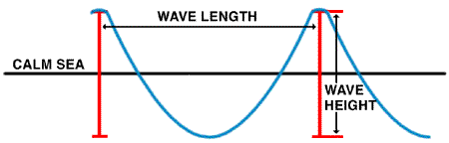
Wave model from www.ndbc.noaa.gov/educate/educate.shtml
The water in the ocean is always ----. Waves are one movement of the ocean----.
They are caused by the----.The ----of these waves depends on wind----, on the ----
of the wind and on the----. It is measured from the wave ----to the wave----. The wave -----is defined as the horizontal distance between two successive----.
Water; moving; height; waves; length; crest ; troughs; wind ; duration; fetch; speed

- Create your own ocean wave!
Follow this link and discover the wave machine…
http://www.pbs.org/wnet/savageseas/multimedia/wavemachine.html

