2. Waves and wind

Worksheet 1: How can waves be described?
Grouping
- Bring photographs, pictures or paintings about waves to class
- Share them with the class and describe them
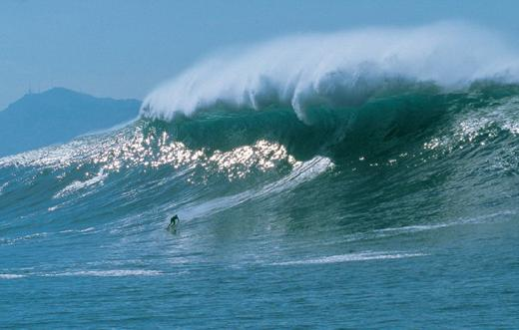
2- grouping
Match each word to its definition
Duration | bottom of a wave
Trough | length of time
Crest | distance over which the wind blows
Fetch | top of a wave

