1. The oceans in the world

Worksheet 2
Grouping
- Read the definitions and label the map
Oceans cover nearly 71% of the Earth's surface.
The Pacific Ocean is the largest ocean and borders the five continents.
The Atlantic Ocean’s neighbouring seas include the Mediterranean Sea, the North Sea and the Baltic Sea.
The Arctic Ocean is the smallest ocean. It surrounds the North Pole. It is frozen all the time, except at its edges.
The Southern Ocean is where you'll find Antarctica and the South Pole.
The Indian Ocean borders areas from the southern hemisphere.

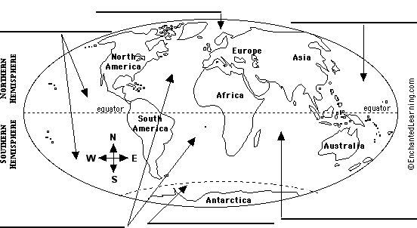
- Check your answers and learn more about the five oceans by following this link:
http://www.gdrc.org/oceans/world-oceans.html

