1. The oceans in the world

Worksheet 1
Grouping
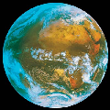
- Fill in the chart below after discussing the items with your friends and your teacher (use the language you know best / your teacher will help you if necessary)
What we know about the ocean | What we want to Learn about the ocean
-  -  -  (…) | -  -  -  (…)
- Answer the question after discussing it with your friends and your teacher (use the language you know best/ your teacher will help you if necessary)
Why does the water of the sea move?
…………………………………………………………………
………………………………………………………………….

