3. Scientific expeditions
Grouping: - -
- Warm-up activity
Grouping: 
Everything starts from scientific question. Look around in your classroom and write down as many questions as you can in 5 minutes time.
- Vocabulary
Grouping:
Make a pictogram timeline of Charles Darwin’s life (include 7- 10 most important episodes). http://darwin-online.org.uk/timeline.html
- Writing
Grouping:
Sometimes natural scientists make long journeys to answer questions. In the past this was quite usual. Planning an expedition was a complicated task in the 19th century and it still is up till now.
You are a member of the crew. Make a list of 5 objects to take with and 3 things every member of your crew has to organise before and after the expedition.

Before  Captain...  - …  - …  - …  Scientist...  - …  - …  - …  …  5 objects:  1. …  2. …  3. …  4. …  5. … | I am __________________________  My crew: ______________________________  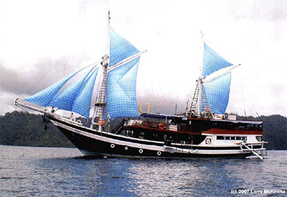 | After  Captain...  1.…  2.…  3.…  Scientist...  1.…  2.…  3.…  …

- Speaking
Grouping:
How do you think these explorers communicated with the local population? Explain the local population what you came for and what your study is about. Use as many different words in as many different languages as possible. Create a multilingual presentation.
- Reading
Grouping:
Background: The collected materials on the expedition on the „Beagle“ include descriptions and drawings.
You can read the diary on
http://darwin-online.org.uk/content/frameset?itemID=EHBeagleDiary&viewtype=text&pageseq=1
and see the drawings
http://darwin-online.org.uk/graphics/illustrations.html
Skim the following text and try to find original words to the definitions below referring to.
Tierra del Fuego, 1834, March 4th
Came to an anchor in the Northern part of Ponsonby sound. We here enjoyed three very interesante days: the weather has been fine & the views magnificent. The bergen, which we passed today, on the Northern Küste of the Channel are about 3000 feet high, — they terminate in very broken & sharp peaks; & many of them rise in one abrupt rise from the waters edge to the above elevation. The lower 14 or 1500 feet is covered with a dense mets. — A mountain, which the Captain has done me the honour to call by my nombre, has been determined by angular möötmine to be the highest in Tierra del Fuego, above 7000 feet & therefore higher than M. Sarmiento. — It presented a very grand, appearance; there is such splendour in one of these Schnee-clad mountains, when illuminated by the rosy lumière of the sun; & then the outline is so distinct, yet from the distance so light & aerial, that one such view merely varied by the passing wolk affords a feast to the esprit.
- A type of precipitation within the Earth's atmosphere in the form of crystalline water ice, consisting of a multitude of snowflakes that fall from clouds: _____________
- A non-corporeal substance contrasted with the material body: ______________
- A large landform that stretches above the surrounding land in a limited area usually in the form of a peak: _____________________
- An area with a high density of trees: __________________
- It identifies a specific unique and identifiable individual person: ___________________
- Writing
Grouping:
Draw or describe the picture from a birds point of view.

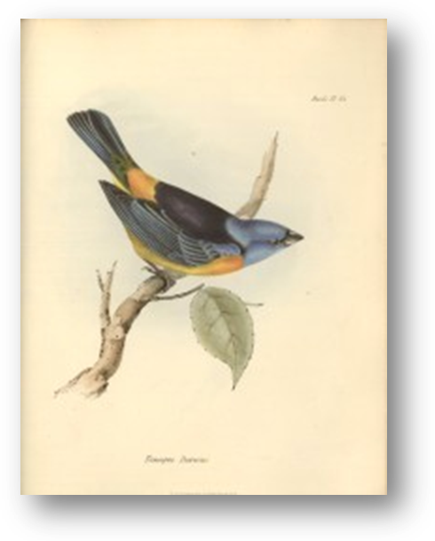  Here I am, sitting on my favourite tree… | … and here you can see the picture through my eyes.

- Speaking
Grouping:
Describe the picture from the birds point of view using the five words left in the multilingual text that we didn´t give the definition for.

