

Worksheet 1: FROM THE HISTORY OF MATHEMATICS

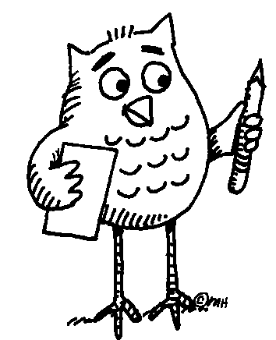 Task 1: Read the paragraph using the dictionary to clarify the meaning of unknown words or phrases.
Understanding mathematics has always meant asking a lot of questions. Sometimes, in order to find the right answers we find it useful to look back and learn from history. Mathematical knowledge of today has a long tradition; all the different cultures in different periods of history have contributed to its development. Due to the lack of contact, however, each of the early civilizations developed its own specific number system. This process was often closely related to body parts, an approach common to different parts of the world. For example, the sizes of dishes in many countries were usually based on the average size of hands and feet. Whereas European mathematics later turned away from concrete things and became abstract, the concept of mathematics elsewhere, outside the European influence, has often remained unchanged. Nowadays, body parts are still used either as an aid to tallying (e.g. fingers and toes) or for counting according to a conventionally defined order, e.g. by the people of Papua New Guinea.
Task 2: Talk to each other in English or your mother tongue. Try to come up with
examples of OLD measures of length, capacity, or weight. Share with the rest of the class.

Task 3: Write one example each for a mathematical problem expressed
- in numbers:

- in letters:

Share with the rest of the class.

