2. Let’s study Japanese (a little)
Grouping: 

Worksheet 1
- Study the Katakana table (Document 2) and call each syllable out loud. Follow the recommended reading direction. Now, can you guess where the first page of a Japanese book is located? And the last page? Do you know other languages that behave in the same manner?
Document 2 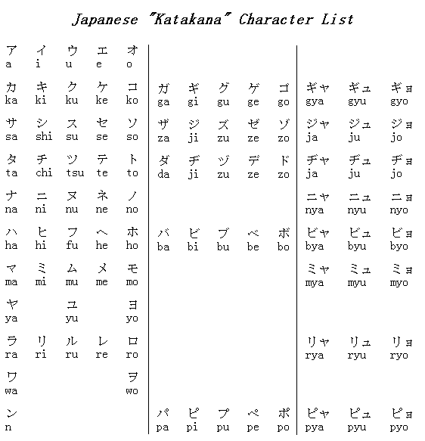
This table is read from right to left or from top to bottom
Only nouns and names can be imported from other languages into Japanese.

