1. Discovering Japanese calligraphy
Grouping: 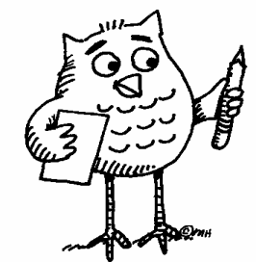

Worksheet 1
- Look at the short film shown on http://markun.cs.shinshu-u.ac.jp/japan/shodou/index-e.html. (The explanations are in English). It shows you how to write Japanese characters. You can also study Document 1 on Japanese calligraphy and/or go back to the site to see an interactive version of the Katakana table.
http://markun.cs.shinshu-u.ac.jp/japan/japan/Katakana1.html
- Practise writing a French/German/Italian or Portuguese noun of your choice in Japanese in Document 1. Can you copy the other nouns that are shown on Document 1?
- Can you pronounce these words from other languages (Document 1)?
Document 1:
From Spanish
フラメンコ from "flamenco"
From Portuguese
パン from "pan"
サンバ from "samba"

From German
アルバイト from "Arbeit", which just means "work"
サルサ from "salsa" (Portuguese?)
ルンバ from "rumba"
タンゴ from "tango"

From French
バカンス from "vacances"
シネマ from "cinéma"
カフェー from "café"
カフェオレ from "café au lait"
ショコラ from "chocolat"
クロワッサン from "croissant"
エクレア from "éclair"
タルト from "tarte"
ガトー from "gâteau"

From Italian
イタリア from "Italia"
パスタ from "pasta"
スパゲッティ from "spaghetti"
ピッザ from "pizza”
From English:
ジョン
jon John
ジョージ
jōji George
マリー
marī Marie
マイケル
maikeru Michael
ピーター
pītā Peter

