CONTENT BASED TEACHING ConBaT+
Addictively tasty
For the teacher

Sofie JONCKHEERE, Arzu BASOGLU & Kristel PROVOST
2/4/2011
TEACHER TEMPLATE

Addictively tasty

Sofie JONCKHEERE, Arzu BASOGLU & Kristel PROVOST

sofie.jonckheere@foyer.be

Regional Integration Centre Foyer & Cardijnschool Brussels

Belgium
-------------------------------------------------------------------------------------------------
Target Group:
- The materials are created for special needs schools for children with a light mental disability (12-16). However, most of the activities can also be used in mainstream education (10-14)

Subjects:
- Home economics
- Geography
- History

Aims:
- Learn the map of Europe
- Learn about ingredients and cooking
- Learn about the colonial times
- Develop positive attitudes towards other languages
- Learn to interact with each other

Key Competencies:

Communication in languages:
- Interact in English (improve listening and speaking)
- Improve reading and writing in English
- Learn about similarities and differences between languages
- Value the diversity of languages
- Use different strategies to understand foreign languages
- Comparing different writing systems

Learning to learn:
- Look for information and share it with others
- Use the atlas
- Resolve problems in a systematic and logic way
- Plan and organise the tasks
- Control own learning process

Digital competences :
- Positive attitude towards IT
- Work independently on the computer
- Use the computer to express own ideas in a creative way

Social and civic competences :
- Learn to work together in a diverse group
- Respect and value other opinions
- Learn to be critical and express own opinion

Timing of the overall activities:
- 3 hours

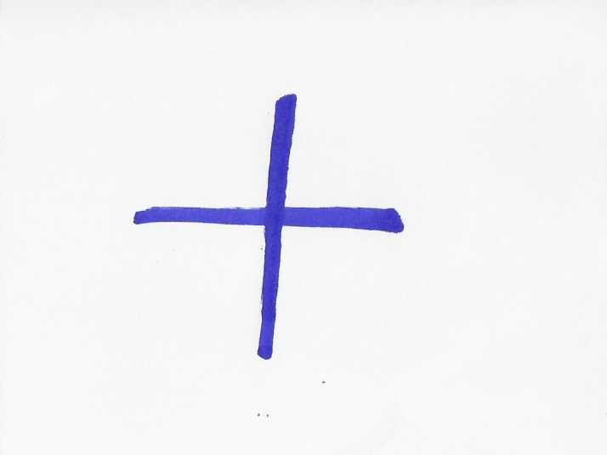

1. A delicious ingredient

Notes for the teacher: This first task is an introduction. Students discover the ingredient chocolate in different languages. The teacher provides worksheet 1 for every student.

Timing: 15’

Grouping: 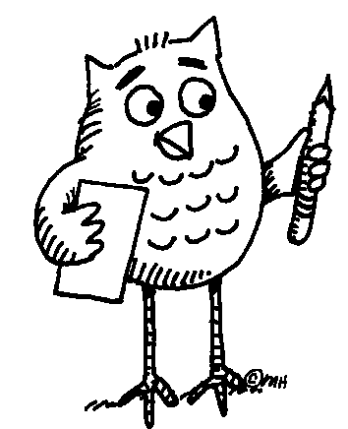

Focus on content:
- Chocolate as a mean ingredient for dessert

Focus on languages:
- Interact in English (improve listening and speaking)
- Improve reading and writing in English
- Learn about similarities and differences between languages
- Value the diversity of languages

Learner worksheet 1:

Which ingredient do you recognise below? _______________________

Which languages do you recognise? Write the language next to the word.

1. čokolada ……………………………….
2. czekolada ……………………………….
3. ciocolată ……………………………….
4. cioccolato ……………………………….
5. sjokolade ……………………………….
6. chocolate ……………………………….
7. schokolade ……………………………….
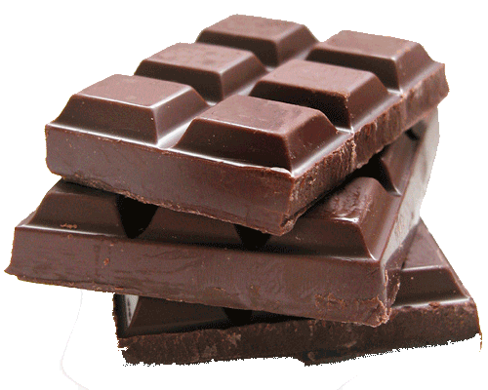
8. choklad ……………………………….
9. chocolade ……………………………….
10. chocolat ……………………………….

Which languages resemble each other? _________________________
________________________________________________________________________________________________________________________
Have you any idea why that is so? ______________________________ __________________________________________________________

Answer sheets:

Čokolada = Croatian
Czekolada = Polish
Ciocolată = Romanian
Cioccolato = Italian
Sjokolade = Norwegian
Chocolate = English, Portuguese, Spanish
Schokolade = German
Choklad = Swedish
Chocolade = Dutch, Danish
Chocolat = French

The following words resemble each other because they belong to the same language family. In special needs schools this doesn’t have to be discussed in the class. The students can discover that these countries are geographically related.

Germanic languages | Romanesque languages | Slavic languages
Chocolade (Dutch) | Chocolat (French) | Czekolada (Polish)
Schokolade (German) | Cioccolato (Italian) | Čokolada (Croatian)
Chocolate (English) | Chocolate (Spanish)
Chocolade (Danish) | Ciocolată (Romanian)
Choklad (Swedish) | Chocolate (Portuguese)
Sjokolade (Norwegian)

----------------------------------------------------------------------------------------------------------

2. Europe

Notes for the teacher: The teacher provides worksheet 1 for every student. When there’s a map of Europe on the wall in the class, students can show the countries they know on it. If not they can do that in the atlas.

Timing: 25’

Resources: map of Europe on the wall and/or an atlas

Grouping:

Focus on content/Contenu/Contenido:
- Orientate oneself in space
- Explore map of Europe and the languages spoken
- Work with atlas

Focus on languages:
- Interact in English (improve listening and speaking)
- Improve reading and writing in English

Learner worksheet 1:

In which European countries are these languages official languages? Try this for 6 languages.

Language: _______________  Countries: ____________________  ____________________ | Language: _______________  Countries: ____________________  ____________________ | Language: _______________  Countries: ____________________  ____________________
Language: _______________  Countries: ____________________  ____________________ | Language: _______________  Countries: ____________________  ____________________ | Language: _______________  Countries: ____________________  ____________________

Can you find these countries on the map of Europe?

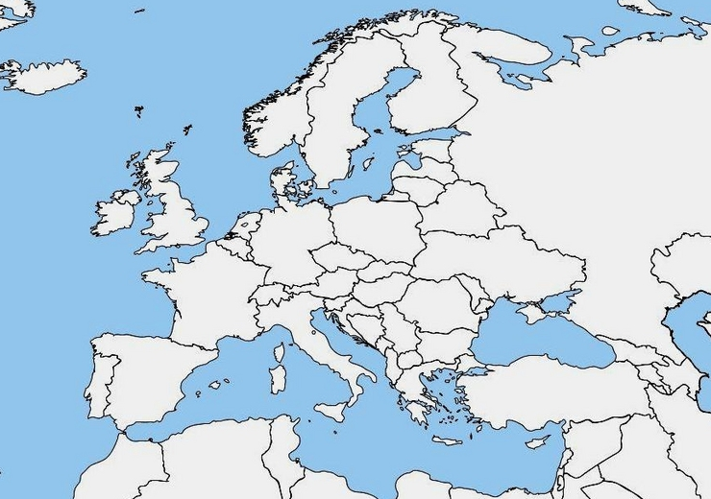

Afterwards you can check the atlas if you were right.

Answer sheet:

Dutch: Belgium, The Netherlands | French: France, Belgium, Luxemburg, Switzerland, Italy | Polish: Poland
German: Belgium, Germany, Switzerland, Austria, Luxemburg, Liechtenstein | Italian: Italy, Switzerland | Croatian: Croatia, Bosnia, Herzegovina, Austria, Italy, Serbia
English: England, Ireland | Spanish: Spain
Danish: Denmark | Romanian: Romania
Swedish: Sweden | Portuguese: Portugal
Norwegian: Norway

----------------------------------------------------------------------------------------------------------

3. Word search

Notes for the teacher: For students with a light mental handicap it’s not so easy to concentrate for longer periods of times. Therefore it’s important to include some shorter and easier in between exercises. This word search allows them to relax and work by themselves. The words they have to look for are the same as in worksheet 1. They are hidden in the frame horizontally, vertically and diagonally in all directions. The teacher provides worksheet 1 for every student.

Timing: 15’

Grouping:

Focus on content:
- Chocolate as a main ingredient for dessert

Focus on languages:
- Interact in English (improve listening and speaking)
- Improve reading and writing in English
- Learn about similarities and differences between languages
- Value the diversity of languages

Learner worksheet 1:

Try to find the following words: sjokolade, chocolade, schokolade, chocolate, czekolada, cioccolato, choklad and chocolat



T F N S H W R E O O R E I F
F N E J C W I R M O R G D F
T Z D O Z N Q O I T C F S H
I A E K E N S M D A Q C E S
O I U O K E N R S L H R D D
F T O L O N T A L O C O H C
L F N A L F A A C C D C E C
U R P D A H I O L C O R E S
H M C E D A L O K O H C S A
S I S H A A I N I I C K S S
T E E T D M T J C C I O R I
D A H E S C E N Q A V C H H
T W N A P M S D A L K O H C
P G N N T C D L I R M C B A

Assessment :
- The students report on their solutions and share with their classmates.

Answer sheet:

T F N S H W R E O O R E I F
F N E J C W I R M O R G D F
T Z D O Z N Q O I T C F S H
I A E K E N S M D A Q C E S
O I U O K E N R S L H R D D
F T O L O N T A L O C O H C
L F N A L F A A C C D C E C
U R P D A H I O L C O R E S
H M C E D A L O K O H C S A
S I S H A A I N I I C K S S
T E E T D M T J C C I O R I
D A H E S C E N Q A V C H H
T W N A P M S D A L K O H C
P G N N T C D L I R M C B A

-----------------------------------------------------------------------------------------------------

4. The origin of chocolate

Notes for the teacher: The students read the text out loud, every student a paragraph. The teacher doesn’t say in advance that it’s a multilingual text. It will be a surprise for the students to discover new words in languages they might not know and still understand the text. They can also discover new letters and sounds. The teacher provides worksheet 1 for every student. They fill out the questions in pairs.

Timing: 30’

Grouping:

Focus on content:
- Learn about the colonial times

Focus on languages:
- Interact in English (improve listening and speaking)
- Improve reading and writing in English
- Learn about similarities and differences between languages
- Value the diversity of languages
- Use different strategies to understand foreign languages
- Comparing different writing systems

Learner worksheet 1:
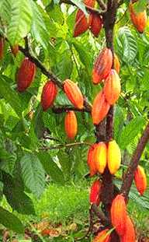
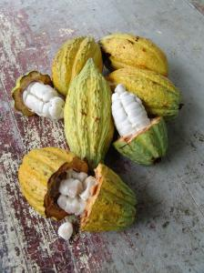
The premier contact of the Western world with Kakao took place in 1528 when the Spanish explorador Fernando Cortez returned from Mexico with Kakao. At that temps cacao was used to make une boisson. The cacaobonen were very duur. Only rich insanlar could payer them. Only in 1900 Kakao became a national drink due to a sharp drop in prix of Kakao. The main ingredient of chocolate is Kakao, made from cacaobonen. They come from the fruta of the Kakaobaum. Kakaobaumen grow in warm and humid tropical ülkeler, surtout in the ülkeler around the équateur. The best-known fournisseurs are Indonesia, Ecuador, Kenia, Ivory Coast... A Kakaobaum has to grow tres tot four jaren and can become quinze metros hoog. Most Kakaobaumen are pruned and become only vier metros hoog. That way it’s easier to pick the Früchte. Every arbre gives about dertig to veertig Früchte par an. The tree has bloemen all year long. Big, hard Früchte grow out of every bloem. After about cinco maanden the Früchte are ripe. After these vijf aylar they can be picked. The ripe fruits are geel. They are about zwanzig Zentimeter long. Every fruta contains about quarante tohumlar. These seeds are the cacaobonen. Kakao is made of these tohumlar. Every year an arbre delivers bir to twee kilo kakao. They open the Früchte with a couteau. They take out the bonen and put them in bins. The bins are covered with big feuilles. After a semaine the bonen are bruin. The bonen are taken out of the bins and put in the Sonne to dry. The bonen are put in big sacs and transported to Europe by Fahrzeug. De sacs are unloaded in the haven of Amsterdam and they take them to the chocolate fabrics by camions. In the fabrics they are converted into chocolate.
Answer the following questions:
Who brought the cacao to Europe? _____________________________
In which year was that? ______________________________________
Which country does the cacao come from? _____________________
Where do cacao trees grow? __________________________________
________________________________________________________________________________________________________________________
How much cacao does a cacao tree deliver a year? _____________
How many seeds does a cacao tree fruit contains? _______________

Assessment :
Teacher asks:
  - Do you notice any difference in writing systems? [fe. In German the nouns are written with capital letter]
- Did you understand the multilingual text?
- Was it difficult?
- Which words did you understand?
- What made you understand them?
  - Did you derive their meaning from other languages you know or from the context?
- Which words didn’t you understand at all?

Answer sheet:

The first contact of the Western world with cacao took place in 1528 when the Spanish explorer Fernando Cortez returned from Mexico with cacao. At that time cacao was used to make a drink. The cacao beans were very expensive. Only rich people could afford them. Only in 1900 cacao became a national drink due to a sharp drop in price of cacao.
The main ingredient of chocolate is cacao, made from cacao beans. They come from the fruit of the cacao tree. Cacao trees grow in warm and humid tropical countries, especially in the countries around the equator. The best-known suppliers are Indonesia, Ecuador, Kenia, Ivory Coast... A cacao tree has to grow three to four years and can become fifteen metres high. Most cacao trees are pruned and become only four metres high. That way it’s easier to pick the fruits. Every tree gives about thirty to forty fruits a year. The tree has flowers all year long. Big, hard fruits grow out of every flower. After about five months the fruits are ripe. After these five years they can be picked. The ripe fruits are yellow. They are about twenty centimetres long. Every fruit contains about fourty seeds. These seeds are the cacao beans. Cacao is made of these seeds. Every year a tree delivers one to two kilo cacao.
They open the fruits with a knife. They take out the beans and put them in bins. The bins are covered with big leaves. After a week the beanes are brown. The beans are taken out of the bins and put in the sun to dry. The beans are put in big bags and transported to Europe by ship. De bags are unloaded in the port of Amsterdam and they take them to the chocolate fabrics by trucks. In the fabrics they are converted into chocolate.

- Who brought the cacao to Europe? The Spanish explorer Fernando Cortez.
- In which year was that? In 1528.
- Which country does the cacao come from? From Mexico.
- Where do cacao trees grow? In warm and humid tropical countries, especially in the countries around the equator.
- How much cacao does a cacao tree deliver a year? One to two kilo.
- How many seeds does a cacao tree fruit contains? About fourty.
-----------------------------------------------------------------------------------------------------

5. Quartet

Notes for the teacher:
Game:
There are 10 quartets so 40 cards all in all. Every quartet contains one ingredient in 4 different languages. The students can pronounce the word or just ask for the language fe. Ask if you can have the “leche” or the “Spanish milk”.

Rules:
The students play in groups of 3 to 5. Each group receives a complete set of cards. One player shuffles the cards and divide them equally. Every player takes the cards in his hands and doesn’t show them to the others. The first player asks another player to give him a card he doesn’t have, belonging to a quartet he has at least one card of. He names the quartet and then the card he wants fe. “Do you have milk, leche?” or “Do you have milk, the Spanish milk?” If the player has it, he has to give it and the first player can continue asking him or another player. If he doesn’t have it, the turn goes to the last player he asked a card from. If a player gets a set of 4 cards, he says “quartet” and lays the 4 cards on the table. The winner is the one with the most quartets.

Timing: 50’

Material required: a full set of quartet cards for every group of students.

Grouping:

Focus on content:
- Learn about ingredients and cooking
- Respect hygiene and safety when cooking

Focus on languages:
- Interact in English (improve listening and speaking)
- Improve reading and writing in English
- Learn about similarities and differences between languages
- Value the diversity of languages
- Use different strategies to understand foreign languages
- Comparing different writing systems

Assessment :
- Which languages resemble each other?
- Which desserts can you make with these ingredients?
- Do you know any other recipe you can make with these ingredients?
- Do you notice any difference in writing systems?

As an additional task, they can prepare one of the desserts in the cooking class.

-----------------------------------------------------------------------------------------------------

6. Alphabet game

Notes for the teacher: For students with a light mental handicap it’s not so easy to concentrate for longer periods of times. Therefore it’s important to include some shorter and easier in between exercises. This alphabet exercise allows them to relax and work by themselves. They look for words that have something to do with this lesson. They write them first in English, then in their mother tongue and then in any other language they might know. Only in English the word have to start with the letters from the alphabet. The teacher provides worksheet 1 for every student.

Timing: 30’

Grouping:

Focus on content:
- It can be a repetition of what they have learned during this lesson

Focus on languages:
- Interact in English (improve listening and speaking)
- Improve reading and writing in English
- Learn about similarities and differences between languages
- Value the diversity of languages
- Use different strategies to understand foreign languages
- Comparing different writing systems

Learner worksheet 1:

Try to make a word with every letter of the alphabet. The words must have something to do with this lesson about chocolate. Translate this word into your mother tongue and in another language you know.
English | Your mothertongue | Another language
A____________________ | ____________________ | ____________________
B____________________ | ____________________ | ____________________
C____________________ | ____________________ | ____________________
D____________________ | ____________________ | ____________________
E____________________ | ____________________ | ____________________
F____________________ | ____________________ | ____________________
G____________________ | ____________________ | ____________________
H____________________ | ____________________ | ____________________
I____________________ | ____________________ | ____________________
J____________________ | ____________________ | ____________________
K____________________ | ____________________ | ____________________
L____________________ | ____________________ | ____________________
M____________________ | ____________________ | ____________________
N____________________ | ____________________ | ____________________
O____________________ | ____________________ | ____________________
P____________________ | ____________________ | ____________________
Q____________________ | ____________________ | ____________________
R____________________ | ____________________ | ____________________
S____________________ | ____________________ | ____________________
T____________________ | ____________________ | ____________________
U____________________ | ____________________ | ____________________
V____________________ | ____________________ | ____________________
W____________________ | ____________________ | ____________________
X____________________ | ____________________ | ____________________
Y____________________ | ____________________ | 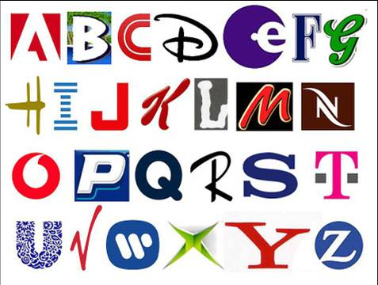  ____________________
Z____________________ | ____________________ | ____________________

Assessment :
- The students compare the languages of the class.
- Do they resemble or not?
- Can they understand them?

-----------------------------------------------------------------------------------------------------

7. Word cloud

Notes for the teacher: The students go to the computer class and make a word cloud on http://www.wordle.net/ with all the words they associate with chocolate. They can do this in different languages. They create a nice lay-out using different colours, print their work of art and hang it on the wall of the classroom.

Timing: 15’

Material required: computer, internet

Grouping:

Focus on content:
- All the words they use are related to the cooking class

Focus on languages:
- Interact in English (improve listening and speaking)
- Improve reading and writing in English
- Learn about similarities and differences between languages
- Value the diversity of languages
- Use different strategies to understand foreign languages
- Comparing different writing systems

Assessment
- The students compare the languages of the class.
- Do they resemble or not?
- Can they understand them?

----------------------------------------------------------------------------------------------------------

References

- Word search: http://www.smhc.info/spelletjes/woordzoeker/zelf_woordzoeker_maken.php
- Word cloud: http://www.wordle.net/
- Map of Europe: http://www.schoolplaten.com/nl-kleurplaat-kleurplaten-foto-blanco-kaart-Europa-i7464.html
- Language families: htpp:\\nl.wikipedia.org
- Multilingual text: www.groenewiel.nl/tropischeproducten/infoblad, http://www.leerkracht.nl, Ferris, J. (Red.)WOW! de avontuurlijkste encyclopedie over alles. Uitgeverij Unieboek, De Guibert, F. (2008). Hoe wordt dat gemaakt? Aartselaar: Deltas.
- Images: www.spreekbeurtenstartpagina.nl/voeding.html, http://fx82.giganet.nl/~ivntest/images/stories/foto/schoolgids/Riki-vergrootglas.gif, www.anthemis.nl/beeldaroma/cacaobonen2.jpg, www.anthemis.nl/beeldaroma/cacaoboom.jpg, marjoleinfermie.c3log.nl/wp-content/alfabet.jpg
Quartet images:
Milk: http://www.schoolcateringdiemen.nl/Gezonde%20voeding/melk.jpg
Butter: http://www.inkopers-cafe.nl/upload/images/berichten/thumbs/Boter-detail.jpg
Chocolate: http://www.babble.com/CS/blogs/strollerderby/Chocolate.png
Sugar: http://equilibriodinamico.es/wp-content/uploads/2010/03/sugar.jpg
Egg: http://unchealthcare.files.wordpress.com/2009/11/egg.jpg
Flour: http://www.mybabysweetz.com/shoppe/catalog/images/flour.jpg

----------------------------------------------------------------------------------------------------------

