CONTENT BASED TEACHING ConBaT+
BODY PART MATHEMATICS
For the Teacher
Marie Hofmannová

body part mathematics
Table of Contents
Introductory Information 3
Learner worksheet 1: From the history of mathematics 5
Learner worksheet 2: Body parts 7
Learner worksheet 3: Body part counting in New Guinea 11
Learner worksheet 4: Body part measuring in Europe 14
Learner worksheet 5: Number systems 17
Learner worksheet 6: task to be introduced by the teacher to the whole class 20

Introductory Information
AUTHOR: Marie Hofmannová
E-MAIL: marie.hofmannova@pedf.cuni.cz
INSTITUTE: Charles University, Prague, Faculty of Education, Czech Republic
Target Group:
Learners aged 15 – 16
Subjects:
Mathematics, English as a foreign language (intermediate level - B2)
Aims:
- To introduce the concept of body part counting and measuring.
- To present examples from different cultures worldwide.
- To demonstrate the way “body part mathematics” reflects in diverse number systems.
- To explore multilingual/cultural aspects of body part counting and measuring.
Key Competencies regarding:
Communication in language(s):
Communication in L1 (the mother tongue or the language of instruction)
- negotiating meaning in reading comprehension tasks
- discussing the concepts and findings
Communication in English and other foreign languages
- improving reading comprehension skills
- learning and practicing new vocabulary for problem solving
- enhancing fluency through discussions in pairs
- including the languages of the learners present in the classroom
Learning to learn:
- looking up information with the help of bilingual or monolingual dictionaries
- exploring diversity through comparing different European languages
Digital competences:
- exploring diversity through comparing different counting and measuring systems
- looking for relevant information on the Internet
Social and civic competences:
- learning to cooperate in multilingual/cultural pairs
- learning about the cultures of the pupils present in the classroom
- learning about diversity from the history of mathematics

Timing of the overall activities:
approximately 120 minutes, preferably introduced as a sequence of six shorter lesson stages.
Resources and materials needed:
bilingual / monolingual dictionaries, access to the Internet, map of the world.
Focus on content:
Mathematics (body part counting and measuring, number systems);
Focus on languageS:
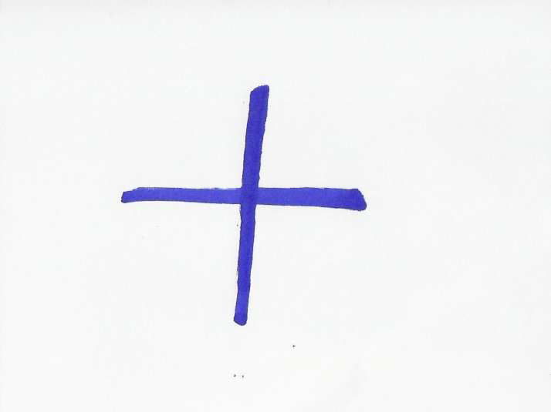Vocabulary: everyday language (names of body parts in different languages), subject specific terminology: language of Mathematics (number systems, units of length);
Grammar: speculating, i.e. expressing modality (Worksheet 3).
Note: All the materials for the students are framed.

Learner worksheet 1: From the history of mathematics
Timing: 10 minutes
Grouping: 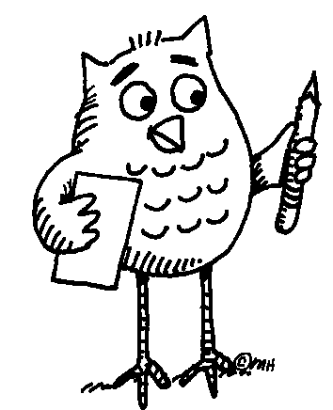 ( ... ) Learners work in pairs. Later they compare their results with the others in class.



Worksheet 1: FROM THE HISTORY OF MATHEMATICS

Task 1: Read the paragraph using the dictionary to clarify the meaning of unknown words or phrases.
Understanding mathematics has always meant asking a lot of questions. Sometimes, in order to find the right answers we find it useful to look back and learn from history. Mathematical knowledge of today has a long tradition; all the different cultures in different periods of history have contributed to its development. Due to the lack of contact, however, each of the early civilizations developed its own specific number system. This process was often closely related to body parts, an approach common to different parts of the world. For example, the sizes of dishes in many countries were usually based on the average size of hands and feet. Whereas European mathematics later turned away from concrete things and became abstract, the concept of mathematics elsewhere, outside the European influence, has often remained unchanged. Nowadays, body parts are still used either as an aid to tallying (e.g. fingers and toes) or for counting according to a conventionally defined order, e.g. by the people of Papua New Guinea.
Task 2: Talk to each other in English or your mother tongue. Try to come up with examples of OLD measures of length, capacity, or weight. Share with the rest of the class.
Task 3: Write one example each for a mathematical problem expressed
- in numbers:
- in letters:
- in pictures:
Share with the rest of the class.
Assessment: The aim of all the activities is to motivate learners. Therefore it is advisable to encourage the learners, help them do the task, monitor their work carefully, and show interest in their results. Suggested issues: Are the learners interested in the ideas? Are they busy working/discussing? Do they have ‘positive feelings’ about the activity? - Whereas affective aspects of learning and the engagement of learners can be assessed, there is no need to assess language accuracy and/or the correctness of problem solving. The learners should, however, get acquainted with the correct language forms or solving procedures.
Resources:
In case of interest, more information can be found in the Ethnomathematics Digital Library http://www.ethnomath.org/search/browseResources.asp?type=subject&id=523 http://www.und.nodak.edu/dept/math/history/counting.htm
http://en.wikipedia.org/wiki/History_of_measurement
Notes for the teacher: Worksheet 1
Task 1 - Additional information: (i.e. what the teacher can tell the class in case of interest)
“Archeological evidence shows the earliest symbols were related to groupings of objects (frequent symbolic representations of cattle, fish, farm produce etc. suggesting a connection with barter or trade, or with accounting or early forms of payment or taxation). From this evolved different ways of counting different things: cattle were grouped differently from sheep or fish or cobs of corn; in some cultures trees were counted in a different way from stones, etc. (In many countries eggs are still bought in boxes of six or twelve). However strange this may sound, it is culturally significant.”
Answers (checking the students´ comprehension): To seek answers = search for (look for) answers. Due to the lack of contact … = because (the early civilizations) did not meet. A number system = a way of counting. An aid to tallying = a kind of help in counting, scoring or matching. A conventionally defined order = the order agreed upon by use and custom.
Task 2 - The learners work in pairs first. Later they present examples to the others in class. The teacher should elicit answers in different languages. (An example of an old unit of length in English: 1 league = 3 miles.)
Task 3 - The teacher should monitor what the learners are writing. If necessary, some examples may be presented out loud or written on the board.
References:
Barnes, I. 2009. Dávné civilizace. Computer Press. Translated from the English original: 2007 Classical World. London: Cartographica Press.
Joseph, G.G. The Crest of the Peacock, London: Penguin Books Ltd., 2000.

Learner worksheet 2: Body parts
Resources: Worksheet 2
Timing: 10 minutes (5 minutes for writing, 5 for checking and pronouncing the words in different languages)
Grouping: | ...
Focus on content: measures
Focus on languages: parts of the body in English and languages of the class



Learner worksheet 2: BODY PARTS

Task: Write down words that represent different parts of human hands and arms.
Make two columns:
English Your mother tongue 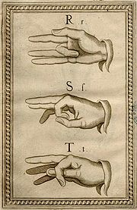
Manual alphabet (Bonet, 1620)
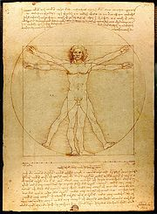
Vitruvio man. From: The Notebooks of Leonardo da Vinci (original edition 1883)

... Follow up activity for the whole class: Can you teach your friends how to say the names of body parts in your language?
Notes for the teacher: Worksheet 2
- Pairs of learners write down different parts of human hands and arms.
- After finishing they compare their answers with the rest of the class.
- Finally, the learners teach some of the words to the others in class in their own language.
Answer sheet
Hand: a thumb, fingers (index finger, middle finger, ring finger, little finger). Palm, wrist.
Arm: forearm, elbow, shoulder
Additional information: Some languages use only the word “finger” for all ten, whereas others differentiate between eight fingers and “a thumb”.
Follow up activity: Idioms related to body parts (presented or elicited by the teacher), e.g.
HEAD:
to head - to lead
to lose your head - to lose your presence of mind
EYE:
to make eyes at - to look lovingly at
to keep an eye on - to watch over
HAND:
to give a hand - to help
to take in hand - to take control of someone or something
FINGER:
all my fingers are thumbs - my hands are clumsy
to have a thing at one´s finger-tips - to know a thing thoroughly
SHOULDER:
to give the cold shoulder to someone - to ignore
to shoulder - to undertake
FOOT:
to foot the bill - to pay
to put your foot in it - to make a bad mistake
References: Worrall, A.J. English Idioms for Foreign Students. Longman 1970.

Learner worksheet 3: Body part counting in New Guinea
Resources: Worksheet 3
Focus on content: numbers and body parts
Focus on languages: written comprehension; oral production
Timing: 20 minutes
Grouping: ( ... ) Learners work in pairs. Later they compare their results with the others in class.




Learner worksheet 3: BODY PART COUNTING IN NEW GUINEA
Task 1: Read the paragraph using the dictionary to clarify the meaning of unknown words or phrases. Find New Guinea on the map.
Nowhere in the world is the diversity of cultures and languages so marked as on the island of New Guinea. The number systems reflect this diversity. Saxe (1982) in Joseph (2000) describes the counting system of a province in Papua New Guinea in the following terms: starting with the thumb of a hand, counting proceeds along the fingers of that hand, so that 7 is the forearm along the upper periphery of the body, to the face, with 12 being the nearest ear to the hand that has been counted, to the nearest eye -13, the nose -14, the other eye -15, the other ear -16 and down along the other side of the body to the little finger on the other hand -27. Such a system of number representation has been used to describe a range of diverse activities, whether counting a set of objects, measuring the length of an object, or establishing the location of a house in relation to other houses on a path.
Adapted from: Joseph, G.G. The Crest of the Peacock, London: Penguin Books Ltd., 2000.
Task 2: Speculate which parts of the body represent numbers that are not mentioned in the text. You can speak in English or your mother tongue. After you agree, try to write the body parts in the two languages below.
6 20
8 21
9 22
10 23
11 24
17 25
18 26
19
Notes for the teacher: Worksheet 3
Task 2 – Answer sheet: It was not possible to find the correct answers. Therefore, the activity is meant as language practice. Learners revise vocabulary for body parts. While talking to each other in pairs, they can also practice grammar – ways of expressing modality (“It may / must / could be …, it can’t be …”).
Additional information:
- Playing different musical instruments means the use of different of numbering for fingers. The teacher can elicit the following:
Piano: thumb-1, index finger-2, middle finger-3, ring finger-4, little finger-5
Violin: ----------, index finger-1, middle finger-2, ring finger-3, little finger-4
Flute: thumb-0, index finger-1, middle finger-2, ring finger-3, little finger-4
- Manual alphabets are used by a number of deaf communities all over the world. The first book on deaf education was written by Juan Pablo Bonet, a Spanish monk, in 1620 but the earliest documents date back to 15th and 16th century.
References:
Joseph, G.G. The Crest of the Peacock, London: Penguin Books Ltd., 2000.
Longman Dictionary of Contemporary English, 1990.

Learner worksheet 4: Body part measuring in Europe
Resources: worksheet 4
Focus on content: measures
Focus on languageS: dictionary skills + French, Czech, Italian, English
Timing: 25 minutes
Grouping: | ... Learners work in pairs. After finishing task 4, they share their results with the others in class.




Learner worksheet 4: BODY PART MEASURING IN EUROPE
Task 1: Read the text using the dictionary to clarify the meaning of unknown words.
“ … 4 fingers make a palm, and 4 palms make a foot; 6 palms make 1 cubit, 4 cubits make a man's height, and 4 cubits make one pace ... “
From: The Notebooks of Leonardo da Vinci (original edition 1883).
Task 2: Measure yourself or each other to verify the above statement.
Task 3: Compare the names of measures in English, Czech, French and Italian. Complete the table below.
4 doigts font une paume, et 4 paumes font un pied; 6 paumes font une coudée, 4 coudées font la taille d’un homme, et 4 coudées font un pas ...
4 diti fa un palmo, e 4 palmi fa un pie; 6 palmi fa un cubito, 4 cubiti fa un homo, e 4 cubiti fa un passo ...
4 prsty představují dlaň a 4 dlaně jsou jedna stopa; 6 dlaní představuje 1 loket, 4 lokte představují výšku člověka a 4 lokte představují i krok …
ENGLISH CZECH FRENCH ITALIAN YOUR LANGUAGE
4 fingers
a palm
a foot
1 cubit
... Follow up activity for the whole class:
Can you give examples of body part counting or measuring in your culture?
Notes for the teacher: Worksheet 4
Task 3 - Answer sheet:
ENGLISH CZECH FRENCH ITALIAN
4 fingers 4 prsty 4 doigts 4 diti
a palm dlaň une paume un palmo
a foot stopa un pied un pie
1 cubit loket une coudée un cubito
Additional information:
- Not all body parts translate directly into measures, e.g.
English: 1. elbow (body part), 2. cubit (an ancient unit of length equal to the length of the
arm between the wrist and the elbow)
Czech: loket [loket] = both a body part and an old unit of length
- In some languages, number 1 is expressed by an indefinite article.
Follow up activity:
It is advisable that the learners share their results with the others. To do this, the teacher can use the board or other means. Even though this is primarily a writing task, the learners can be encouraged to pronounce “their” words. They should also tell the others if these units of length are used in their culture and how.
References:
Favilli, F. (ed.). Lower Secondary School Teacher Training in Mathematics. Comparison and best practices. Pisa: Edizioni Plus – Pisa University press, 2006, p. 145. lim.dm.unipi.it
The Notebooks of Leonardo da Vinci, Vol. 1 (of a 2 vol. set in paperback) pp. 182-3, Dover, ISBN 0-486-22572-0 (J. P. Richter, original edition 1883).

Learner worksheet 5: Number systems
Resources: worksheet 5
Timing: 25 minutes or more (depends on the learners´ involvement and interest)
Grouping: ( ... )
Focus on content: calculations
Focus on languageS: number systems in a variety of cultures/languages



Learner worksheet 5: NUMBER SYSTEMS
Task 1: Study the following text carefully in order to succeed in Task 2.
- Base 10 (b = 10) Decimal system (counting by 10´ or 10 count system) is the most widespread. It is associated with the use of fingers on both hands. In the past it was used e.g. by the Inca of South America. The system requires digits to represent the numbers from zero to nine.
- Base 12 (b = 12) The system was used in English and German: e.g. units of measure (12 inches = 1 foot), old money (12 pence = 1 shilling), and also in terms such as a dozen = 12. Some of the units are still in use.
- Base 20 (b = 20) The system was used in French and Dutch. The scale may have originated in finger- and toe-counting. In the past it was used e.g. by the Maya of Central America, or the Yoruba of West Africa. The system requires the use of both digits (numbers from zero to nine), and letters (10 = A, 11 = B, 12 = C, 13 = D, 14 = E, 15 = F, 16 = G, 17 = H, 18 = I, 19 = J).
Task 2: Before you continue, try to find the countries mentioned in Task 1 on the map.
- Compare: 2510 = 2 . 101 + 5 . 100 = 2 . 10 + 5
    - 25₂₀ = 2 . 20¹ + 5 . 20⁰ = 2 . 20 + 5 = 45₁₀
- Convert to base 20. Example: 144₁₀ = 7 . 20 + 4 . 1 = 7 . 20¹ + 4 . 20⁰ = 74₂₀
66₁₀
78₁₀
520₁₀
- Can you think of more problems that your friends might like to solve?

... Follow up activity for the whole class (in English or your mother tongue
Can you tell the class about the number system(s) used in your culture?
Notes for the teacher: Worksheet 5
Task 1 - Additional information:
Base 10 comes from the Harappan civilization in the Indus Valley (3000 BC) and most probably came to Europe via the translation of Arab science and mathematics. Important social and technical factors in the spread of base 10 was the development of accounting in the Italian City States in the 14th and 15th centuries, the use of paper technology and ink for writing, and Gutenberg’s printing press.
Many number systems are mixed base systems – a relic from the times when people counted different things in different ways. Great Britain only changed over to metric in the 1970s. Before there were pounds, shillings and pence (12p = 1s; 20 s = £1); yards, feet and inches (12 inches =1 foot, 3 feet =1 yard, etc.) Recently Britain had an amendment to the law that now allows shopkeepers to sell things in old units (provided they show the metric equivalent).
Task 2b
Grouping: ( ... ): individual work first. Later the learners can compare their results with the others in class. Finally, everybody should learn the correct answers.
Answer sheet:
66₁₀ = 3 . 20 + 6 = 36₂₀ This could be written as 3,6
78₁₀ = 3 . 20 + 18 = 3I₂₀ This could be written as (3,18)₂₀ i.e. 3 . 20 and 18 ‘units’
520₁₀ = 1 . 20² + 6 . 20¹ + 0. 20⁰ = 160₂₀
Task 2c
If the learners come up with their own problems for the others to solve, the results can be checked on: http://www.kaagaard.dk/service/convert.htm

Learner worksheet 6: task to be introduced by the teacher to the whole class
Resources: see below
Grouping: 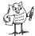
Focus on content: mathematics
Focus on language: English
“In many ancient societies numbers used to be represented in a symbolic way, e.g. by pictures or colors
- the Egyptians used “red auxiliaries” to help them solve problems in arithmetic
- the Chinese used red color for positive numbers, and black for negative numbers
Have you noticed the symbols in the top right-hand corner of your worksheets? Each of them represents a number:”
(Now the teacher should write the following table on the board.)
1 4 7
2 5 8
3 6 9

Task:
“Is there a system for easily remembering these symbols without memorizing? You can discuss it in pairs or you can come up with suggestions right now.”
Answer sheet:
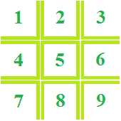

References:
Joseph, G.G. The Crest of the Peacock, London: Penguin Books Ltd., 2000.

