Our home – our world
For the student
Marie Hofmannova
OUR HOME – OUR WORLD
Marie HOFMANNOVÁ & Radek VÍT

UNIT 1: Exploring diversity

Acivity 1.1: THE PLACE WHERE WE LIVE

Worksheet 1.1.1
-  In what language is the title?
- Can you match the text with the name of the language?

RUSSIAN, CZECH, GERMAN, ITALIAN, SLOVAK, VIETNAMESE, ENGLISH, FRENCH, SPANISH, POLISH, SWEDISH
The place where we live.
L´endroit où nous habitons.
Место, где мы живём
Stället där vi bor.
Chỗ sống của chúng tôi
Místo, kde žijeme.
Miesto, kde žijeme.
Il luogo dove viviamo.
El lugar donde vivimos.
Der Platz, wo wir leben.
Miejsce, gdzie mieszkam.

3. Can you translate the title into any other language? If so, please, write it down here:
………………………………………………………………………………………………….
………………………………………………………………………………………………….
... Follow up tasks for the whole class:
1. Do you know where these languages are spoken? Show the countries on the map.
2. Can you say the title “The place where we live” in any other language?
3. Can you teach your classmates how to say it? They will repeat after you.

Activity 1.2: CONTINENTS
- Here is a photocopy of the map of the world.

Worksheet 1.2.1
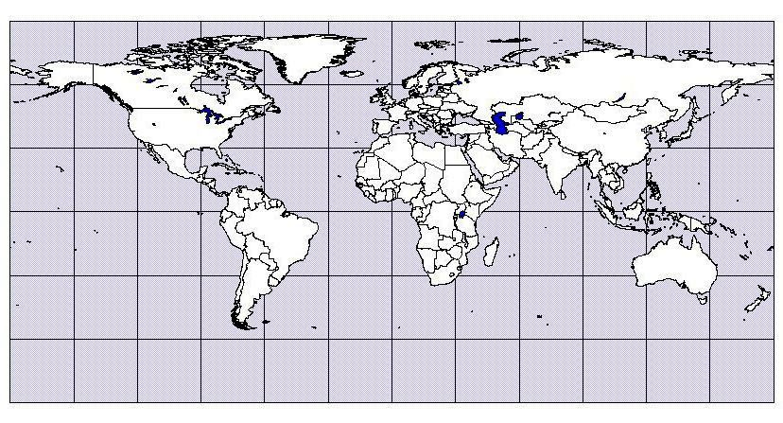
In pairs, write the English names of the continents on your map.

AFRICA, ANTARCTICA, NORTH AMERICA, EUROPE, ASIA,
SOUTH AMERICA, AUSTRALIA
... Follow up tasks for the whole class:
- Check your answers in the whole class and show the continents on a big map.
- Can you say the names of the continents in another language?

Activity 1.3: COUNTRIES
Here is a photocopy of a map of Europe.

Worksheet 1.3.1
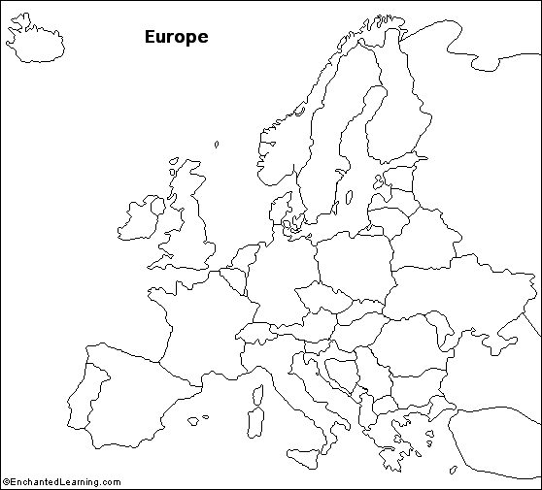
Work in pairs. Find your country and its neighbors. Write their names in English on your map. Try to find the place where you live and make a cross. Write its name here:
………………………………………………………………………………………………….
... Follow up tasks for the whole class:

- Name the countries and show them on a big map of Europe.
- Can you say the names of the neighboring countries in the language of that neighbor?
- Can you teach your classmates how to say the names? They will repeat after you.

Activity 1.4: MY COUNTRY

Worksheet 1.4.1
Work in pairs.
First, write the name of your country in the middle. (You can use English or your mother tongue.) Then write the names of languages spoken in your country by people who live there (not tourists).
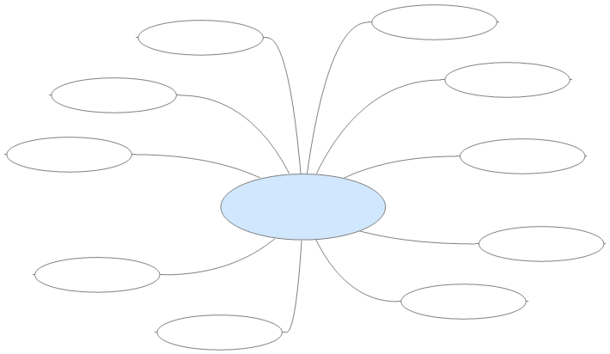

... Follow up tasks for the whole class:
- Read the names of the languages in English and in the language(s) spoken in your school or class.
- What languages do tourists speak in your country?

Activity 1.5: LOOKING FOR INFORMATION
Work in groups of 4.
Discuss in English or in your mother tongue:
“What is the difference between migration, immigration, emigration?”
If you are not sure, look up the words in an encyclopedia, in a dictionary, or on the Internet.
You can use these Internet addresses:
http://en.wikipedia.org/wiki/Main_Page (in English)
http://cs.wikipedia.org/wiki/Hlavn%C3%AD_strana (in Czech)

Activity 1.6: HUMAN MIGRATION
...
Discuss the topic in the whole class. Speak English or your mother tongue.

Suggested questions:
- Why do people migrate, emigrate, and immigrate?
- What do you know about immigrants in this country? Which languages do they speak?
- What do you know about people who emigrated or immigrated in the past?
- Where from? Where to?
- Why did they decide to do it?

UNIT 2: Changing the place where we live

Activity 2.1: MIGRATION - FAMILY PERSPECTIVE
...
Discuss in the whole class. Speak English or your mother tongue.

Suggested questions:
- Do you know of anyone in your family who lived / has lived abroad?
- Who was / is it? Your parents / aunt / uncle / grandmother / grandfather / cousin?
- When was that?
- Can you tell us more about it? (e.g. where from, where to, how long, why)

Activity 2.2: MIGRATION - CZECH PERSPECTIVE
- You are going to work in 7 groups. Each group (2-3 pupils) will get a different text to read. Together, find answers to the questions above the text. After you finish, you will tell the class about your text in English. The questions and answers will help you prepare your presentation.

Worksheet 2.2.1
Questions:
Will the number of immigrants in the Czech Republic be higher or lower in the future?
…………………………………………………………………………………………………...
Which countries do the immigrants come from?
…………………………………………………………………………………………………...
Why does the country need them?
…………………………………………………………………………………………………...

Text:

The Number of immigrants to the Czech Republic is growing, the economy needs them
Released: 14/ 4/ 2008 11:07, author: ČT24, ČTK
Prague – The number of immigrants to the Czech Republic has been steadily growing and its growth will continue. Of all the post-communist countries, ours is the one most sought after. An international study shows that in twelve years’ time immigrants and their families could form up to 7.5 percent of Czech population. By the year 2065, this proportion may rise up to one third. According to a study prepared by demographer Dušan Drbohlav’s team at Charles University, most people will come from the Ukraine and other post-Soviet republics, Vietnam and China. Immigrants are mostly attracted by easy access to work – the country’s growing economy offers tens of thousands of job vacancies. Unlike some other European countries, the country is actively trying to attract foreigners. For example, the government has prepared “green cards”, or work and residence permits. If the parliament approves these permits, they will come into force in January 2009. The study concludes that due to the aging of its own population, the Czech Republic will need thousands of foreigners each year to keep the economy going.

Worksheet 2.2.2
Questions:
Which countries do illegal immigrants to the Czech Republic come from?
…………………………………………………………………………………………………...
How do these immigrants cross the borders?
…………………………………………………………………………………………………...
How many foreigners were there in the Czech Republic in 2008?
…………………………………………………………………………………………………...
Text:

Increasing numbers of illegal migrants from China and Egypt are pouring into the Czech Republic.
Author: Jan Langer
Increasing numbers of illegal migrants from China, Egypt and Iraq keep pouring into the Czech Republic. The number of foreigners entering fictitious marriages is also on the rise. One reason for the increase of “illegals” is their small chance of being granted an asylum here. The trend of rising migration from China to Europe has been monitored since 2004.

In the trunk of a car
According to the police, foreigners cross the border illegally, for example in freight hold of vans or trucks, but also in trunks of private cars. Some of them also use the services of the so-called foot traffickers to be taken across the “green border”. Many aliens are trying to obtain residence permits by fraudulent marriages. The Czech Republic is a transit country and the people, after falsification of personal documents, are transported to other countries of the European Union.

The number of aliens is growing
It is estimated that the number of “illegals” living in the Czech Republic is somewhere between thirty and forty thousand. No considerable growth can be observed in comparison to the year 2006. In contrast, the number of “legal” foreigners living in the Czech Republic is increasing at a record rate. While in 2006 their number grew by 43 thousand, last year it was almost by 71 thousand. In total the statistics register 410 thousand foreigners, the majority of whom are of Ukrainian, Slovak and Polish origin.

Worksheet 2.2.3
Questions:
Why did the Czechs immigrate to Canada (from 1880 to 1939)?
…………………………………………………………………………………………………...
Where did the immigrants work (after 1880)?
…………………………………………………………………………………………………...
Where did the Czechs live and work after World War I?
…………………………………………………………………………………………………...

Text:

The Czechs in the world - Canada /part 1/
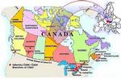
4/ 3/ 2008
Migration and settlement
Massive immigration of Czechs to Canada started in the second half of the 19th century and can be divided into four phases: In the first two phases (about 1880-1939) the motivation of most Czech emigrants was economic, while in the period of 1945-1989 they often were political refugees who left their homeland to avoid the Communist regime. Czech immigrants after 1880 started to come not only to the USA but also to western Canada because of the relatively fertile and cheap land. The government of Canada offered the new settlers land for cultivation. However, it was not rare that before obtaining their own land people had to work for the railways or in the mines. Farmers generally settled in the prairie provinces. The first Czech settlement, Kolin, was founded in 1884. Smaller groups of Czechs also settled in towns, especially in Edmonton, where one could find several Czech doctors, lawyers and craftsmen around 1900. Changes occurred after WWI. On the basis of an agreement between the Sugar Beet Grower´s Association of Canada and The Czech Foreign Institute (Český zahraniční ústav) a number of Czech sugar beet farmers left for Canada to help to develop Canadian sugar beet industry. Recruitment organized by the Canadian Pacific Railway experienced similar success. In 1939, the town of Batawa was founded near Frankford in the province of Ontario under the auspices of Tomáš Baťa.

Worksheet 2.2.4
Questions:
How many Czechs immigrated to Canada between 1948 and 1952?
…………………………………………………………………………………………………...
Where in Canada did they live after 1968?
…………………………………………………………………………………………………...
Who immigrated in the 1990s?
…………………………………………………………………………………………………...

Text:

The Czechs in the world - Canada /part 2/
4/ 3/ 2008
Migration and settlement
After the Second World War some Czechs left their homes from the fear of the growing influence of the Communist party. The emigration wave became massive after February 1948. In 1948-1952 more than 10 thousand Czechoslovaks got asylum in Canada. Most refugees were highly educated individuals such as doctors, lawyers, politicians, scientists, legislators, businessmen and craftsmen who were in the beginning forced to accept work far below their qualification. Businessmen of Czech origin, predominantly in Ontario, trying to help their compatriots, offered work to new immigrants, sometimes with the assistance of the federal government. An important role was played namely by the following Czech companies: Bata Shoe, Hamilton Carhart, Opal Manufacturing, Staruba Industrial Corporation and Hesky Flax Products. The situation of emigrants who fled to Canada after 1968 was in many respects similar, but also different. The knowledge of English and French enabled these immigrants to find jobs in larger cities. The most frequent destination of the newcomers after 1968 was no longer Montreal but Vancouver and Toronto. Contemporary Czech immigration to Canada is happening in a completely different international political situation. About 1,500 Czech Roma (Gypsy) people applied for political refugee status in Canada in 1997.

Worksheet 2.2.5
Questions:
How many Czechs live in the Ukraine today?
…………………………………………………………………………………………………...
When did most of them come there?
…………………………………………………………………………………………………...
What can you say about ČNRU?
…………………………………………………………………………………………………...

Text:

The Czechs living in the Ukraine
The number of Czechs living in the Ukraine today is about 10,000. According to the census in 1989 the number of Czechs in the Ukraine was 9,122, most of whom – 5,763 lived in towns. The largest number of the Czechs is settled in the Zhytomyr region – 1,835 people. 35.5% of the Czech population in the Ukraine regard Czech as their mother tongue. The present Czech communities in the Ukraine are the remains of the former quite numerous Czech settlement, which was the consequence of the extensive migration from the Czech lands predominantly in the 2nd half of the 19th century. Czech was taught there until 1930. However, the beginning of the 1930s witnessed political trials with Czech teachers, a number of whom was sentenced to death or sent to Eastern Siberia. Schools offering education in minority languages were closed in 1937. Nowadays, there are only few purely Czech national villages in the Ukraine. There are about 3,000 Czechs living in these villages; they keep the Czech language, customs and church services in everyday life. The first compatriotic societies were revived towards the end of the 1980s. The compatriotic organization – the Czech National Council of the Ukraine (Česká národní rada Ukrajiny – ČNRU) – which associates 20 revival compatriotic societies from various provinces was founded in May 1995. Among its goals is preservation of the Czech language, re-establishment of Czech schools, publishing a Czech newspaper, teacher training and religious revival.

Worksheet 2.2.6
Questions:
Name the 5 biggest Czech communities abroad.
…………………………………………………………………………………………………...
What is a country club?
…………………………………………………………………………………………………...
In which Australian cities do the Czech immigrants live?
…………………………………………………………………………………………………...

Text:

The Czechs living in Australia /part 1/
The number of compatriots
The community of Czechs and Czechoslovaks living abroad is usually quoted as the fifth most numerous compatriotic community in the world (ranking after communities in the USA, Slovakia, Canada and Croatia). The data regarding the exact number of Czechs living in Australia differ. The Australian Portfolio of Immigration and Citizenship stated in 1991 that there were 18,000 Czechs and Slovaks (taken as one nationality) in Australia; the estimate of the Embassy of the Czech Republic in Canberra was 30,000 people of both nationalities. The data of CTK for Australia and Oceania for 1994 speak of 15,000 Czechs and 16,000 Slovaks. A part of the compatriotic community is registered in compatriotic societies – the statistics of the Czech Ministry of Foreign Affairs register 17 societies of the Czechs and Czechoslovaks living in Australia. Even today, social life and activities of these societies are partaken by a numerous group of Slovaks. The Czechs and Slovaks living in Australia are associated not only in the Sokol and other societies but also in the so-called country clubs, social organizations that specialize in social and sport events. The Czechs living in Australia are prolific in publishing (monthlies of the societies); the Czech radio broadcasting on the waves of the Australian radio SBS is also successful. The most numerous communities of the Czechs living in Australia are in the largest Australian cities of Sydney and Melbourne, smaller communities can be found around Canberra, Adelaide, Darwin and Perth. About 36% of all the Czechs living in Australia are settled in Sydney and its environs, about 27% live in Melbourne.

Worksheet 2.2.7
Questions:
Which two historical events made Czech people immigrate to Australia in the 20th century?
…………………………………………………………………………………………………...
What work did they usually do in the first two years?
…………………………………………………………………………………………………...
Do Australian universities accept Czech certificates and diplomas?
…………………………………………………………………………………………………...

Text:

The Czechs living in Australia /part 2/
History
The arrival of the first waves of Czech immigrants after the Second World War goes back to 1949 when 4,167 people from Czechoslovakia settled in Australia. 5,020 arrived in 1950. Most of them signed an employment contract before leaving Europe, which bound them to accept any work anywhere in Australia. In consequence to this measure, even people with academic education spent two years working manually, predominantly in agriculture. Even after expiration of the contract, especially doctors, lawyers and other professions found it very difficult to get adequate work – local professional chambers refused to recognize their qualification. In consequence, a number of specialists re-emigrated from Australia to the USA or Canada. The first group of immigrants after August 1968 formed by 173 people disembarked in Sydney on 14th September 1968. The Central Committee of Compatriotic Societies in Australia and New Zealand decided to offer these refugees all possible help to protect them from undergoing the same hardships as the post-1948 immigrants had to bear. It is due to their activities that Australian universities started to validate Czech university certificates and diplomas.

Activity 2.3: MATHEMATICS

Worksheet 2.3.1
or
How many of these word problems can you solve? Use a calculator if you like.
In the year 2002 there were 231,608 immigrants in the Czech Republic. In 2008, this number was higher by 178,486.
- How many immigrants were there in the Czech Republic in 2008? ………………………..
In the year 2006 there were 321,456 immigrants in the Czech Republic, but in the year 2004 there were 254,294 immigrants. Compare the numbers.
- Were there more immigrants in 2006 or in 2004? …………………………………………
- What is the difference? ……………………………………………………………………...
Sasha lives in our town. He writes five text messages to his friends in the Ukraine every week. One text message costs 9.50 Czech crowns (CZK).
- How much does he pay for text messages to his Ukrainian friends every week?
………………………………………………………………………………………………….
- How much does he pay for text messages to his Ukrainian friends a year?
………………………………………………………………………………………………….

Activity 2.4: MIGRATION AND OUR TOWN
...
Discuss in your mother tongue (or the language of the school).

Suggested questions:
- What is the situation of immigrants in our town / region?
- Where can you meet immigrants?
- What language do they speak?
- What do they do for living?

UNIT 3: Meeting new friends in our town

Activity 3.1: NEW CLASSMATES
This is a speaking activity – a role play. You will work in groups of 4 -
Now each of you will get a card with your role.

- Read the information on your card and prepare what you want to say.
- Find the other 3 members of your group.
- Talk to each other in your group.
- When you finish, you will tell the class about your new classmate and say what all of you have in common.
Role-cards (for the teacher to cut and distribute)

Group 1: Pupil A
You are new to your class. Your family has moved to this town because your father is a businessman. Now you will meet your new classmates. They want to learn something about you and make friends with you.

Introduce yourself.
Your name: Peter Cabadaj
Nationality: Slovak
Your age: 11
Born in: Bratislava, Slovakia
Your speak: Slovak, Czech and some English
Hobbies: ................................, ................................
Favorite subject: Physical Education
Family: mother (Slovak), father (Czech), a sister (age: ………)
Jobs: mother: ................................, father: ................................

Ask questions:
How old / you?
What / are / hobbies?
How big / your family?
What / father / job?
What / favorite / subject?

Group 1: Pupil B
Now you will meet a new classmate, who does not know anybody in this town. He / She would like to learn something about you and make friends with you. You are going to ask questions.

Introduce yourself:
Your name: Josef Fischer
Nationality: Czech
Your age: 12
Born in: Brod
Hobbies: skiing, music
Favorite subjects: Physical Education, Music
Family: mother (doctor), father (engineer), two brothers (15 and 25 years old), grandmother lives in Germany

Ask questions:
How old / you?
Where / come / from?
What / are / hobbies?

Group 1: Pupil C
Now you will meet a new classmate, who does not know anybody in this town. He / She would like to learn something about you and make friends with you.

Introduce yourself:
Your name: Lucie Šebestová
Nationality: Czech
Your age: 11
Born in: Brod
Hobbies: cooking Favorite subject: English
Family: mother (cook), father (farmer), a sister (17 years old), aunt Anna - moved to Canada

Ask questions:
How big / your family?
What / father / job?
What / favorite / subject?

Group 1: Pupil D
Now you will meet a new classmate, who does not know anybody in this town. He / she would like to learn something about you and make friends with you.

Introduce yourself:
Your name: ………………………
Nationality: ……………………...
Your age: ………………………..
Born in: ………………………….
Hobbies: …………………………
Favorite subject: …………...……
Family: mother (job: ……….), father (job: ……….), a sister / brother (age: ………..)

Ask questions:
What / do / weekends?
Where / grandmother / live?
What / mother / job?

Group 2: Pupil A
You are new to your class. Your family has moved to this town because your father found work in a local factory. Now you will meet your new classmates. They want to learn something about you and make friends with you.

Introduce yourself:
Your name: Mai Tran
Nationality: Vietnamese
Your age: 11
Born in: Hanoi
You speak: Vietnamese, some English, very little Czech
Hobbies: ………………., ……………………
Favorite subject: Mathematics
Family: mother (job:………………..), father (job:…………….), a sister (age:…………)

Ask questions:
How old / you?
What / are / hobbies?
How big /your family?
What / father / job?
What / favorite / subject?

Group 2: Pupil B
Now you will meet a new classmate, who does not know anybody in this town. He / She would like to learn something about you and make friends with you. You are going to ask questions.

Introduce yourself:
Your name: Josef Fischer
Nationality: Czech
Your age: 12
Born in: Brod
Hobbies: skiing, music
Favorite subjects: Physical Education, Music
Family: mother (doctor), father (engineer), two brothers (15 and 25 years old), grandmother lives in Germany

Ask questions:
How old / you?
Where / come / from?
What / are / hobbies?

Group 2: Pupil C
Now you will meet a new classmate, who does not know anybody in this town. He / She would like to learn something about you and make friends with you.

Introduce yourself:
Your name: Lucie Šebestová
Nationality: Czech
Your age: 11
Born in: Brod
Hobbies: cooking
Favorite subject: English
Family: mother (cook), father (farmer), a sister (17 years old), aunt Anna - moved to Canada

Ask questions:
How big / your family?
What / father / job?
What / favorite / subject?

Group 2: Pupil D
Now you will meet a new classmate, who does not know anybody in this town. He / She would like to learn something about you and make friends with you.

Introduce yourself:
Your name: ……………………..
Nationality: ……………………..
Your age: ……………………….
Born in: …………………………
Hobbies: ………………….……..
Favorite subject: ………………..
Family: mother (job: ……………), father (job: …………….), a sister / brother (age:……)

Ask questions:
What / do / weekends?
Where / grandmother / live?
What / mother / job?

Group 3: Pupil A
You are new to your class. Your family has moved to this town because your mother will teach in a local school. Now you will meet your new classmates. They want to learn something about you and make friends with you.

Introduce yourself:
Your name: Alexander Pavlov
Nationality: Ukrainian
Your age: 12
Born in: Kiev, Ukraine
You speak: Czech, Ukrainian, English
Hobbies: hockey, films
Favorite subject: English
Family: mother (Ukrainian), father (Czech), a sister (age: ………)
Jobs: mother: ………………………, father: …..….……………..

Ask questions:
How old / you?
What / are / hobbies?
How big / your family?
What / father / job?
What / favorite / subject?

Group 3: Pupil B
Now you will meet a new classmate, who does not know anybody in this town. He / She would like to learn something about you and make friends with you. You are going to ask questions.

Introduce yourself:
Your name: Josef Fischer
Nationality: Czech
Your age: 12
Born in: Brod
Hobbies: skiing, music
Favorite subjects: Physical Education, Music
Family: mother (doctor), father (engineer), two brothers (15 and 25 years old), grandmother lives in Germany

Ask questions:
How old / you?
Where / come / from?
What / are / hobbies?

Group 3: Pupil C
Now you will meet a new classmate, who does not know anybody in this town. He / She would like to learn something about you and make friends with you.

Introduce yourself:
Your name: Lucie Šebestová
Nationality: Czech
Your age: 11
Born in: Brod
Hobbies: cooking
Favorite subject: English
Family: mother (cook), father (farmer), a sister (17 years old), aunt Anna - moved to Canada

Ask questions:
How big / your family?
What / father / job?
What / favorite / subject?

Group 3: Pupil D
Now you will meet a new classmate, who does not know anybody in this town. He / She would like to learn something about you and make friends with you.

Introduce yourself:
Your name: …………..…………
Nationality: ……………………..
Your age: ……………..………...
Born in: …………….…………...
Hobbies: ………………………...
Favorite subject: ………………..
Family: mother (job ……………….), father (job ..……………), a sister / brother (age …….)

Ask questions:
What / do / weekends?
Where / grandmother / live?
What / mother / job?

Group 4, Pupil A:

You are new to your class. Your family has moved to this town because your mother will work in a local hospital. Now you will meet your new classmates. They want to learn something about you and make friends with you.

Introduce yourself:
Your name: Monika Horváthová
Nationality: Roma
Your age: 12
Born in: Vinica, Slovakia
You speak: Romany, Slovak, some Hungarian, very little English
Hobbies: ……………….., …………………
Favorite subject: Music
Family: mother, father, three sisters (ages: ………………)
Jobs: mother: …………………., father: …………………, one sister ………………..

Ask questions:
How old / you?
What / are / hobbies?
How big / your family?
What / father / job?
What / favorite / subject?

Group 4: Pupil B
Now you will meet a new classmate, who does not know anybody in this town. He / She would like to learn something about you and make friends with you. You are going to ask questions.

Introduce yourself:
Your name: Josef Fischer
Nationality: Czech
Your age: 12
Born in: Brod
Hobbies: skiing, music
Favorite subjects: Physical Education, Music
Family: mother (doctor), father (engineer), two brothers (15 and 25 years old), grandmother lives in Germany

Ask questions:
How old / you?
Where / come / from?
What / are / hobbies?

Group 4: Pupil C
Now you will meet a new classmate, who does not know anybody in this town. He / She would like to learn something about you and make friends with you.

Introduce yourself:
Your name: Lucie Šebestová
Nationality: Czech
Your age: 11
Born in: Brod
Hobbies: cooking
Favorite subject: English
Family: mother (cook), father (farmer), a sister (17 years old), aunt Anna - moved to Canada

Ask questions:
How big / your family?
What / father / job?
What / favorite / subject?

Group 4: Pupil D
Now you will meet a new classmate, who does not know anybody in this town. He / She would like to learn something about you and make friends with you.

Introduce yourself:
Your name: ……………………….
Nationality: ……………………….
Your age: ………………………....
Born in: …………………………...
Hobbies: …………………………..
Favorite subject: ………………….
Family: mother (job: …..………….), father (job: ………...….), a sister / brother (age: …….)

Ask questions:
What / do / weekends?
Where / grandmother / live?
What / mother / job?

Activity 3.2: OUR TOWN - OUR REGION
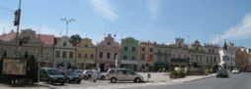

Worksheet 3.2.1
- 1. On your own, read the text:
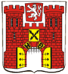
The Highlands region has much to be proud of. It is of historical and cultural interest for tourists not only from our country but also from abroad. The town of Havlíčkův Brod is mentioned as a gateway to the Czech part of the Czech-Moravian borderlands. In the course of its existence, it has always been an important center of the region. It belongs to the oldest towns on the Sázava River - it is more than 750 years old, and qualifies almost as a historical preserve. Its older name (Deutsch Brod) was linked to German miners. Some of them came to work in the nearby village of Silver Mountains in 1503. Later the town was named after Karel Havlíček Borovský, a journalist who was active in the Czech National Revival. Of the important personalities we should also recall two musicians and composers: J. V. Stamic, the founder of the Mannheim Instrumental School, who was born in Brod, and Bedřich Smetana, who studied here.
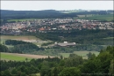 | 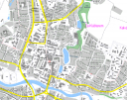 | 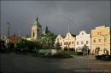 | 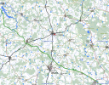

- Work in your group (4 pupils) -. First discuss the following questions in the mother tongue. Then write the main ideas in English.

What I know / what I read about our town / our region: | What else I would like to learn and tell our new classmates:

Compare your answers with other groups.

Activity 3.3: OUR TOWN AND THE WORLD
- The teacher will show you a map of the town / region and explain the project:
Stage 1: introductory activities at school (Unit 3)
- Establishing a grid over the map: Groups divide the map into several areas to be explored. They present their concept of division to the class.
- Discussing the project. The whole class agrees on the main rules and the choice of tasks.
- Preparing the excursion.
Stage 2: out-of-school excursion (Unit 4)
- Groups explore their part of the town / region. They trace different cultural markers: (verbal, architectural, etymological, environmental, political, entrepreneurial, behavioral, and interpersonal). They collect evidence (e.g. by talking to people, taking notes, taking photographs, recording the sounds, marking information on the map).
Stage 3: presentation of results in class (Unit 5)
- In L2, L1 and the languages in the class and from the town.
- Developing thematic maps of the town / region according to the researched topics.

- The class carries out the activities described in Stage 1.

Grouping: ...
The size of groups depends on the class size and the pupils´ decision.

UNIT 4: Exploring multicultural aspects of our town / region

Activity 4.1: A POEM
”Av manca, čhajori”

Téra Fabiánová (Romane giľa,1979)
Come with me, my sweet, to my mother’s village
Where after dark the Roma spin their tales
Come with me, I’ll never leave your side
Or bring you pain or shame.
When the Roma see me bring you
The fiddler will strike up a tune, ...
(Translated into English by David Vaughan, 2004.)

Discuss in your mother tongue (or the language of the school) how the poem relates to the topic of the project.
Grouping: ... (the whole class)

Worksheet 4.2.1:
- Where can we find museums in our town / region?
………………………………………………………………………………………………….
- What are the closest national cultural monuments?
………………………………………………………………………………………………….
- Where can we find them?
………………………………………………………………………………………………….
- What UNESCO monuments are there in our region?
………………………………………………………………………………………………….
- Where can we find them?
………………………………………………………………………………………………….
- How many villages are there in our region?
………………………………………………………………………………………………….
- Write examples of old (German) and new (Czech) names of villages.
………………………………………………………………………………………………….
- What nationalities can we find in our town / region?
………………………………………………………………………………………………….
- Write examples of foreign investment in our region.
………………………………………………………………………………………………….
- What are the jobs that immigrants do in our town?
………………………………………………………………………………………………….
- Who were the most famous emigrants of our region?
………………………………………………………………………………………………….
- What are they famous for?
………………………………………………………………………………………………….

Activity 4.2: OUT-OF-SCHOOL EXPLORATION
... Suggested tasks for groups:

UNIT 5: Presenting exploration results – Our town and the world
In this lesson you will present the results of your out-of-school exploration. Before the lesson you should decide how you are going to do it. You should not only answer the questions but support your exploration with maps, pictures or photographs. It would be best if you put everything on a large sheet of paper.
You can also invite your parents, grandparents or friends to school to listen to your group presentation.

