Motion in the ocean
For the student
Martine Kervran

MOTION IN THE OCEAN
Martine KERVRAN

1. The oceans in the world

Worksheet 1
Grouping
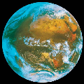
- Fill in the chart below after discussing the items with your friends and your teacher (use the language you know best / your teacher will help you if necessary)
What we know about the ocean | What we want to Learn about the ocean
-  -  -  (…) | -  -  -  (…)
- Answer the question after discussing it with your friends and your teacher (use the language you know best/ your teacher will help you if necessary)
Why does the water of the sea move?
…………………………………………………………………
………………………………………………………………….

Worksheet 2
Grouping
- Read the definitions and label the map
Oceans cover nearly 71% of the Earth's surface.
The Pacific Ocean is the largest ocean and borders the five continents.
The Atlantic Ocean’s neighbouring seas include the Mediterranean Sea, the North Sea and the Baltic Sea.
The Arctic Ocean is the smallest ocean. It surrounds the North Pole. It is frozen all the time, except at its edges.
The Southern Ocean is where you'll find Antarctica and the South Pole.
The Indian Ocean borders areas from the southern hemisphere.

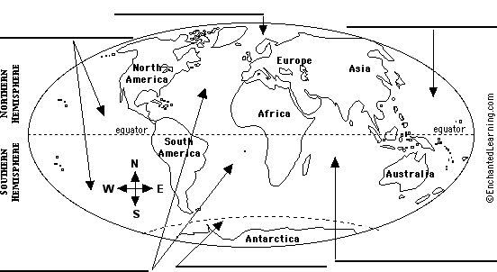
- Check your answers and learn more about the five oceans by following this link:
http://www.gdrc.org/oceans/world-oceans.html

Worksheet 3: multilingual ocean!
Grouping:
Look at the translations of the world ocean in a few different languages and try to answer these questions
Language | The word ocean
German | ozean
French | océan
Italian | oceano
Russian | океан
Danish | ocean
Deutch | oceaan
Spanish | océano
Portuguese | oceano
Suedish | ocean
… | …
… | …
Then discuss them with the whole class (use the language you know best/ your classmates and teacher will help you if necessary)
What do you notice?
…………………………………………………………………………..
Can you guess why?
……………………………………………………………
Can you write the word ocean in any other language(s)? If so, add it to the list above

2. Waves and wind

Worksheet 1: How can waves be described?
Grouping
- Bring photographs, pictures or paintings about waves to class
- Share them with the class and describe them
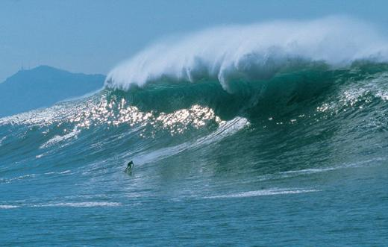
2- grouping
Match each word to its definition
Duration | bottom of a wave
Trough | length of time
Crest | distance over which the wind blows
Fetch | top of a wave

Worksheet 2: How are waves measured?
grouping
- 1.Look at the diagram and fill in the blanks in the text with words from the list below
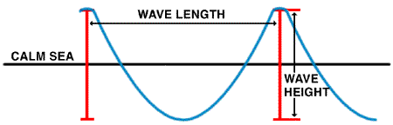
Wave model from www.ndbc.noaa.gov/educate/educate.shtml
The water in the ocean is always ----. Waves are one movement of the ocean----.
They are caused by the----.The ----of these waves depends on wind----, on the ----
of the wind and on the----. It is measured from the wave ----to the wave----. The wave -----is defined as the horizontal distance between two successive----.
Water; moving; height; waves; length; crest ; troughs; wind ; duration; fetch; speed

- Create your own ocean wave!
Follow this link and discover the wave machine…
http://www.pbs.org/wnet/savageseas/multimedia/wavemachine.html

3- When the waves grow bigger and bigger…

Worksheet 1: The Beaufort wind scale
In 1805, British admiral Francis Beaufort devised a descriptive wind scale to standardize wind reports. The Beaufort wind scale is still used today.
1- Look at the chart below and read it carefully
Beaufort scale number | Descriptive term | Wind speed km/h | Description of the sea | Description of the land
0 | Calm | 0 | Sea like a mirror.
1-3 | Light winds | 19 km/h or less | Small wavelets
4 | Moderate winds | 20 - 29 km/h | Small waves
5 | Fresh winds | 30 - 39 km/h | Moderate waves
6 | Strong winds | 40 - 50 km/h | Large waves
7 | Near gale | 51 - 62 km/h | Sea heaps up and white foam
8 | Gale | 63 - 75 km/h | Moderately high waves of greater length
9 | Strong gale | 76 - 87 km/h | High waves; spray may affect visibility.
10 | Storm | 88 - 102 km/h | Very high waves ; the surface of the sea takes on a white appearance with visibility affected.
11 | Violent storm | 103 -117 km/h | Exceptionally high waves; the sea is completely covered with long white patches of foam.
12+ | Hurricane | 118 km/h or more | The air is filled with foam .The sea is completely white; visibility is very seriously affected

- In pairs, cut out the drawings and stick them in the right place in the above chart to describe the land at each stage.
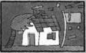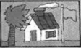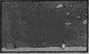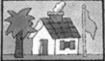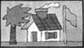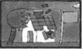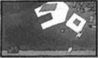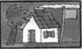

Worksheet 2: All kinds of storms at sea
Grouping
There are various kinds of storms at sea that are given different names. Those names depend on the region of the world where those phenomena generally occur.
- Link each English word to the original word you think it comes from.
English word | original word
Hurricane | Kyklōma
Typhoon | 
Tsunami | Huracan
Cyclone | 台 风

- Try to find out what is the name of each of those languages
The word hurricane comes from……
The word typhoon comes from…….
The word tsunami comes from…….
The word cyclone comes from……..
- Look for a definition of each term in a dictionary and write it down:
Hurricane: -------------------------------------------------------------------------------------------------
Typhoon: -------------------------------------------------------------------------------------------
Tsunami: -------------------------------------------------------------------------------------------
Cyclone: --------------------------------------------------------------------------------------------

- Look for more information about those phenomena on the Internet
Read the information on those web pages and write a very short summary of the contents
Cyclones http://ww2010.atmos.uiuc.edu/(Gh)/guides/mtr/cyc/def.rxml
Hurricanes : http://ww2010.atmos.uiuc.edu/(Gh)/guides/mtr/hurr/def.rxml
Typhoons: http://library.thinkquest.org/03oct/00477/NatDisasterPages/jeb.webpages/Typhoon/typhoon_definition.htm
Tsunamis: http://www.pbs.org/wnet/savageseas/neptune-side-tsunamis.html

Assessment
- Grouping
Discuss with your friends and your teacher and fill in the chart below
What we have learnt
- Grouping
Now that you know what you have learnt, is there anything else you would like to know about oceans?
- Make your own multilingual ocean scrapbook
- Collect information and documents about waves and other information about the motion of the ocean from this module, classbooks, websites, magazines or books.
- Make sure the documents
  - come from various sources,
  - include various types of information (texts, pictures, drawing, paintings, photographs, stories…),
  - are written in different languages.
- Choose the most interesting ones, put them together, arrange them into chapters and make them into a nice file or book.
- Share your ocean scrapbook with your classmates and your teacher.

