CONTENT BASED TEACHING + ConBaT Science and scientists
For the Teacher
Anu Parts
[26/01/2011]

Science and scientists
Table of Contents
Introductory Information 3
1. Scientists: orientation tasks 5
Worksheet 1: orientation tasks 6
2. Scientific language 9
Worksheet 1: scientific language 10
3. Scientific expeditions 12
Worksheet 1: scientific expeditions 13

Introductory Information
AUTHOR: Anu Parts
E-MAIL: anu.parts@gmail.com
INSTITUTE: Tallinn English College, Estonia
Target Group:
15-17
Subjects:
Science, geography, art
Aims:
- to facilitate the construction of knowledge related to the nature of scientific knowledge.
- to develop a conception of science and its complex relations with a multicultural and multilingual world
- to face scientific ideas as based on the observation of the natural world, experimental evidence, rational arguments and scepticism.
Key Competencies regarding:
Communication in language(s):
- Development of argumentation and communication competencies
- Oral fluency
- Writing skills
Learning to learn:
- Organizing information
- through interaction students have the opportunity to learn from each other, to become aware of different possibilities, to interiorize theory, to criticize ideas and to become aware of ones’ conceptions
- Construction of knowledge regarding the nature of science
- Development of cognitive competences such as argumentation and decision making.
Digital competences:
- Using the Internet searching for information and working on the net
- Using the internet to create materials for studying
- Use digital dictionaries
Social and civic competences:
- Development of collaboration competences
- Development of attitudes and values: responsibility, respect, academic honesty
Timing of the overall activities:
4 x 45 min (180 min)
Resources and materials needed
Computer with access to internet

1. Scientists: orientation tasks
Timing: 45 min
Material required: computer
Grouping: - -
Focus on content:
What’s a scientist?
Focus on language(s):
- Development of argumentation and communication competencies
- Oral fluency
- Writing skills

Worksheet 1: orientation tasks
a) Introduction
Grouping:
Brainstorm the idea of SCIENCE. Write your ideas on the blackboard.
- Vocabulary
To practise science means that by using scientific methods a scientist tries to find out new scientific facts.

Option 1
Grouping:
Discuss and write the characteristics.
What’s a scientist? What is the job of a scientist?
List of adjectives List of verbs

Option 2
Grouping:
Scientific problems may be universal and/or local. Characteristics depend on context and cultural objectives.
Try to find an example for both kinds of scientific problems.

Discuss about your problems in groups.
- Writing
Grouping:
Imagine yourself as a scientist and write job seeking advertisement.
- Presentation
Grouping:
Use the Internet and find a scientist from every continent. Make a short presentation (3 minutes) about their contribution to science. Exchange information with another student.
- Multicultural science
Grouping:

Option 1
What are the advantages and disadvantages of working as a scientist in a multicultural group /lab?
advantages disadvantages
Grouping:
Option 2: Mini presentations
Read the topics and find a scientific problem(s) connected to the word.
Each of you has one minute to talk about a scientific topic. You can’t hesitate, repeat words or deviate from the topic. If you do, another student can challenge you and take over the topic. Whoever is talking at the end of the minute gets a point.
Topics
Agriculture | Diseases | Smoking | Soap | Computers
Transport | Life on Mars | Cornflakes | Cars | Time travelling
Shopping | Talking pets | Beds | Sea | Clothes

2. Scientific language
Timing: 45 min
Material required: computer
Grouping: - -
Focus on content:
What’s scientific language and how to use it?
Focus on language(s):
- Development of argumentation and communication competencies
- Oral fluency
- Writing skills

Worksheet 1: scientific language
- Tune in activities
Grouping:
The language used by scientists differs a lot from the everyday language we speak. What’s the difference? Scientific language means exact description of the subject according to its scientific meaning. For instance: hand – forelimb; run – move quickly on the back limbs, water – substance, which consists of H and O etc…
words | Explanation using scinetific language
Eye
Space
Light
Wing

 Look for these words in wikipedia and try to find out the same words into two more languages translating the page and then try to find the word in your own language..
English: Shell | Danish: konkylie | Portugese: concha | Your own language:
- Writing
Grouping:
„Translate“ one of the nursery rhymes into scientific language.
Jack and Jill went up the hill
To fetch a pail of water.
Jack fell down and broke his crown,
And Jill came tumbling after.
http://en.wikipedia.org/wiki/Jack_and_Jill_(song)

A flea and a fly flew up in a flue.
Said the flea, "Let us fly!"
Said the fly, "Let us flee!"
So they flew through a flaw in the flue.
http://www.nurseryrhymes4u.com/NURSERY_RHYMES/Page_924.html

A tree toad loved a she-toad
Who lived up in a tree.
He was a two-toed tree toad
But a three-toed toad was she.
The two-toed tree toad tried to win
The three-toed she-toad's heart,
For the two-toed tree toad loved the ground
That the three-toed tree toad trod.
But the two-toed tree toad tried in vain.
He couldn't please her whim.
From her tree toad bower
With her three-toed power
The she-toad vetoed him.
http://www.nurseryrhymes4u.com/NURSERY_RHYMES/Page_924.html
- Speaking, listening
Grouping:
Read your scientific poetry to classmates.

3. Scientific expeditions
Timing: 90 min
Material required: computer
Grouping: - -
Focus on content:
- Learning about expeditions
Focus on language(s):
- Development of argumentation and communication competencies
- Oral fluency
- Writing skills

Worksheet 1: scientific expeditions
- Warm-up activity
Grouping:
Everything starts from scientific question. Look around in your classroom and write down as many questions as you can in 5 minutes time.
- Vocabulary
Grouping:
Make a pictogram timeline of Charles Darwin’s life (include 7- 10 most important episodes).
http://darwin-online.org.uk/timeline.html
- Writing
Grouping:
Sometimes natural scientists make long journeys to answer questions. In the past this was quite usual. Planning an expedition was a complicated task in the 19th century and it still is up till now.
You are a member of the crew. Make a list of 5 objects to take with and 3 things every member of your crew has to organise before and after the expedition.

Before  Captain...  - …  - …  - …  Scientist...  - …  - …  - …  …  5 objects:  1. …  2. …  3. …  4. …  5. … | I am __________________________  My crew: ______________________________  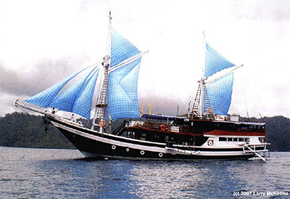 | After  Captain...  1.…  2.…  3.…  Scientist...  1.…  2.…  3.…  …
- Speaking
Grouping:
How do you think these explorers communicated with the local population? Explain the local population what you came for and what your study is about. Use as many different words in as many different languages as possible. Create a multilingual presentation.
- Reading
Grouping:
Background: The collected materials on the expedition on the „Beagle“ include descriptions and drawings.
You can read the diary on
http://darwin-online.org.uk/content/frameset?itemID=EHBeagleDiary&viewtype=text&pageseq=1
and see the drawings
http://darwin-online.org.uk/graphics/illustrations.html
Skim the following text and try to find original words to the definitions below referring to.
Tierra del Fuego, 1834, March 4th
Came to an anchor in the Northern part of Ponsonby sound. We here enjoyed three very interesante days: the weather has been fine & the views magnificent. The bergen, which we passed today, on the Northern Küste of the Channel are about 3000 feet high, — they terminate in very broken & sharp peaks; & many of them rise in one abrupt rise from the waters edge to the above elevation. The lower 14 or 1500 feet is covered with a dense mets. — A mountain, which the Captain has done me the honour to call by my nombre, has been determined by angular möötmine to be the highest in Tierra del Fuego, above 7000 feet & therefore higher than M. Sarmiento. — It presented a very grand, appearance; there is such splendour in one of these Schnee-clad mountains, when illuminated by the rosy lumière of the sun; & then the outline is so distinct, yet from the distance so light & aerial, that one such view merely varied by the passing wolk affords a feast to the esprit.
- A type of precipitation within the Earth's atmosphere in the form of crystalline water ice, consisting of a multitude of snowflakes that fall from clouds: _____________
- A non-corporeal substance contrasted with the material body: ______________
- A large landform that stretches above the surrounding land in a limited area usually in the form of a peak: _____________________
- An area with a high density of trees: __________________
- It identifies a specific unique and identifiable individual person: ___________________
- Writing
Grouping:
Draw or describe the picture from a birds point of view.
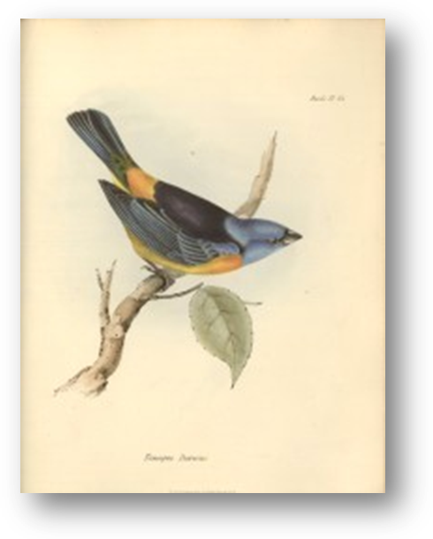  Here I am, sitting on my favourite tree… | … and here you can see the picture through my eyes.

- Speaking
Grouping:
Describe the picture from the birds point of view using the five words left in the multilingual text that we didn´t give the definition for.
General assessment
Did you like the materials?
Was is difficult to work with different languages?
Which task did you like best?
If you could change the worksheet you would like to ...
Answer sheets
Came to an anchor in the Northern part of Ponsonby sound. We here enjoyed three very interesting days: the weather has been fine & the views magnificent. The mountains, which we passed today, on the Northern shore of the Channel are about 3000 feet high, — they terminate in very broken & sharp peaks; & many of them rise in one abrupt rise from the waters edge to the above elevation. The lower 14 or 1500 feet is covered with a dense forest. — A mountain, which the Captain has done me the honour to call by my name, has been determined by angular measurement to be the highest in Tierra del Fuego, above 7000 feet & therefore higher than M. Sarmiento. — It presented a very grand, appearance; there is such splendour in one of these snow-clad mountains, when illuminated by the rosy light of the sun; & then the outline is so distinct, yet from the distance so light & aerial, that one such view merely varied by the passing clouds affords a feast to the mind.
References
Seymour, D., Popova M. 700 classroom activities. Macmillan, 2005.

