Body parts mathematics
For the student
Marie Hofmannova
Body part mathematics
Marie Hoffmanová



Worksheet 1: FROM THE HISTORY OF MATHEMATICS

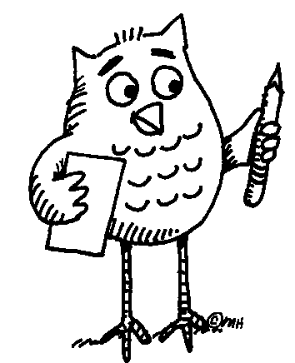 Task 1: Read the paragraph using the dictionary to clarify the meaning of unknown words or phrases.
Understanding mathematics has always meant asking a lot of questions. Sometimes, in order to find the right answers we find it useful to look back and learn from history. Mathematical knowledge of today has a long tradition; all the different cultures in different periods of history have contributed to its development. Due to the lack of contact, however, each of the early civilizations developed its own specific number system. This process was often closely related to body parts, an approach common to different parts of the world. For example, the sizes of dishes in many countries were usually based on the average size of hands and feet. Whereas European mathematics later turned away from concrete things and became abstract, the concept of mathematics elsewhere, outside the European influence, has often remained unchanged. Nowadays, body parts are still used either as an aid to tallying (e.g. fingers and toes) or for counting according to a conventionally defined order, e.g. by the people of Papua New Guinea.
Task 2: Talk to each other in English or your mother tongue. Try to come up with
examples of OLD measures of length, capacity, or weight. Share with the rest of the class.

Task 3: Write one example each for a mathematical problem expressed
- in numbers:

- in letters:

Share with the rest of the class.



Worksheet 2: BODY PARTS
Task: Write down words that represent different parts of human hands and arms.
Make two columns:
English Your mother tongue 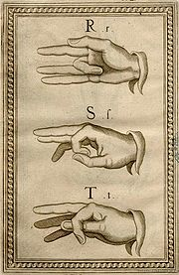
Manual alphabet (Bonet, 1620)
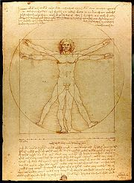

From: The Notebooks of Leonardo da Vinci (original edition 1883).
... Follow up activity for the whole class:
Can you teach your friends how to say the names of body parts in your language?



Worksheet 3: BODY PART COUNTING IN NEW GUINEA
Task 1: Read the paragraph using the dictionary to clarify the meaning of unknown words or phrases. Find New Guinea on the map.
Nowhere in the world is the diversity of cultures and languages so marked as on the island of New Guinea. The number systems reflect this diversity. Saxe (1982) in Joseph (2000) describes the counting system of a province in Papua New Guinea in the following terms: starting with the thumb of a hand, counting proceeds along the fingers of that hand, so that 7 is the forearm along the upper periphery of the body, to the face, with 12 being the nearest ear to the hand that has been counted, to the nearest eye -13, the nose -14, the other eye -15, the other ear -16 and down along the other side of the body to the little finger on the other hand -27. Such a system of number representation has been used to describe a range of diverse activities, whether counting a set of objects, measuring the length of an object, or establishing the location of a house in relation to other houses on a path.
Adapted from: Joseph, G.G. The Crest of the Peacock, London: Penguin Books Ltd., 2000.

Task 2: Speculate which parts of the body represent numbers that are not mentioned in the text. You can speak in English or your mother tongue. After you agree, try to write the body parts in the two languages below.
6 20
8 21
9 22
10 23
11 24
17 25
18 26
19



Worksheet 4: BODY PART MEASURING IN EUROPE

Task 1: Read the text using the dictionary to clarify the meaning of unknown words.
“ … 4 fingers make a palm, and 4 palms make a foot; 6 palms make 1 cubit, 4 cubits make a man's height, and 4 cubits make one pace ... “

From: The Notebooks of Leonardo da Vinci (original edition 1883

Task 2: Measure yourself or each other to verify the above statement.

Task 3: Compare the names of measures in English, Czech, French and Italian. Complete the table below.
4 doigts font une paume, et 4 paumes font un pied; 6 paumes font une coudée, 4 coudées font la taille d’un homme, et 4 coudées font un pas ...
4 diti fa un palmo, e 4 palmi fa un pie; 6 palmi fa un cubito, 4 cubiti fa un homo, e 4 cubiti fa un passo ...
4 prsty představují dlaň a 4 dlaně jsou jedna stopa; 6 dlaní představuje 1 loket, 4 lokte představují výšku člověka a 4 lokte představují i krok …
ENGLISH CZECH FRENCH ITALIAN YOUR LANGUAGE
4 fingers
a palm
a foot
1 cubit

... Follow up activity for the whole class:
Can you give examples of body part counting or measuring in your culture?


Worksheet 5: NUMBER SYSTEMS

Task 1: Study the following text carefully in order to succeed in Task 2.
- Base 10 (b = 10) Decimal system (counting by 10´ or 10 count system) is the most widespread. It is associated with the use of fingers on both hands. In the past it was used e.g. by the Inca of South America. The system requires digits to represent the numbers from zero to nine.
- Base 12 (b = 12) The system was used in English and German: e.g. units of measure (12 inches = 1 foot), old money (12 pence = 1 shilling), and also in terms such as a dozen = 12. Some of the units are still in use.
- Base 20 (b = 20) The system was used in French and Dutch. The scale may have originated in finger- and toe-counting. In the past it was used e.g. by the Maya of Central America, or the Yoruba of West Africa. The system requires the use of both digits (numbers from zero to nine), and letters (10 = A, 11 = B, 12 = C, 13 = D, 14 = E, 15 = F, 16 = G, 17 = H, 18 = I, 19 = J).
Task 2: Before you continue, try to find the countries mentioned in Task 1 on the map.
- Compare: 25₁₀ = 2 . 10¹ + 5 . 10⁰ = 2 . 10 + 5
25₂₀ = 2 . 20¹ + 5 . 20⁰ = 2 . 20 + 5 = 45₁₀
- Convert to base 20. Example: 144₁₀ = 7 . 20 + 4 . 1 = 7 . 20¹ + 4 . 20⁰ = 74₂₀
66₁₀

78₁₀
520₁₀
- Can you think of more problems that your friends might like to solve?

... Follow up activity for the whole class (in English or your mother tongue)
Can you tell the class about the number system(s) used in your culture?

