Our beautiful Earth: A view from space
For the student
Angeliki DELIGIANI & Sofia AVTZOGLOU
Our beautiful Earth: A view from space
Angeliki DELIGIANI & Sofia AVTZOGLOU

1. Snapshots of our Earth from space
Grouping: 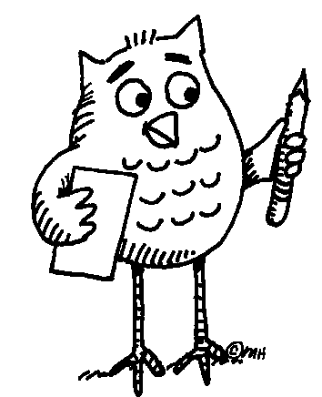 (whole class)

Worksheet 1: Countries around the world
1. “The Earth reminded us of a Christmas tree ornament hanging in the blackness of space”, said astronaut James Irwin (Apollo 15, 1971) (from http://www.solarviews.com/eng/earthsp.htm). Seeing the Earth from space is a rare privilege we have only had in the last 50 years. Thanks to modern technology we can all enjoy a glimpse or two of our “home” from another perspective. Watch our pps presentation and find out if you share James Irwin’s view.

2. Express your thoughts and feelings
Grouping: A, B (individual) and C (small group)
- A. Write down a thought you made, or the feelings you experienced, while watching the presentation.
________________________________________________________________________________________________________________________________________________________________________________________________
- B. What did you like best or what impressed you the most in this presentation?
________________________________________________________________________________________________________________________________________________________________________________________________
- C. Discuss your answers with your partner/partners. Are there any similarities/differences?

2. Finding information about different countries
Grouping: A.1, A.2 (pairs) or (small group) and A.3 (whole class)

Worksheet 1
- Now work with your partner/partners and try to answer the following questions:
- Write down the names of as many of the countries presented in the video that you remember. If you think you need to watch the presentation once more, you can ask your teacher to do so.
- Countries around the strait of Gibraltar:
- Countries around the Black Sea:
- Countries around the Red Sea:
- Countries in North America:
- Countries in South America:
- Countries in Europe:

Worksheet 2.
Can you find the capitals of these countries? What language is spoken in each one of them?
Country | Capital | Language
Country | Capital | Language
- As a class check your answers.

3. Exploring the languages of different countries 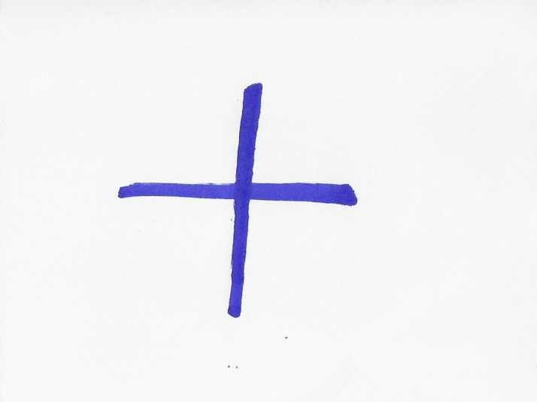
Grouping: A, B (small group) and C (whole class)

Worksheet 1
- Do you know how to say “Hello” or some other greeting in any of these languages? Tell your partners and help them repeat the words themselves.
- Do you find any similarities among the words from the different languages or with the words from your own language? Discuss with your partners and altogether try to form groups of languages that appear to have similar words. Also, write next to them the countries where the languages of each group are spoken.
________________________________________________________________________________________________________________________________________________________________________________________________________________________________________________________________
________________________________________________________________________________________________________________________________________________________________________________________________________________________________________________________________________________________________________________________________
- C. Each group in turn announce to your fellow students what you have found out. As you listen to the other groups’ findings you can add information to you own lists.

4. Emails and countries.
Grouping: A (small group) and B (whole class)

Worksheet 1
- Could you match the email addresses to the countries? Work with your partners and draw lines to connect them.
pharaohs@mail.eg | Spain
redbuses@co.uk | Canada
toronto@niagarafalls.ca | Egypt
iberic@berenjenasdulces.es | Brazil
rio@paralatinoamerica.br | France
rouge@bonjour.fr | United Kingdom

- B. Check your answers with the whole class and explain your choices.

5. Experimenting with languages
Grouping: (individual)

Worksheet 1
- Did you know that you can read and write in languages you do not speak? On the lines below, write down the email addresses of one or some of your partners and try to send them e-cards in English or / and a language of your choice. You can find multilingual e-cards at http://www.wintranslation.com/sendcard/. After selecting the card of your choice, you could add a text. Use the translating machine at http://www.athropolis.com/translate.htm, to translate your message in the language of your choice.
________________________________________________________________________________________________________________________________________________________________________________________________________________________________________________________________

6. The Strait of Gibraltar
Grouping: (individual)

Worksheet 1: The Geography of the strait of Gibraltar
- On the following link, you can find maps of the Strait of Gibraltar and the wider area: http://www.worldatlas.com/aatlas/infopage/gibraltar.htm
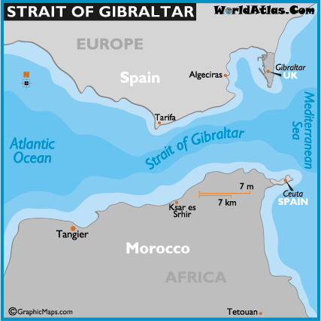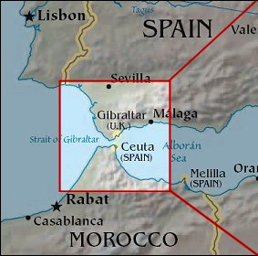
- Find a map of the Straight of Gibraltar in the above address or use another map to answer the following questions (Circle or underline the correct one/ones):
- The strait of Gibraltar is located in
- Southern Europe / Northern Africa
- Northern Europe / Southern Africa
- The strait of Gibraltar connects
- an ocean to a sea
- two oceans
- two seas
- The strait of Gibraltar is bordered by
- Morocco
- Spain
- Gibraltar
- Ceuta (a Spanish autonomous city)
- France
- Egypt
- Portugal
E. The Strait of Gibraltar is located in the
- Northern
- Southern
- Eastern
- Western coast of Spain

Worksheet 2: Learning what STRAITS, ISTHMI/ISTHMUSES, CANALS are
Grouping: A.1, A.2, A.3, A.4 (individual) and A.5 (whole class)
- Look at the pictures of a strait and an isthmus.
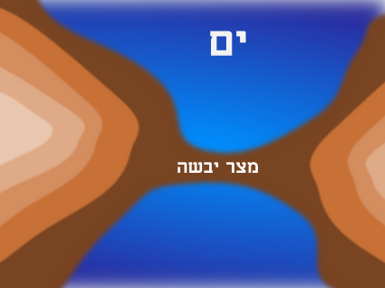
Source:http://en.wikipedia.org/wiki/Strait http://upload.wikimedia.org/wikipedia/commons/8/8a/Isthmus.png
STRAIT (or STRAITS) ISTHMUS
- Can you describe what each one is?
________________________________________________________________________________________________________________________________________________________________________________________________________________________________________________________________
- To check out your answers, and for more information, read the following text and fill in the blanks below:
STRAITS, ISTHMI/ISTHMUSES, CANALS
(from Wikipedia: http://en.wikipedia.org/wiki/Isthmus
http://en.wikipedia.org/wiki/Strait )
A strait is a narrow, navigable channel of water that connects two larger bodies of water. This channel of water lies between two land masses. Many straits are economically important. Straits can lie on important shipping routes, and wars have been fought for control of these straits.
An isthmus is a narrow strip of land that connects two larger bodies of land. An isthmus is the opposite of a strait - a narrow body of water that connects two larger bodies of water. Therefore, straits are the converse of isthmi. That is, while straits lie between two land masses and connect two larger bodies of water, isthmi lie between two bodies of water and connect two larger land masses.
An isthmus is usually a good place to build a canal to connect the two bodies of water on either side of the landmass. They create a shortcut. Numerous canals, have been constructed to connect two bodies of water over land.
For example, the Suez Canal adjoins the Mediterranean Sea and the Indian Ocean, cutting across the Isthmus of Suez to connect the Mediterranean Sea and the Gulf of Suez/Red Sea. It is the fastest crossing from the Atlantic Ocean to the Indian Ocean.
Another well known Canal is the Panama Canal which connects the continents of North America and South America and also the North Atlantic and Pacific Oceans.
Please fill in: .…………….…………….. and ……..………………….. are natural formations. …………………………… are manmade formations.
- If in your mother tongue, you use any of the words isthmus, canal, strait, and you want to find its origin, you can go to http://www.enl.auth.gr/links/findex.htm and look it up in the Webster dictionary.
- As a class, check your answers and exchange information.

Worksheet 3: Exploring the languages around the Gibraltar strait
Grouping: A.1, A.2, A.3, (pairs) or (small group) and A.4 (whole class)
- Below are the words “Gibraltar Strait” in the languages spoken in the three countries around the strait of Gibraltar. Can you guess in which country you will see a sign with the following words on it? (Put the initial letter of each country in the brackets).
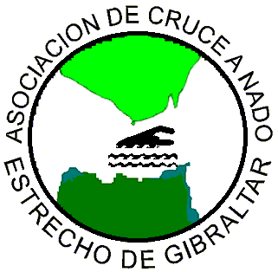
(picture from
http://www.acneg.com/)

1)“ Estrecho de Gibraltar” ( )
2) “مضيق جبل طارق” ( )
3) “Gibraltar Strait” ( )
- Here are some more words in the languages spoken around the strait of Gibraltar. They have the same meaning in the horizontal cells. Can you mark the countries where they are spoken by putting the initial of the country in the brackets next to the words? If you wish, you could also help each other to memorize them. (The bold letters indicate where the stress is):
Bienvenido/a ( ) | مرحبا /Merhaba / ( ) | Welcome ( )
سلام / Salam / ( ) | Hola ( ) | Hello ( )
Gracias ( ) | Thanks ( ) | شكرا /Shukran/ ( )
…سميتي /Smiyti…/ ( ) | mi nombre es ….. ( ) | My name is…. ( )
- Think of the countries in our Earth presentation: Can you think which of these words you could use to communicate in South America, around the Red Sea, in Cuba, Mexico and North America? Name as many countries as you can, where you think that these words would be useful to you and write down the countries inside the cells of the above table.
- In one of the areas we saw in our presentation, these words would not help you to communicate, because neither Arabic nor English or Spanish is spoken there. Which area is that?
________________________________________________________________
- As a class, check your answers and exchange information.
Useful information: For more Moroccan Arabic you can visit http://www.speakmoroccan.com/

7. The Black Sea and the Red Sea
Learning about the location and the names of the Black Sea and the Red Sea in different languages
Grouping:

Worksheet 1
- A. Read the following text to find out interesting information about these two water formations, which are so important for many countries and nations: (Sources: http://en.wikipedia.org/wiki/Black_Sea#Name , http://en.wikipedia.org/wiki/Red_sea )
The Black Sea is located between Europe and Asia. It is surrounded by six countries and it is very important to all of them because it provides them access to the Mediterranean waters, through the Bosporus straits.
The Red Sea is located in Middle East. It is a rich and diverse ecosystem. More than 1200 species of fish have been recorded in the Red Sea, and around 10% of these are found nowhere else.
- B. Why, do you think, they have these names? Do you know or can you guess? Read the following text to find out and check out your guesses.
Their names: A theory favoured by some modern scholars is that in the case of the Red Sea, the name red is referring to the direction South, just as the Black Sea's name may refer to North. The basis of this theory is that some Asiatic languages used color words to refer to the cardinal directions.
However, it is very possible that Black Sea owes its name to its dark waters and Red Sea to a kind of red- coloured bacteria, which bloom near its surface.

The Black Sea and the countries around it
Grouping: (individual)

Worksheet 2
  - Read some more information on the Black Sea, from the same sources:
In antiquity, the ancient Greeks used to call the Black Sea the 'Hospitable sea', Euxeinos Pontos (Εὔξεινος Πόντος). But this was a euphemism, in order to reverse the fact that the sea was difficult to navigate, due to frequent storms and because its shores were inhabited by savage tribes.
Today, all the peoples surrounding this deep water basin, call it by a name meaning “Black Sea” in their own language. (In the brackets you can see the original writing in the alphabet of the languages that do not use the Latin letters. The bold letters indicate where the stress is. Source: http://en.wikipedia.org/wiki/Black_Sea):
Greek Mavri Thalassa (Μαύρη Θάλασσα),
Bulgarian Cherno more (Черно море),
Georgian Shavi zghva (შავი ზღვა),
Romanian Marea Neagră,
Russian Chornoye more (Чёрное море),
Turkish Karadeniz,
Ukrainian Chorne more (Чорне море),
B. Can you find out which of the above words mean “sea” and which ones mean “black?” (The Turkish name is a compound word). If you need help, you can use a translation site: http://www.athropolis.com/translate.htm

Language | Black | Sea
Greek | Mavri
Bulgarian |  | more
Georgian | Shavi
Romanian
Russian
Turkish
Ukrainian

The Red Sea
Grouping: A.1, A.2 (individual) and A.3 (whole class)

Worksheet 3
- 1 Read the name “Red Sea” in Latin, Greek, Arabic and Hebrew. All these languages belong to people who live or had lived in the broader area where the Red Sea is located and have had close contact with this sea. (In the brackets you can see the original writing in the alphabet of the languages that do not use the Latin letters. The bold letters indicate where the stress is. Source: http://en.wikipedia.org/wiki/Red_Sea):
Greek Erythra Thalassa (Ερυθρά Θάλασσα),
Latin Mare Rubrum
Arabic Al-Bahr Al-Ahmar (البحر الأحمر)
Hebrew Hayam ha-adom (הים האדום)
- Using the information in Worksheet 2 and in this worksheet try to fill in the table below:
Language | Red | Sea
Greek
Latin
Arabic |  | Al-Bahr
Hebrew | ha-adom
3. Check your answers of Task 1 and Task 2 with those of your fellow students.

“Black” and “Red” are not just colours
Grouping: A.1, A.2, A.3, A.4, A.5 (small group) and A.6 (whole class)

Worksheet 4:
Often, the words “black” and “red” are used to express something more than colours.
- Take a look at the following expressions and together with your partners try to guess where to use “black” “red”, to fill in the gaps. If you need help, you can use an English dictionary or go to http://www.learn-english-today.com/idioms/idiom-categories/colour-idioms.htm
  - I was very angry. I saw ___________.
  - I owe money to the bank. I am in the ___________.
  - My friend has money in her bank account. She is in the _________.
  - If our football team gets the title we shall paint the town ____________.
  - My uncle does not follow the family tradition. He is the _____________ sheep of the family.
- Colours often carry heavy symbolisms. With regard to the expressions above, which colour would you connect with the words “excitement”, “danger”, “security”, “strong emotions”, “vitality” “bad behaviour”, “action”? Discuss and decide with your partners. Then, write next to each colour the words that you think are connected with that colour:
red:_____________________________________________________________________________________________________________________
___________________________________________________________
__________________________________________________________
black:____________________________________________________________________________________________________________________
___________________________________________________________
___________________________________________________________
- Can you think of other words and symbolisms which are connected with those colours? Add them to the above lists.
- Can you think of any expressions with “red” and “black” in your own mother tongue or other languages that you know? Tell your fellow students. Are they similar to any of the English expressions that were previously mentioned? Discuss if “red” and “black” carry the same symbolisms.
- Are you aware of any other colours that carry symbolisms? Which are those colours and what are their symbolisms? Discuss with your fellow students and write them down. If you happen to notice that there differences in colour symbolisms among the different cultures, you can note that down next to each colour.
____________________________________________________________________________________________________________________________________________________________________________________________________________________________________________________________________________________________________________________________________________________________________________________________________________________________________________________________________________________________________________________________________________________________________________________________________________________________________________________________________________________________________________________________________
- As a class discuss your answers and exchange information.

8. Time zones
Grouping: (individual)

Worksheet 1: Finding out about the time zones
- Have you ever felt you needed more time and wished you could turn the clock back? Well, actually you can. If you travel with a supersonic plane, you can arrive to your destination earlier than you started your trip. Be careful, though, to travel westwards. Because, only the places that are west of you are earlier in time. On the contrary, if you decide to travel eastwards, you will lose some valuable time, which you will never be able to regain.
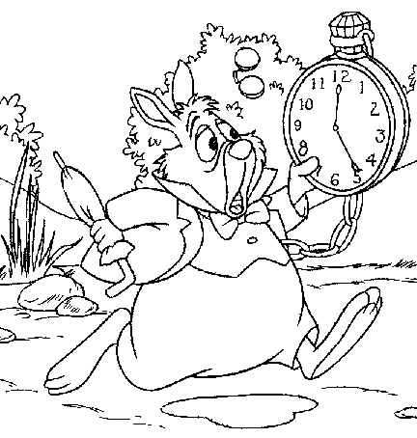
Look at the following map. The whole world is divided in 24 time zones. Each zone represents an hour difference in time. Find your home place on the map. The places in the first zone to the left are one hour earlier, the places in the second zone are two hours earlier and so on. The places in the first zone to the right are one hour later, the places in the second zone are two hours later and so on.
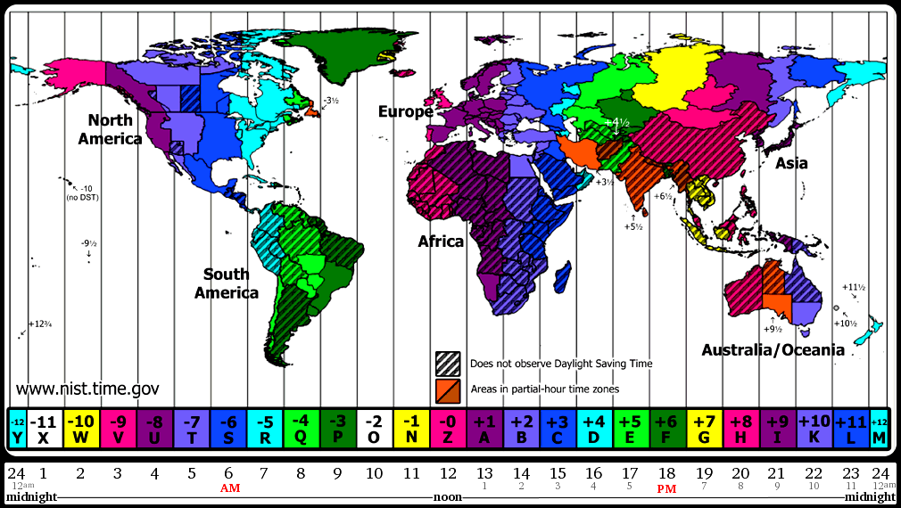
Time moves from the east to the west.
The Greenwich Observatory in the
UK is the centre of time measuring Map from http://nist.time.gov/images/worldzones.gif

- Using the above map, can you name two places whose time is ahead of yours and two places whose time is earlier than yours? Can you also calculate, what time it is there?
Ahead: …………………………………… …….………………………………….
Earlier: …………….…………………….. …………………………………………
Useful information: You can go to http://www.what-time-is-it.com/ to find out what time it is in various places of the world.

Worksheet 2: “Good morning” and “Good evening” in different languages
Grouping: (pairs) or (small group)
- Using the above site or any other site of your preference, please complete the following exercise:
If it is 13.00 in London…
It is …………...………in Paris.
It is …………………..in Barcelona.
It is …………….……..in New York.
It is ……………..……in Bucharest.
It is ……………….….in Cairo.
- If it is 12 at noon in Greenwich, how would the students in the following countries greet each other?
(If you do not know how to pronounce any of these expressions, ask your partners, they may know. If they do not, can you think of anyone who might know? In any case, you can always use a dictionary from these languages to yours, or go to the internet and find such a dictionary).

A. In Australia, they will say: a) Good morning b) Good night
B. In France, they will say: a) Bonjour b) Bonne nuit
C. In Brazil, they will say: a) Boa manhã b) Boa noite
D. In the USA, they will say: a) Good morning b) Good night
E. In Italy, they will say: a) Buon giorno b) Buona notte
F. In South America, they will say: a) Buenos días b) Buenas noches

- Have you noticed any words that show a common origin? Write them down in groups on the following lines:
_________________________________________________________________________________________________________________________________________________________________________________
___________________________________________________________
___________________________________________________________

Worksheet 3: Learning “Good morning” and “Good evening” in different languages
Grouping: (whole class)

- Check your answers to the previous task with those of your fellow students and exchange information.
- Do you know how people say “good morning” and “good evening” in other languages? Share with your fellow students.
- Try to learn these greetings in the different languages. (If you think that it is too much, do not worry. Learn them in as many languages as you like).

9. Review and Assessment Project
Grouping: (small group) and (whole class)

Worksheet 1: Reviewing the information on countries and languages
A. Do you think you could all work together and make a poster using a world map, where you would pin pieces of paper with the names of countries and cities in English? You can use a map from your geography lessons where the different countries are already marked or you could use a blown up photocopy of the following map, where you will need to locate the countries and write down their names yourselves. If you wish, you could watch the ppt presentation once more, for help. Work in groups and decide which of the following jobs each group will undertake:
B. Mark the strait of Gibraltar, the Black and Red Seas (write the name of the seas in different languages) and any isthmuses or canals that you know.
C. Write on pieces of paper any foreign words you have learnt and pin them in the countries that they can be used. If they can be used in many countries, prepare corresponding pieces of paper and pin them on the map. You will find out that you have learnt some quite useful words, that can help you greet people/say thanks/introduce yourself or say something to a very great number of people in our world, on OUR BEAUTIFUL EARTH.
D. Draw a sun and a moon on two separate pieces of paper. Put them on your map, to mark where you think it is night and where it is daytime, at the time you are working on your poster. Using the time zones map from Worksheet 4, you can mark what time is at some or all of the countries you will mark on the map.
E. After you have finished the poster you can talk about the new things each one of you has learned by participating in this project.
Map from http://vectorya.com/gallery/img65.search.htm
