CONTENT BASED TEACHING + ConBaT Our Beautiful Earth: A view from Space
For the Teacher
Angeliki Deligianni, Sofia Avtzoglou
2/8/2011

Our Beautiful Earth: A view from Space
Table of Contents
Introductory Information 4
1. Countries around the world 7
1. Countries around the world Snapshots of our Earth from space 9
Worksheet 1: 9
2. Finding information about different countries 10
Worksheet 1 10
Worksheet 2 11
3. Exploring the languages of different countries 15
Worksheet 1 15
4. Emails and countries. 16
Worksheet 1 16
5. Experimenting with languages 18
Worksheet 1 18
6. The Strait of Gibraltar 19
Worksheet 1: The Geography of the strait of Gibraltar 20
Worksheet 2: Learning what STRAITS, ISTHMI/ISTHMUSES, CANALS are 23
Worksheet 3: Exploring the languages around the Gibraltar strait 26
7. The Black Sea and the Red Sea 32
Worksheet 1: Learning about the location and the names of the Black Sea and the Red Sea in different languages 33
Worksheet 2: The Black Sea and the countries around it 34
Worksheet 3: The Red Sea 36
Worksheet 4: “Black” and “Red” are not just colours 38
8. Time zones 41
Worksheet 1: Finding out about the time zones 42
Worksheet 2: “Good morning” and “Good evening” in different languages 44
Worksheet 3: Learning “Good morning” and “Good evening” in different languages 47
8. Review and Assessment Project 48
Worksheet 1: Reviewing the information on countries and languages 49
References 51

Introductory Information
AUTHOR: Angeliki DELIGIANNI
E-MAIL: ade@gecon.gr
INSTITUTE: School Advisor of Central Makedonia, Northern Greece
AUTHOR: Sofia Avtzoglou
E-MAIL: av_sofia@hotmail.com
INSTITUTE: Experimental Primary School of Thessaloniki Aristotle University, Greece
Target Group:
Intermediate (14-16 years old)
Subjects:
Geography, Natural Sciences (Geoscience or Earth Science)
Aims:
- Explore the geography of the Earth and learn about countries, cities and continents
- Learn the geography of straits, isthmuses and canals
- Understand the time difference across the Earth and find out about time zones
- Learn greetings and other common expressions in languages of the countries that are explored in the project
- Understand that there are connections among the different languages
- Learn English expressions with “black” and “red” and thus understand the symbolism behind those colours in the English culture. Explore the symbolism of those colours in the students’ own culture
Key Competencies regarding:
Communication in language(s):
The communication in FOREIGN LANGUAGES
- Develop reading comprehension competence in EFL (skimming, scanning)
- Build vocabulary related to Earth Science
- Practise writing skills in English
- Develop speaking competence in the context of related content terminology
- Find out about borrowings amongst various languages
- Find out about the distribution of languages in the world (English, Spanish, Arabic, Slavic languages)
SUBJECT: GEOGRAPHY and NATURAL SCIENCES
- Learning about the geography of the Earth
- Learning about countries, their capitals and their position on the globe
- Learning what are the straits, canals and isthmuses
- Exploring the time zones on earth and the difference in time among the different countries and continents
Learning to learn & Digital competences:
- Learning in a spiral process activating and building on past experiences
- Analyzing and synthesizing new information critically aiming to improve content knowledge and language level
- Self –assessment of performance
- Searching for information on the Internet
- Extracting information from the Internet
- Selecting the information needed
- Compare and find similarities and differences
- Making associations and connections
Social and civic competences:
- Cooperating with peers and discuss findings
- Making associations and connections
- Exchanging views about likes/dislikes
- Synthesizing opinions, negotiating and getting to final conclusions
- Practicing language skills exploiting the humanistic perspective
- Helping each other to learn
Timing of the overall activities:
5-6 hours
Language(s) used in these materials
English as the primary language of communication and the languages spoken by the students, as well as expressions from other languages such as: Spanish, Arabic, Hebrew, Slavic languages, etc.
Resources and materials needed
- Photocopies of the Worksheets
- Dictionaries (on line and hard copies)
- Access to the Internet
- Geography books
- World map and a globe
- Projector connected to a computer

1. Countries around the world
Notes for the teacher:
- The project begins with a ppt Presentation, which is meant to be enjoyed and become an aesthetic stimulus (beautiful pictures and music) that will motivate students to appreciate our Beautiful Planet and want to learn more about it. Therefore, the teacher should let the students enjoy the presentation without comments or interruptions.
- Before the presentation, the teacher distributes photocopies of Worksheet 1 to the students and explains that they are going to see some unique views of our planet. People have only been able to enjoy them recently, thanks to modern technology. Therefore, we are a fortunate generation, for we can appreciate better our “home” and get to know it better than the previous generations.
- Although, most of us can only enjoy these views of the Earth from pictures, there is a small group of people who had the privilege to see it with their own eyes, the astronauts who have flown in space,. The teacher asks the students to read the words of astronaut James Irwin, expressing his thoughts on seeing the Earth from space, and then lets the students watch the presentation and judge by themselves how they feel about what they see.
- The first two parts of Worksheet 1 are meant to be done individually, so that the students have the opportunity to think and express their personal thoughts and feelings.
- In Section 2. the teacher could assign each student group to deal with a different group of countries or ask all student groups to deal with all countries, depending on the time they wish to spend on this task.
- In Section 4, the students should utilize their knowledge from History (eg. the word “pharaoh” is connected to the Egyptian history) or other fields and make the connections with the respective countries.
- Section 5 can be done as homework but a demonstration in the classroom could be very useful, especially for the students who are not very familiar with Information Technology. It is advisable for the teacher to visit the sites given beforehand and see how they operate.
Duration: 70 minutes
Necessary material:
- Photocopies of the Worksheets
- Dictionaries (on line and hard copies)
- Access to the Internet
- Geography books
- World map and a globe
- Projector connected to a computer

Countries around the world
Snapshots of our Earth from space
Grouping: 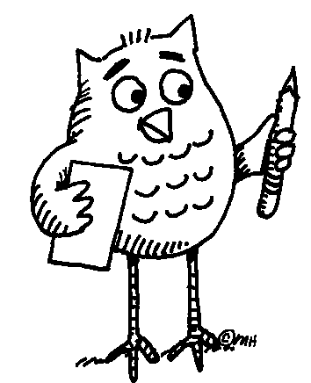 (whole class)

Worksheet 1:
- The Earth reminded us of a Christmas tree ornament hanging in the blackness of space”, said astronaut James Irwin (Apollo 15, 1971) (from http://www.solarviews.com/eng/earthsp.htm). Seeing the Earth from space is a rare privilege we have only had in the last 50 years. Thanks to modern technology we can all enjoy a glimpse or two of our “home” from another perspective. Watch our pps presentation and find out if you share James Irwin’s view.
- Express your thoughts and feelings
Grouping: A, B (individual) and C (small group)
- Write down a thought you had, or the feelings you experienced, while watching the presentation.
- What did you like best or what impressed you the most in this presentation?
- Discuss your answers with your partner/partners. Are there any similarities/differences?

Finding information about different countries
Grouping:
A.1, A.2 (pairs) or (small group) and A.3 (whole class)

Worksheet 1
Now work with your partner/partners and try to answer the following questions:
Write down the names of as many of the countries presented in the video that you remember. If you think you need to watch the presentation once more, you can ask your teacher to do so.
- Countries around the strait of Gibraltar:
- Countries around the Black Sea:
- Countries around the Red Sea:
- Countries in North America:
- Countries in South America:
- Countries in Europe:

Answer sheet for Worksheet 1
- Countries around the strait of Gibraltar: Spain, Gibraltar, Morocco
- Countries around the Black Sea: Russia, Turkey, Romania, Bulgaria, Ukraine, Georgia
- Countries around the Red Sea: Egypt, Israel, Jordan, Saudi Arabia
- Countries in North America: Canada, USA, Cuba, Haiti, Puerto Rico, Mexixo
- Countries in South America: Brazil
- Countries in Europe: Greece, Italy, France, United Kingdom (England), Spain, Portugal, Iceland

Worksheet 2
Can you find the capitals of these countries? What language is spoken in each one of them?
Country | Capital | Language
As a class check your answers.

Answer sheet for Worksheet 2
Country | Capital | Language
Spain | Madrid | Spanish
Gibraltar | Gibraltar | English
Morocco | Rabat | Arabic
Russia | Moscow | Russian
Turkey | Ankara | Turkish
Romania | Bucharest | Romanian
Bulgaria | Sofia | Bulgarian
Ukraine | Kiev | Ukrainian (Slavic language)
Georgia | Tbilisi | Georgian
Egypt | Cairo | Egyptian
Israel | Jerusalem | Hebrew
Jordan | Amman | Arabic
Saudi Arabia | Riyadh | Arabic
Canada | Ottawa | English – French
USA | Washington, D.C. | English
Cuba | Havana | Spanish
Haiti | Port – au – Prince | French, Haitian Creole
Puerto Rico | San Juan | Spanish, English
Mexico | Mexico City | Mexican
Brazil | Brasilia | Brazilian
Greece | Greece | Greek
Italy | Rome | Italian
France | Paris | French
United Kingdom | London | English
Spain | Madrid | Spanish
Portugal | Lisbon | Portuguese
Iceland | Reykjavik | Icelandic

3. Exploring the languages of different countries
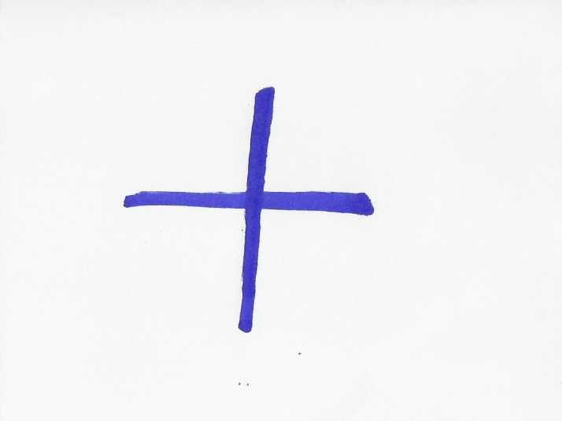
Grouping: A, B (small group) and C (whole class)

Worksheet 1
- Do you know how to say “Hello” or some other greeting in any of these languages? Tell your partners and help them repeat the words themselves.
- Do you find any similarities among the words from the different languages or with the words from your own language? Discuss with your partners and altogether try to form groups of languages that appear to have similar words. Also, write next to them the countries where the languages of each group are spoken.
________________________________________________________________________________________________________________________________________________________________________________________________________________________________________________________________
________________________________________________________________________________________________________________________________________________________________________________________________________________________________________________________________________________________________________________________________

- Each group in turn announce to your fellow students what you have found out. As you listen to the other groups’ findings you can add information to you own lists.

Answer sheet for A
The answer depends on the students’ knowledge of other languages.

Answer sheet for B
The answer depends on what languages the students are familiar with. If they find that there are similarities in the words of the languages they know, they form groups of those languages that seem to have similar words.

4. Emails and countries.
Grouping: A (small group) and B (whole class)

Worksheet 1
- Could you match the email addresses to the countries? Work with your partners and draw lines to connect them.
pharaohs@mail.eg | Spain
redbuses@co.uk | Canada
toronto@niagarafalls.ca | Egypt
iberic@berenjenasdulces.es | Brazil
rio@paralatinoamerica.br | France
rouge@bonjour.fr | United Kingdom
- Check your answers with the whole class and explain your choices.

Answer sheet for A
A connection should be made on the basis of the words included in the addresses and the initials of each country at the end of the email addresses. That is:
pharaohs@mail.eg is connected to Egypt, because of the word “pharaoh” and the initials “eg”,
redbuses@co.uk is connectdd to the United Kingdom, because of the word “redbuses” and the initials “uk”
toronto@niagarafalls.ca is connected to Canada, because of the words “niagarafalls” and “toronto”, the well-known city, and the initials “ca”
iberic@berenjenasdulces.es is connected to Spain, because of the word “iberic”, referring to the Iberian peninsula and the initials “es”,
rio@paralatinoamerica.br is connected to Brazil, because of the word “rio” (from Rio de Janeiro) and the initials “br”,
rouge@bonjour.fr is connected to France, because of the well-known greeting “bonjour” (also the word “rouge”) and the initials “fr”.
If the students have a difficulty in identifying the countries, the teacher could help them by pointing to some of those words.

5. Experimenting with languages
Grouping: (individual)

Worksheet 1
- Did you know that you can read and write in languages you do not speak? On the lines below, write down the email addresses of one or some of your partners and try to send them e-cards in English or / and a language of your choice. You can find multilingual e-cards at http://www.wintranslation.com/sendcard/. After selecting the card of your choice, you could add a text. Use the translating machine at http://www.athropolis.com/translate.htm, to translate your message in the language of your choice.
________________________________________________________________________________________________________________________________________________________________________________________________________________________________________________________________

6. The Strait of Gibraltar
Notes for the teacher
- This Worksheet begins with tasks aiming to familiarize students with English terminology connected to geoscience and provides practice in understanding written texts of this kind and extracting information from them. That is why the first tasks are done individually.
- The teacher hands out to students photocopies of Worksheet 2 and before the students begin working on their own, the teacher should make sure they know the needed vocabulary, such as “located”, “bordered”.
- Task 3 is done in pairs or small groups of 4 or 5 students, so that they can negotiate the answers and reach conclusions.
Duration: 60 minutes
Necessary material:
- Photocopies of the Worksheets
- Dictionaries (on line and hard copies)
- Access to the Internet
- Geography books
- World map and a globe

Worksheet 1: The Geography of the strait of Gibraltar
Grouping: (individual)
- On the following link, you can find maps of the Strait of Gibraltar and the wider area: http://www.worldatlas.com/aatlas/infopage/gibraltar.htm
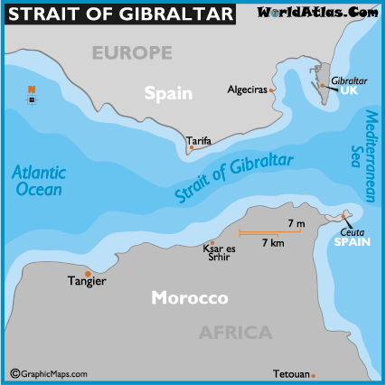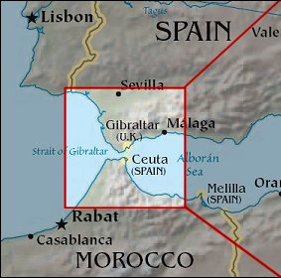
- Find a map of the Straight of Gibraltar in the above address or use another map to answer the following questions (Circle or underline the correct one/ones):
  - The strait of Gibraltar is located in
    - Southern Europe / Northern Africa
    - Northern Europe / Southern Africa
  - The strait of Gibraltar connects
    - an ocean to a sea
    - two oceans
    - two seas

  - The strait of Gibraltar is bordered by
    - Morocco
    - Spain
    - Gibraltar
    - Ceuta (a Spanish autonomous city)
    - France
    - Egypt
    - Portugal
  - The Strait of Gibraltar is located in the
    - Northern
    - Southern
    - Eastern
    - Western coast of Spain

Answer sheet for Worksheet 1
- The strait of Gibraltar is located in
  - Southern Europe / Northern Africa
- The strait of Gibraltar connects
  - an ocean to a sea
- The strait of Gibraltar is bordered by
  - Morocco
  - Spain
  - Gibraltar
  - Ceuta (a Spanish autonomous city)
- The Strait of Gibraltar is located in the
  - Southern coast of Spain

Worksheet 2: Learning what STRAITS, ISTHMI/ISTHMUSES, CANALS are
Grouping: A.1, A.2, A.3, A.4 (individual) and A.5 (whole class)
- Look at the pictures of a strait and an isthmus.
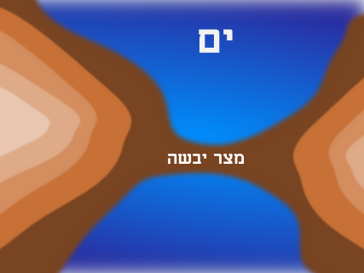
Source:http://en.wikipedia.org/wiki/Strait http://upload.wikimedia.org/wikipedia/commons/8/8a/Isthmus.png
STRAIT (or STRAITS) ISTHMUS
- Can you describe what each one is?
________________________________________________________________________________________________________________________________________________________________________________________________________________________________________________________________
- To check out your answers, and for more information, read the following text and fill in the blanks below:
STRAITS, ISTHMI/ISTHMUSES, CANALS
(from Wikipedia: http://en.wikipedia.org/wiki/Isthmus
http://en.wikipedia.org/wiki/Strait )
A strait is a narrow, navigable channel of water that connects two larger bodies of water. This channel of water lies between two land masses. Many straits are economically important. Straits can lie on important shipping routes, and wars have been fought for control of these straits.

An isthmus is a narrow strip of land that connects two larger bodies of land. An isthmus is the opposite of a strait - a narrow body of water that connects two larger bodies of water. Therefore, straits are the converse of isthmi. That is, while straits lie between two land masses and connect two larger bodies of water, isthmi lie between two bodies of water and connect two larger land masses.
An isthmus is usually a good place to build a canal to connect the two bodies of water on either side of the landmass. They create a shortcut. Numerous canals, have been constructed to connect two bodies of water over land.
For example, the Suez Canal adjoins the Mediterranean Sea and the Indian Ocean, cutting across the Isthmus of Suez to connect the Mediterranean Sea and the Gulf of Suez/Red Sea. It is the fastest crossing from the Atlantic Ocean to the Indian Ocean.
Another well known Canal is the Panama Canal which connects the continents of North America and South America and also the North Atlantic and Pacific Oceans.
Please fill in: .…………….…………….. and ……..………………….. are natural formations. …………………………… are manmade formations.
- If in your mother tongue, you use any of the words isthmus, canal, strait, and you want to find its origin, you can go to http://www.enl.auth.gr/links/findex.htm and look it up in the Webster dictionary.
- As a class, check your answers and exchange information.

Answer sheet for B
The students will answer this in their own words, but they should clearly define that a “strait” is a strip of water between two pieces of land and an “isthmus” is a strip of land dividing two seas.

Answer sheet for C
Please fill in: .……straits….….………. and ………isthmuses……... are natural formations. …………Canals………….… are manmade formations.

Answer sheet for D

Excerpts from Webster dictionary:Origin of ISTHMUS: Latin, from Greek isthmos
First Known Use: 1555
Origin of STRAIT: Middle English, from Anglo-French estreit, from Latin strictus strait, strict, from past participle of stringere
First Known Use: 13th century
Origin of CANAL: Middle English, from Latin canalis pipe, channel, from canna reed. First Known Use: 15th century.

Worksheet 3: Exploring the languages around the Gibraltar strait
Grouping: A.1, A.2, A.3, (pairs) or (small group) and A.4 (whole class)
- Below are the words “Gibraltar Strait” in the languages spoken in the three countries around the strait of Gibraltar. Can you guess in which country you will see a sign with the following words on it? (Put the initial letter of each country in the brackets).
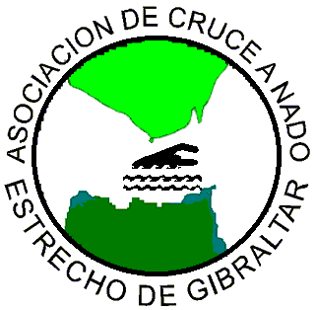
(picture from
http://www.acneg.com/)

1)“ Estrecho de Gibraltar” ( )
2) “مضيق جبل طارق” ( )
3) “Gibraltar Strait” ( )

- Here are some more words in the languages spoken around the strait of Gibraltar. They have the same meaning in the horizontal cells. Can you mark the countries where they are spoken by putting the initial of the country in the brackets next to the words? If you wish, you could also help each other to memorize them. (The bold letters indicate where the stress is):

Bienvenido/a ( ) | مرحبا /Merhaba / ( ) | Welcome ( )
سلام / Salam / ( ) | Hola ( ) | Hello ( )
Gracias ( ) | Thanks ( ) | شكرا /Shukran/ ( )
…سميتي /Smiyti…/ ( ) | mi nombre es ….. ( ) | My name is…. ( )
- Think of the countries in our Earth presentation: Can you think which of these words you could use to communicate in South America, around the Red Sea, in Cuba, Mexico and North America? Name as many countries as you can, where you think that these words would be useful to you and write down the countries inside the cells of the above table.
- In one of the areas we saw in our presentation, these words would not help you to communicate, because neither Arabic nor English or Spanish is spoken there. Which area is that?
- As a class, check your answers and exchange information.
Useful information: For more Moroccan Arabic you can visit http://www.speakmoroccan.com/

Answer sheet for A
- “ Estrecho de Gibraltar” ( Spain, Ceuta ),
- “مضيق جبل طارق” ( Morocco ),
- “Gibraltar Strait” ( Gibraltar ).

Answer sheet for B
Bienvenido/a (Spain)  Cuba, Mexixo, South America (Argentina, Peru, Chile, Uruguay, Venezuela, etc). (Note: Spanish is spoken in almost all S. American countries, but in the largest one, Brazil, people speak Portuguese). | مرحبا /Merhaba / ( ) | Welcome ( )
سلام / Salam / ( Morocco)  Countries around the Red Sea (Arabic is spoken in Saudi Arabia as well as the rest of the countries in the Arabian peninsula: Yemen, Qatar, Oman, Bahrain, Kuwait and United Arab Emirates. It also spoken in Egypt, Jordan but also in Syria, Iraq, Tunisia, Algeria, Libya and Sudan) | Hola ( ) | Hello ( )
Thanks (Gibraltar)  North America (USA, Canada, but also in Australia,  New Zealand, Ireland) | Gracias ( ) | شكرا /Shukran/ ( )
…سميتي /Smiyti…/ ( ) | mi nombre es ….. ( ) | My name is…. ( )

Answer sheet for C
In South America, Cuba and Mexico we could use the words: Bienvenido/a, Gracias, mi nombre es….
Around the Red Sea we could use the words: مرحبا /Merhaba /, شكرا /Shokran/ , مرحبا /Merhaba / .
In North America we could use the words: Welcome, Thanks, Hello.

Answer sheet for D
The area around the Black Sea is the place where we cannot use either Arabic, or English and Spanish.

7. The Black Sea and the Red Sea
Notes for the teacher
- This Worksheet gives the students the opportunity to take a closer look at two water formations, namely the Red Sea and the Black Sea, and the countries around them.
- The text in Worksheet 1 builds up the students’ competence in English, in dealing with geography issues.
- In addition to the geographical information, there are tasks that provide stimuli for a further exploration of languages around the globe.
- In Worksheet 2 and Worksheet 3 it is worth noting the different alphabets, other than the Latin, used by some of the countries included in the worksheets. Those alphabets are the Greek, Arabic, Cyrillic (for Russian, Bulgarian, Ukrainian), Georgian and Hebrew.
- Worksheet 4 adds a more profound cultural element to the project by exploring colour symbolisms in different cultures, through metaphorical expressions that include “red” and “black”.
- In discussing colour symbolism the teacher should always have in mind that there is nothing intrinsically connected to colours but all symbolism has its roots to different experiences of the different nations and how a colour has been connected to them. The teacher should make that clear to the students and should explain that liking one or another colour has nothing to do with a person’s character being good or bad. Colours bring beauty in our lives and aesthetic appreciation and our preference of one over the other is a matter of personal taste and nothing more. Any reference to skin colour should be avoided.
Duration: 60 minutes
Necessary material:
- Photocopies of the Worksheets
- Dictionaries (on line and hard copies)
- Access to the Internet (optional)
- Geography books
- World map and a globe

Worksheet 1: Learning about the location and the names of the Black Sea and the Red Sea in different languages
Grouping: (individual)
- Read the following text to find out interesting information about these two water formations, which are so important for many countries and nations: (Sources: http://en.wikipedia.org/wiki/Black_Sea#Name , http://en.wikipedia.org/wiki/Red_sea )
The Black Sea is located between Europe and Asia. It is surrounded by six countries and it is very important to all of them because it provides them access to the Mediterranean waters, through the Bosporus straits.
The Red Sea is located in Middle East. It is a rich and diverse ecosystem. More than 1200 species of fish have been recorded in the Red Sea, and around 10% of these are found nowhere else.
- Why, do you think, they have these names? Do you know or can you guess? Read the following text to find out and check out your guesses.
Their names: A theory favored by some modern scholars is that in the case of the Red Sea, the name red is referring to the direction South, just as the Black Sea's name may refer to North. The basis of this theory is that some Asiatic languages used color words to refer to the cardinal directions.
However, it is very possible that Black Sea owes its name to its dark waters and Red Sea to a kind of red- coloured bacteria, which bloom near its surface.

Worksheet 2: The Black Sea and the countries around it
Grouping: (individual)
- Read some more information on the Black Sea, from the same sources:
In antiquity, the ancient Greeks used to call the Black Sea the 'Hospitable sea', Euxeinos Pontos (Εὔξεινος Πόντος). But this was a euphemism, in order to reverse the fact that the sea was difficult to navigate, due to frequent storms and because its shores were inhabited by savage tribes.
Today, all the peoples surrounding this deep water basin, call it by a name meaning “Black Sea” in their own language. (In the brackets you can see the original writing in the alphabet of the languages that do not use the Latin letters. The bold letters indicate where the stress is. Source: http://en.wikipedia.org/wiki/Black_Sea):
Greek Mavri Thalassa (Μαύρη Θάλασσα),
Bulgarian Cherno more (Черно море),
Georgian Shavi zghva (შავი ზღვა),
Romanian Marea Neagră,
Russian Chornoye more (Чёрное море),
Turkish Karadeniz,
Ukrainian Chorne more (Чорне море),
- Can you find out which of the above words mean “sea” and which ones mean “black?” (The Turkish name is a compound word). If you need help, you can use a translation site: http://www.athropolis.com/translate.htm
Language | Black | Sea
Greek | Mavri
Bulgarian |  | more
Georgian | Shavi
Romanian
Russian
Turkish
Ukrainian

Answer Sheet for B
Language | Black | Sea
Greek | Mavri | Thalassa
Bulgarian | Cherno | more
Georgian | Shavi | zghva
Romanian | Neagră | Marea
Russian | Chornoye | more
Turkish | Kara- | deniz
Ukrainian | Chorne | more

Worksheet 3: The Red Sea
Grouping: A.1, A.2 (individual) and A.3 (whole class)
- Read the name “Red Sea” in Latin, Greek, Arabic and Hebrew. All these languages belong to people who live or had lived in the broader area where the Red Sea is located and have had close contact with this sea. (In the brackets you can see the original writing in the alphabet of the languages that do not use the Latin letters. The bold letters indicate where the stress is. Source: http://en.wikipedia.org/wiki/Red_Sea):
Greek Erythra Thalassa (Ερυθρά Θάλασσα),
Latin Mare Rubrum
Arabic Al-Bahr Al-Ahmar (البحر الأحمر)
Hebrew Hayam ha-adom (הים האדום)
- Using the information in Worksheet 2 and Worksheet 3 try to fill in the table below:
Language | Red | Sea
Greek
Latin
Arabic |  | Al-Bahr
Hebrew | ha-adom

- Check your answers of Task 1 and Task 2 with those of your fellow students.

Answer sheet for B
Language | Red | Sea
Greek | Erythra | Thalassa
Latin | Rubrum | Mare
Arabic | Al-Ahmar | Al-Bahr
Hebrew | ha-adom | Hayam

Worksheet 4: “Black” and “Red” are not just colours
Grouping: A.1, A.2, A.3, A.4, A.5 (small group) and A.6 (whole class)
Often, the words “black” and “red” are used to express something more than colours.
- Take a look at the following expressions and together with your partners try to guess where to use “black” “red”, to fill in the gaps. If you need help, you can use an English dictionary or go to http://www.learn-english-today.com/idioms/idiom-categories/colour-idioms.htm
- I was very angry. I saw ___________.
- I owe money to the bank. I am in the ___________.
- My friend has money in her bank account. She is in the _________.
- If our football team gets the title we shall paint the town ____________.
- My uncle does not follow the family tradition. He is the _____________ sheep of the family.
- Colours often carry heavy symbolisms. With regard to the expressions above, which colour would you connect with the words “excitement”, “danger”, “security”, “strong emotions”, “vitality” “bad behaviour”, “action”? Discuss and decide with your partners. Then, write next to each colour the words that you think are connected with that colour:
red:_____________________________________________________________________________________________________________________
___________________________________________________________
___________________________________________________________
black:____________________________________________________________________________________________________________________
___________________________________________________________
___________________________________________________________
- Can you think of other words and symbolisms which are connected with those colours? Add them to the above lists.
- Can you think of any expressions with “red” and “black” in your own mother tongue or other languages that you know? Tell your fellow students. Are they similar to any of the English expressions that were previously mentioned? Discuss if “red” and “black” carry the same symbolisms.
- Are you aware of any other colours that carry symbolisms? Which are those colours and what are their symbolisms? Discuss with your fellow students and write them down. If you happen to notice that there differences in colour symbolisms among the different cultures, you can note that down next to each colour.
____________________________________________________________________________________________________________________________________________________________________________________________________________________________________________________________________________________________________________________________________________________________________________________________________________________________________________________________________________________________________________________________________________________________________________________________________________________________________________________________________________________________________________________________________
- As a class discuss your answers and exchange information.

Answer sheet for A
- I was very angry. I saw ____red_______.
- I owe money to the bank. I am in the ____red_______.
- My friend has money in her bank account. She is in the ____black___.
- If our football team gets the title we shall paint the town ____red________.
- My uncle does not follow the family tradition. He is the _____black________ sheep of the family.

Answer sheet for B
red:____excitement____danger___ vitality ____action _________________
________ strong emotions_____________________________________
black:_____security_______bad behaviour___________________________
___________________________________________________________
___________________________________________________________

Answer sheet for C
(Indicative answers, compatible to the so called Western culture, as colour symbolism may vary among cultures. You can give different answers on the basis of your personal culture).
red:____passion____love___ violence and warfare (blood is red) ________ __________________________________________________________
black:_____death_______mourning_________bad luck (black cat)________
___________________________________________________________

Answer sheet for E:
(Indicative answers, as the answer will depend on the students’ own experiences and background).
Green: ___growth_____ love for nature___________________________
Blue: ___relaxation_____ tranquility______________________________
White: ___purity _____innocence_______________________________

8. Time zones
Notes for the teacher:
- 1. This Worksheet explores the issue of time across the world. It contains information that will help students understand how time differs among countries.
- 2. Perhaps, if some of the students have a friend or a relative abroad, they are aware of the difference in time with particular countries. The teacher could ask and find out. Then, she/he could ask it anybody knows why there is such a difference and the whole class could talk about it, for everybody to understand how it works.
- It would be very useful if the teacher used a globe to demonstrate the Earth’s rotation around the sun and how at any given time, some places are in daytime, others in night time and others in between. Do not talk about time zones at this point.
- You could spot your country on the globe and the countries which students have their friends in and explain why those countries are ahead or behind in time.
- Remember, each day starts in the east, so all the places that are to the right of your country on the globe/map have already experienced the part of the day that you are presently experiencing. The countries that are to your left are waiting for the day “to move towards them”.
- After all this information is understood by the students, the teacher could give the students the photocopies and let them find out themselves about the time zones, from Worksheet 1. Then, they can do the rest of the tasks.

Duration: 60 minutes
Necessary material:
- Photocopies of the Worksheets
- Dictionaries (on line and hard copies)
- Access to the Internet (optional)
- A globe

Worksheet 1: Finding out about the time zones
Grouping: (individual)
- Have you ever felt you needed more time and wished you could turn the clock back? Well, actually you can. If you travel with a supersonic plane, you can arrive to your destination earlier than you started your trip. Be careful, though, to travel westwards. Because, only the places that are west of you are earlier in time. On the contrary, if you decide to travel eastwards, you will lose some valuable time, which you will never be able to regain.
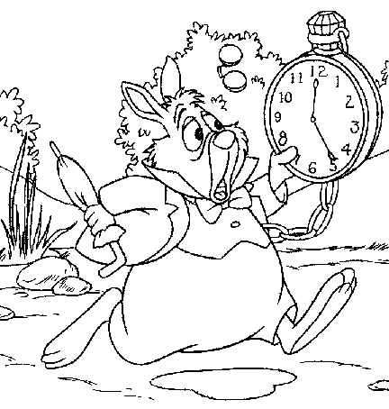
Look at the following map. The whole world is divided in 24 time zones. Each zone represents an hour difference in time. Find your home place on the map. The places in the first zone to the left are one hour earlier, the places in the second zone are two hours earlier and so on. The places in the first zone to the right are one hour later, the places in the second zone are two hours later and so on.
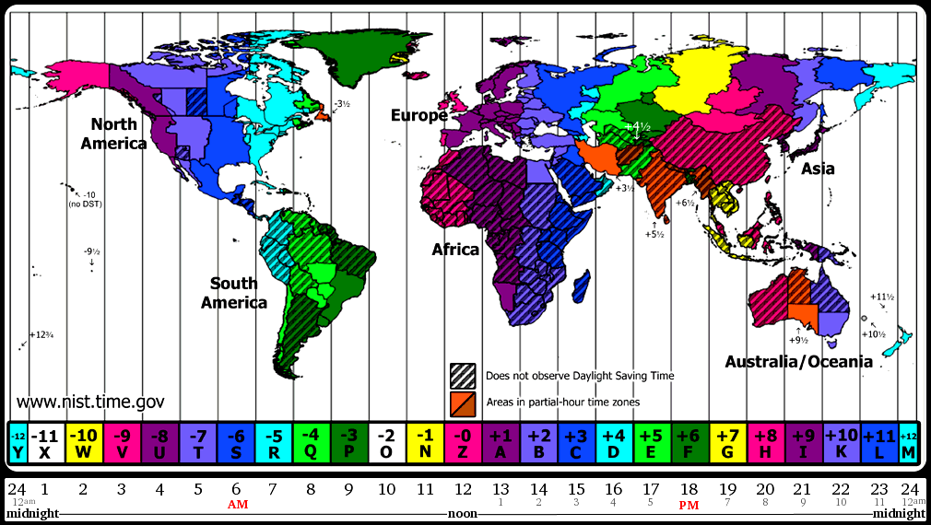
Time moves from the east to the west.
The Greenwich Observatory in the
UK is the centre of time measuring Map from http://nist.time.gov/images/worldzones.gif

- Using the above map, can you name two places whose time is ahead of yours and two places whose time is earlier than yours? Can you also calculate, what time it is there?
Ahead: …………………………………… …….………………………………….
Earlier: …………….…………………….. …………………………………………
Useful information: You can go to http://www.what-time-is-it.com/ to find out what time it is in various places of the world.

Worksheet 2: “Good morning” and “Good evening” in different languages
Grouping: (pairs) or (small group)
- Using the above site or any other site of your preference, please complete the following exercise:
If it is 13.00 in London…
It is …………...………in Paris.
It is …………………..in Barcelona.
It is …………….……..in New York.
It is ……………..……in Bucharest.
It is ……………….….in Cairo.
- If it is 12 at noon in Greenwich, how would the students in the following countries greet each other?
(If you do not know how to pronounce any of these expressions, ask your partners, they may know. If they do not, can you think of anyone who might know? In any case, you can always use a dictionary from these languages to yours, or go to the internet and find such a dictionary).
A. In Australia, they will say: a) Good morning b) Good night
B. In France, they will say: a) Bonjour b) Bonne nuit
C. In Brazil, they will say: a) Boa manhã b) Boa noite
D. In the USA, they will say: a) Good morning b) Good night
E. In Italy, they will say: a) Buon giorno b) Buona notte
F. In South America, they will say: a) Buenos días b) Buenas noches
- Have you noticed any words that show a common origin? Write them down in groups on the following lines:
_____Nuit,_____ noite,______ night,_____ notte,_____ noches _____ ___Bonjour,______ Buon giorno _______________________________
____ dias,_________ day _____________________________________
___________________________________________________________
___________________________________________________________

Answer sheet for A
If it is 13.00 in London…
It is ………14.00…...………in Paris.
It is ………13.00…………..in Barcelona.
It is …………5.00….……..in New York.
It is …………15.00….……in Bucharest.
It is …………15.00…….….in Cairo.

Answer sheet for B
- A. In Australia, they will say: b) Good night
- B. In France, they will say: a) Bonjour
- C. In Brazil, they will say: a) Boa manhã
- D. In the USA, they will say: a) Good morning
- E. In Italy, they will say: a) Buon giorno
- F. In South America, they will say: a) Buenos días

Worksheet 3: Learning “Good morning” and “Good evening” in different languages
Grouping: (whole class)
- Check your answers to the previous task with those of your fellow students and exchange information.
- Do you know how people say “good morning” and “good evening” in other languages? Share with your fellow students.
- Try to learn these greetings in the different languages. (If you think that it is too much, do not worry. Learn them in as many languages as you like).

8. Review and Assessment Project
Notes for the teacher
- The assessment is done through a project - the creation of a poster with a world map - in which all the students participate and contribute with what they have learnt or by using their artistic skills to colour the poster.
- Before the class starts working on the project, they may wish to watch the ppt presentation again, as a means of reviewing the information about countries, their location and their capitals.
- Apart from geographical information, the poster will contain information concerning languages and time. So, it would be advisable for the students to have their previous worksheets to refer to and use the information contained in them.
- The teacher could let the students form 3 groups that will undertake the different jobs mentioned in the instructions. It would be good if the students themselves chose the job they would be interested in doing.
- If you wish to make a large photocopy of the blank map in Worksheet 5, you could cut it in pieces and blow up each piece to the same size and then stick the photocopies together, by using sticky tape on the back side.
Duration: 60 minutes
Necessary material:
- A world map or a blown up photocopy of the map in this worksheet
- Pieces of paper
- Colouring pens
- The previous worksheets

Worksheet 1: Reviewing the information on countries and languages
Grouping: (small group) and (whole class)
Do you think you could all work together and make a poster using a world map, where you would pin pieces of paper with the names of countries and cities in English? You can use a map from your geography lessons where the different countries are already marked or you could use a blown up photocopy of the following map, where you will need to locate the countries and write down their names yourselves. If you wish, you could watch the ppt presentation once more, for help. Work in groups and decide which of the following jobs each group will undertake:
- Mark the strait of Gibraltar, the Black and Red Seas (write the name of the seas in different languages) and any isthmuses or canals that you know.
- Write on pieces of paper the foreign words you have learnt and pin them in the countries that they can be used. If they can be used in many countries, prepare corresponding pieces of paper and pin them on the map. You will find out that you have learnt some quite useful words, that can help you greet people/say thanks/introduce yourself or say something to a very great number of people in our world, on OUR BEAUTIFUL EARTH.
- Draw a sun and a moon on two separate pieces of paper. Put them on your map, to mark where you think it is night and where it is daytime, at the time you are working on your poster. Using the time zones map from Worksheet 4, you can mark what time is at some or all of the countries you will mark on the map.
- After you have finished the poster you can talk about the new things each one of you has learned by participating in this project.
Map from http://vectorya.com/gallery/img65.search.htm
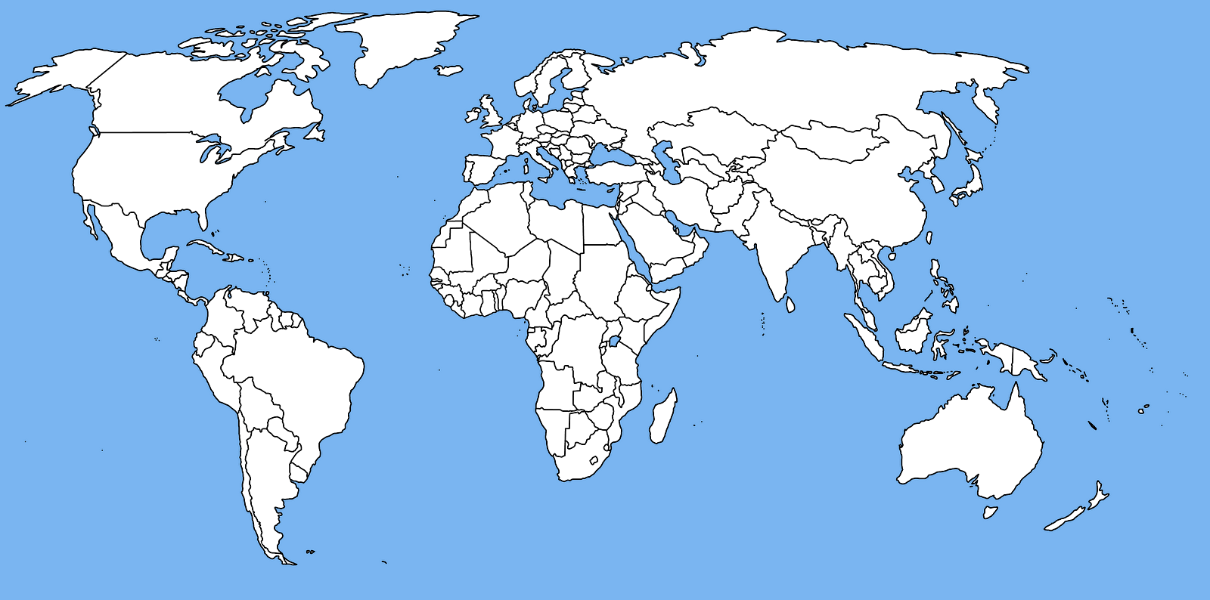

References
http://www.solarviews.com/eng/earthsp.htm
http://www.worldatlas.com/aatlas/infopage/gibraltar.htm
http://en.wikipedia.org/wiki/Strait
http://en.wikipedia.org/wiki/Isthmus
http://www.speakmoroccan.com/
http://en.wikipedia.org/wiki/Black_Sea
http://en.wikipedia.org/wiki/Red_Sea
http://www.athropolis.com/translate.htm
http://www.learn-english-today.com/idioms/idiom-categories/colour-idioms.htm

