Japanese calligraphy
For the student
Aine Furlong
Japanese calligraphy
Áine FURLONG

1. Discovering Japanese calligraphy
Grouping: 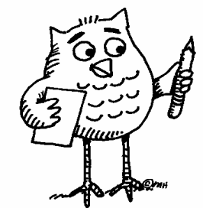

Worksheet 1
- Look at the short film shown on http://markun.cs.shinshu-u.ac.jp/japan/shodou/index-e.html. (The explanations are in English). It shows you how to write Japanese characters. You can also study Document 1 on Japanese calligraphy and/or go back to the site to see an interactive version of the Katakana table.
http://markun.cs.shinshu-u.ac.jp/japan/japan/Katakana1.html
- Practise writing a French/German/Italian or Portuguese noun of your choice in Japanese in Document 1. Can you copy the other nouns that are shown on Document 1?
- Can you pronounce these words from other languages (Document 1)?
Document 1:
From Spanish
フラメンコ from "flamenco"
From Portuguese
パン from "pan"
サンバ from "samba"

From German
アルバイト from "Arbeit", which just means "work"
サルサ from "salsa" (Portuguese?)
ルンバ from "rumba"
タンゴ from "tango"

From French
バカンス from "vacances"
シネマ from "cinéma"
カフェー from "café"
カフェオレ from "café au lait"
ショコラ from "chocolat"
クロワッサン from "croissant"
エクレア from "éclair"
タルト from "tarte"
ガトー from "gâteau"

From Italian
イタリア from "Italia"
パスタ from "pasta"
スパゲッティ from "spaghetti"
ピッザ from "pizza”
From English:
ジョン
jon John
ジョージ
jōji George
マリー
marī Marie
マイケル
maikeru Michael
ピーター
pītā Peter

2. Let’s study Japanese (a little)
Grouping: 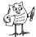

Worksheet 1
- Study the Katakana table (Document 2) and call each syllable out loud. Follow the recommended reading direction. Now, can you guess where the first page of a Japanese book is located? And the last page? Do you know other languages that behave in the same manner?
Document 2 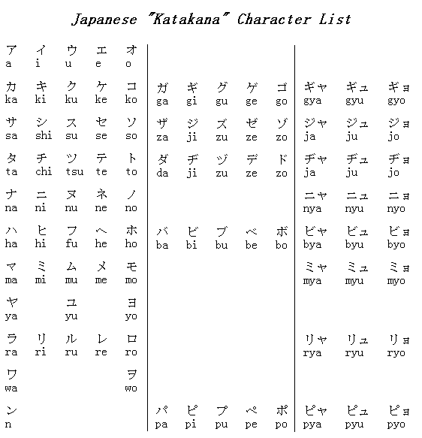
This table is read from right to left or from top to bottom
Only nouns and names can be imported from other languages into Japanese.

3. History of the Katakana table
Grouping:

Worksheet 1
Now that you studied the katakana table, can you find one, two or three pieces of information in the Document 3 text?
Here are some questions to help you:
How many signs are there?
How many vowels are there?
How many consonants are there?
How old is the Katakana table?
Who invented the Katakana table?
What is the table used for?
How were you able to guess the answers?

Document 3
The katakana table comprises 45 basic signs which are still in use today. There are 5 vowels a i u e o which are combined with 40 consonants with additional modified consonants. The katakana table was devised by Buddhist monks over 1000 years ago. Today the table is used to write nouns that have been borrowed from other languages and to transcribe foreign names.

4. Japanese calligraphy on a stone
Grouping:

Worksheet 1
Cut a square in the white cardboard (10 cm).
Cut a smaller square in the black card board (6cm).
Glue the black square onto the white square.

Draw Japanese calligraphy by using English names and foreign nouns imported into Japanese through katakana (example : マイケル maikeru Michael).

Write a Word in katakana on each side of the white cardboard, with a black marker.
Write your favourite katakana sign on the pebble, using the white Tipex pen.
Glue the pebble in the centre of the black cardboard.
Sign your name in katakana at the bottom of the painting.

Admire your work and show it to the class.

