CONTENT BASED TEACHING + ConBaT Japanese calligraphy
For the Teacher
Áine FURLONG
2/4/2011

Table of Contents
Introductory Information 3
Learner Worksheet 1: Raising awareness of Japanese characters (katakana) 6
Learner worksheet 1 Discovering Japanese calligraphy 7
Learner Worksheet 2 9
Learner worksheet 3: History of the Katakana table 11
4. Japanese calligraphy on a stone 12
Learner Worksheet 1 Japanese calligraphy on a stone. 12

Introductory Information
AUTHOR: Áine FURLONG
E-MAIL: afurlong@wit.ie
INSTITUTE: Waterford Institute of Technology, Ireland
Target Group:
mid/ late Primary
Subjects:
Art
Aims:
The child should be enabled to :
- discover how line could convey movement and rhythm : e.g. calligraphic styles (Visual Art curriculum NCCA, p.66) ;
- Make drawings and do color studies based on natural objects brought into the classroom (this becomes more important when children reach the senior classes of the primary school [ 10-12 years old]. The structure of natural objects could provide inspiration in construction activities Visual art teacher guidelines, NCCA, p.37).
Key Competencies regarding:
Communication in language(s):
- Consolidate French vocabulary (nouns) and introduce any other nouns from languages known in the class
- Develop phonological awareness
- Use Japanese Katakana table to achieve these aims
- Develop curiosity in other languages and writing systems
Learning to learn:
- Work collaboratively as part of the learning process
- Draw benefits from a heterogeneous group
- Share what they have learnt
- Look for opportunities to learn and apply learning in a variety of life contexts
Digital competences:
- Ability to search, collect and process information
Social and civic competences:
- Work collaboratively
- Value diversity and cultural identities
Cultural awareness and expression
- Understand cultural and linguistic diversity in Europe and other regions of the world
- Develop creative skills which can be transferred to a variety of contexts
- The willingness to cultivate aesthetic capacity through artistic self-expression and participation in cultural life.

Timing of the overall activities:
- 3 hours
Example of a finished product;
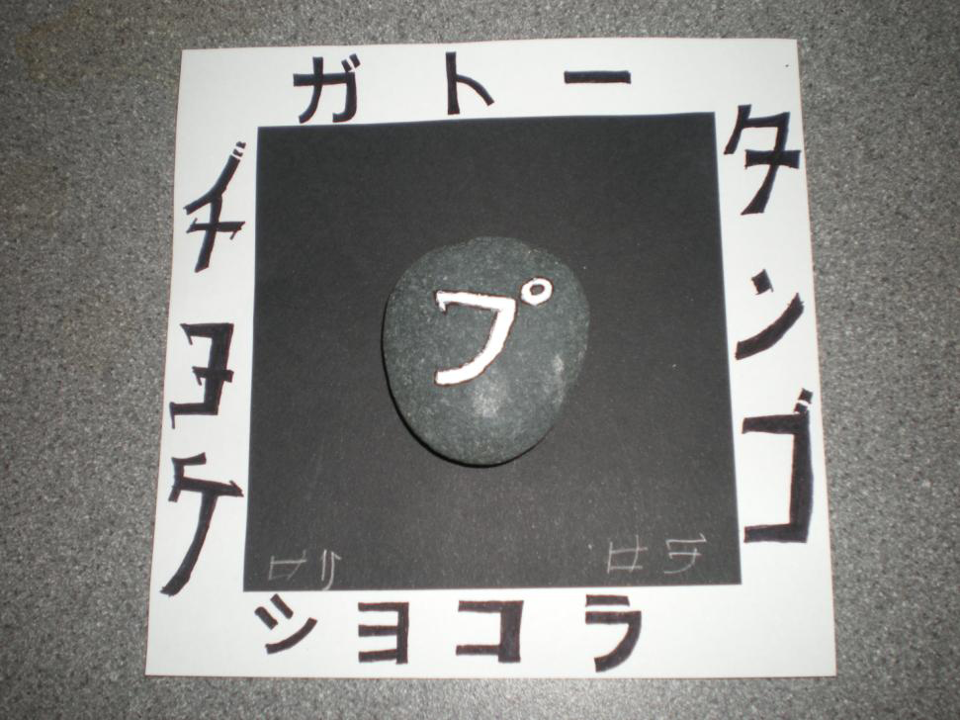

Learner Worksheet 1: Raising awareness of Japanese characters (katakana)
Material required: Japanese calligraphy examples included below. Internet access is optional.
Resources: Document 1, Katakana examples
Grouping: 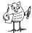and

Focus on content:
Discovering another writing system
Focus on language(S): 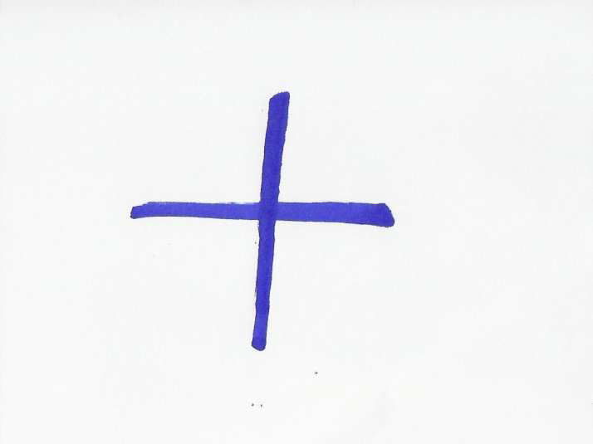
Pronouncing words from other languages
Notes for the teacher:
These tasks can be conducted bilingually. Katakana is syllabic, therefore children must break words into their number of syllables. The sound L is represented by R. There are more signs than those represented in Document 2. These signs can be accessed on the web

Learner worksheet 1 Discovering Japanese calligraphy
- Look at the short film shown on http://markun.cs.shinshu-u.ac.jp/japan/shodou/index-e.html. (The explanations are in English). It shows you how to write Japanese characters. You can also study Document 1 on Japanese calligraphy and/or go back to the site to see an interactive version of the Katakana table.
http://markun.cs.shinshu-u.ac.jp/japan/japan/Katakana1.html
- Practise writing a French/German/Italian or Portuguese noun of your choice in Japanese in Document 1. Can you copy the other nouns that are shown on Document 1?
Can you pronounce these words from other languages (Document 1)?

Document 1:
From Spanish
From Portuguese
パン from "pan" サンバ from "samba"

From German
アルバイト from "Arbeit", which just means "work"
フラメンコ from "flamenco"
サルサ from "salsa" (Portuguese?)
ルンバ from "rumba"
タンゴ from "tango"
From French
バカンス from "vacances"
シネマ from "cinéma"
カフェー from "café"
カフェオレ from "café au lait"
ショコラ from "chocolat"
クロワッサン from "croissant"
エクレア from "éclair"
タルト from "tarte"
ガトー from "gâteau"
From Italian
イタリア from "Italia"
パスタ from "pasta"
スパゲッティ from "spaghetti"
ピッザ from "pizza”
From English:
ジョン
jon John
ジョージ
jōji George
マリー
marī Marie
マイケル
maikeru Michael
ピーター
pītā Peter

Learner Worksheet 2
Material required: The Katakana table. Short history of this syllabic alphabet.
Resources: Document 2, Katakana table
Grouping:
Let’s study Japanese (a little)
1. Study the Katakana table (Document 2) and call each syllable out loud. Follow the recommended reading direction. Now, can you guess where the first page of a Japanese book is located? And the last page? Do you know other languages that behave in the same manner?
Worksheet 2 answers: Reading the katakana table The first page of a Japanese book is located at the end of a European book. The last page is at the beginning of a European book. Another language that behaves in the same manner is Arabic.
Document 2 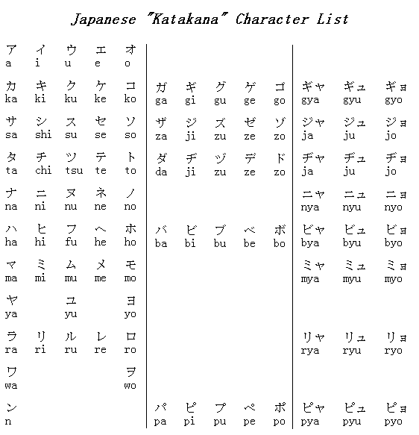
This table is read from right to left or from top to bottom
Only nouns and names can be imported from other languages into Japanese.

Learner worksheet 3: History of the Katakana table
Material required: Short history of this syllabic alphabet (Document 3)
Grouping:
History of the Katakana table
Now that you studied the katakana table, can you find one, two or three pieces of information in the Document 3 text?
Here are some questions to help you:
How many signs are there?
How many vowels are there?
How many consonants are there?
How old is the Katakana table?
Who invented the Katakana table?
What is the table used for?
How were you able to guess the answers?

Document 3
The katakana table comprises 45 basic signs which are still in use today. There are 5 vowels a i u e o which are combined with 40 consonants with additional modified consonants. The katakana table was devised by Buddhist monks over 1000 years ago. Today the table is used to write nouns that have been borrowed from other languages and to transcribe foreign names.
Worksheet 3 answers: Histoire de la table Katakana
How many signs are there? There are 45 signs.
How many vowels are there? There are 5 vowels.
How many consonants are there? There are 40 consonants.
How old is the Katakana table? Over 1000 years old.
Who invented the Katakana table? Buddhist monks.
What is the table used for? To import foreign nouns or names.

4. Japanese calligraphy on a stone

Learner Worksheet 1 Japanese calligraphy on a stone.
Materials required:
- Documents 1 and 2
- An A4 white cardboard sheet between 2 pupils.
- An A4 black card board sheet between 2 pupils.
- A small flat pebble (approximately 5cm x 3cm) per pupil.
- One black marker per pupil.
- One Tipex pen between 2 pupils.
- One pair of scissors per pupil.
- Glue.
Grouping:
Instructions:
Cut a square in the white cardboard (10 cm).
Cut a smaller square in the black card board (6cm).
Glue the black square onto the white square.
Draw Japanese calligraphy by using English names and foreign nouns imported into Japanese through katakana (example : マイケル maikeru Michael).
Write a Word in katakana on each side of the white cardboard, with a black marker.
Write your favourite katakana sign on the pebble, using the white Tipex pen.
Glue the pebble in the centre of the black cardboard.
Sign your name in katakana at the bottom of the painting.
Admire your work and show it to the class.
Assessment:
Guess the sound that is represented on the pebbles of the other pupils in the class
Import a noun in English or in another language and write it in katakana.
To explore the theme a little further : do you know other languages where calligraphy is practised ? Do you have examples ?

