Parasites
Anu Parts & Mare Kallas

1. Diversity of parasites
Grouping:  -

Worksheet 1
- Search the Internet and make a list/compile a mini- dictionary of parasitic organism in alphabetical order. You can use English and add other languages you know. Try to find a parasite for each letter. Provide one sentence to define or characterize each parasite. Make your parasite ABC more attractive by adding illustrations.
http://www.healingdaily.com/colon-kidney-detoxification/what-are-parasites.htm
For example:
A | Ascariasis (roundworms) | Spread mainly in tropical regions, also in areas of poor hygiene
B | Body louse | Transmitter of epidemic typhus
C | ….
D

Watch the videos and organise information http://video.google.com/videosearch?hl=et&q=parasites&lr=&um=1&ie=UTF-8&ei=b_yjSYHzL4OB_gafm-iMBQ&sa=X&oi=video_result_group&resnum=4&ct=title#

Parasite | Way of infection | Damaged organs | Symptoms

Give two conclusions from the table:
..............................................................................................................................................................................................................................................................
- Parasites can be divided into two groups exo- and endoparasites. What's the meaning of these prefixes? Using analogy, try to compose a definition of the prefix.
Exo -
Endo-

To add more examples, go to Natural History Museum homepage and visit collections of invertebrates. Work in pairs.
Exoparasites | are organisms  who live  ……………………………………………………………….  and their role is ……………………………………………………….
Exoparasites | examples
Endoparasites | …………………………………………………………………………  …………………………………………………………………………  …………………………………………………………………………
Endoparasites | examples

2. Parasites around the world
Grouping: - -

Worksheet 1
- Writing task: Study the prevalence, life cycle, diagnosis etc of head louse (Pediculus humanus)
- A Describe your day as a parasite.
- B Describe an adventure as a parasite
- C This is how I died.
- Work in pairs. Spot the prevalence areas of 1-5 parasites in the world map. Define the symbols (colours) to each other.

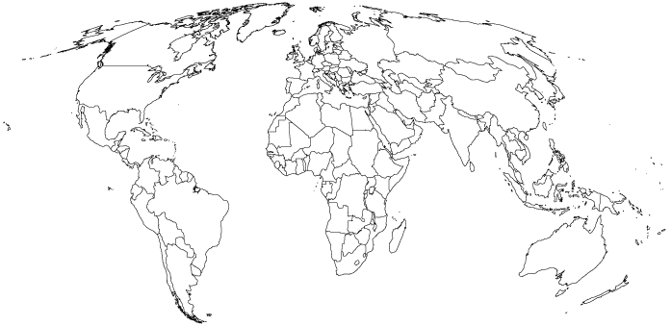
- Classroom discussion
Some people are called “parasites”. They live off others and give nothing in return. Find some examples from your society, justify your opinion. What needs to be done in order to get rid of them/to change them? Present your ideas in the class.
- Interview
The problem of parasites is not just limited to so called third-world countries. We are just as much at risk as anyone else. Visit a pharmacy and interview the pharmacist about the most common parasites in humans currently. Ask about the ways to get rid of them. Write a report on the results or get ready for a classroom presentation.
Prepare your questions to the pharmacist in advance. You can ask help from your teacher.

3. News and poems
Grouping:

Worksheet 1
- A newsletter
Search the Internet and find any up to date news about parasites in the world. Make a short summary. In groups compile The Parasite News, include pictures, comics etc. Any satire or comedy spoof writing are also accepted. If you need inspiration, see the article below:
http://www.thespoof.com/news/spoof.cfm?headline=s5i53412
- Write a haiku or poem about parasites. Use your mother tongue and any other foreign language(s) you know.
- Design your book (blog) of parasites.
Some ideas for the design of your book:
- Make a tapeworm-shaped folded book of poetry, add illustrations.
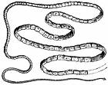
- You can fold the book according to these instructions.
- Take a sheet of paper.
- Fold it to half on both directions. Look at the drawing.

- Open the paper and fold it in half
- Take scissors and cut until the line
cut until the next line | stop here

- Open the paper and fold it by the longitudinal line. Press it gently and you can see the little book formation. Be creative.
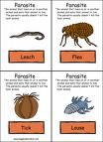 | Parasite poetry  2009

