GUNITS OF MEASUREMENT
For the student
Gayane Hovhannisyan
Aine Furlong

GUNITS OF MEASUREMENT
Gayane Hovhannisyan and Áine Furlong

Measuring things using our body.

Worksheet 1
Grouping: 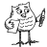 or + whole class
Brainstorming session: why do we have units of measurement ?
To measure…, to make…, to buy…, to sell…, to gauge…, to evaluate…, to understand…, to manage…, to compare…, to trade…, to count…, to own…, to rule…, to describe…, to draw…
- How big, tall, fast, heavy, strong, powerful, deep, expensive, precious are you?
In pairs, use the table below to record all the ’things‘ that can be measured. Don’t forget to place the appropriate unit of measurement next to the thing.
When you have finished, compile a class table of measurable ‘things’. Don’t forget that almost anything around you and in your life can be measured!
Table 1: Units of measurement
Thing | Unit of measurement used by the class | Units of measurement used in your culture

- In pairs, choose a unit of measurement and find an appropriate object or place or ‘thing’ to measure. You can measure a desk, a classroom, the schoolyard, but also water in a jug or the electricty, fuel and water consumed by the school!. Use the Table 2 below to record your work and report to the class.

Unit of measurement | Thing | Measurement
Table 2: How big, tall, fast, heavy, strong, powerful, deep, expensive, precious is… ?
- Design a poster or make a PPT presentation which represents all the units of measurement used by the class
Unit of measurementThingMeasurement

----------------------------------------------------------------------------------------------------------------------------------------------------------------
----------------------------------------------------------------------------------------------------------------------------------------------------------------
----------------------------------------------------------------------------------------------------------------------------------------------------------------
----------------------------------------------------------------------------------------------------------------------------------------------------------------
----------------------------------------------------------------------------------------------------------------------------------------------------------------
----------------------------------------------------------------------------------------------------------------------------------------------------------------
----------------------------------------------------------------------------------------------------------------------------------------------------------------
----------------------------------------------------------------------------------------------------------------------------------------------------------------

- Units of measure according to Leonardo de Vinci

Worksheet 2.
Grouping:
- Match the picture to the unit of measurement to the definition
Picture | Unit of measurement | Definition
a. 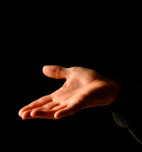 | Fathom | 1. The length of a man's foot
b. 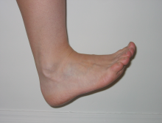 | Span | 2. Old English word fæðm meaning embracing arms or a pair of outstretched arms (used to measure depth of water).
c. 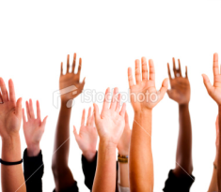 | Handbreadth | 3. The breadth of a male human hand (used for height of a horse for example)
d. 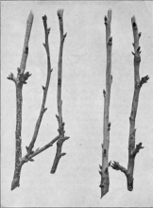 | Foot | 4. From the word for a straight branch or rod
e.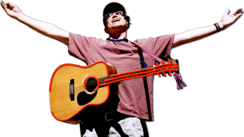 | Cubit | 5. The Egyptian hieroglyph for the unit shows the symbol of a forearm subdivided into 7 'palms' of 4 'digits'
f. 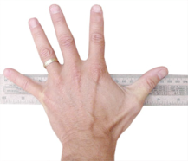 | Ell | 6. The width of a human hand
g. 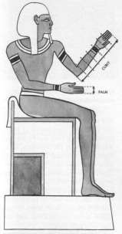 | Yard | 7. From Proto-Indo-European *el- "elbow, forearm.The length of a man's arm.

The Vitruvian man by Leaonardo da Vinci

Worksheet 3
Grouping: 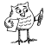
- 1.a In pairs, study the picture and the short text below.

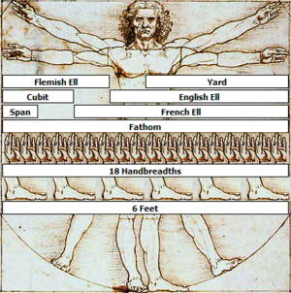
This derivation of the Vitruvian man by Leonardo Da Vinci depicts nine historical units of measurement: the Yard, the Span, the Cubit,, the Flemish Ell, the English Ell, the French Ell the Fathom the Hand, and the Foot. Da Vinci drew the Vitruvian man to scale, so the units depicted here are displayed with their proper historical ratios.

- Now , in can you explain to the class where the name for each of these measures comes from? Can you give the measurement of your desk in Ell? In Foot? In Handbreadths? In Fathom? In Cubit? Remember the work you completed in Worksheet 2.

Discovering the history of measurement through words

Worksheet 4
Grouping:

History of measurement
From Wikipedia, the free encyclopedia
- Find synonyms (similar words) or explanations for each word in bold print:
Units of measurement were among the earliest tools invented by humans. Primitive societies needed measures for constructing dwellings of an appropriate size and shape, fashioning clothing, or exchanging food or raw materials.
Earliest:
Dwellings:
Appropriate:
Fashioning:
Raw materials:
- Something’s wrong! The spaces between the words have disappeared! Can you put a line between each word and re-write the sentences correctly?
Theearliestsystemsofweightsandmeasuresseemtohavebeencreatedsometime
betweenthe4thand3rdmillenniaBCbytheancientpeopleslivingbetweenEgyptand
theIndusValley.Theeasternpeoplesachievedgreataccuracyinmeasuringlength,mass,andtime.
---------------------------------------------------------------------------------------------------------------------------------------------------------------------------------------------------------------------------------------------------------------------------------------------------------------------------------------------------------------------------------------------
- The weight units have been mixed up. Can you put them in the correct order?
Check http://www.etymonline.com to discover the origin of the word ounce and why it is abbreviated as oz.
The smallest division ever recorded on a scale of the Bronze Age was approximately 1.704mm. Weights were based on units of 100, 0.2, 500 , 20 , 2, 5, 10, 50 , 0.5 , 0.05, 200, 1 and 0.1, with each unit weighing approximately 28 grams, similar to the English ounce or Roman uncia.

- The paragraphs have been jumbled up. Number the sentences/paragraphs in the correct order
When it was necessary to compare the capacities of containers such as gourds or clay or metal vessels, they were filled with plant seeds which were then counted to measure the volumes
Early Babylonian and Egyptian records indicate that length was first measured with the forearm, hand, or finger and that time was measured by the periods of the sun, moon, and other heavenly bodies.
When means for weighing were invented, seeds and stones served as standards. For instance, the carat, still used as a unit for gems, was derived from the carob seed.
Other systems were based on the use of parts of the body and the natural surroundings as measuring instruments.
- Count the number of times the word Human/s appears in this paragraph. Can you explain why you think the word appears so often?
Can you explain why we need human scaled objects? (in your own words).
Can you give more examples of human scaled objects?
Human scale means "of a scale comparable to a human being".
Humans interact with their environments based on their physical dimensions, capabilities and limits. The field of anthropometrics (human measurement) is not perfect, but it's still true that human physical characteristics are fairly predictable and objectively measurable. Buildings scaled to human physical capabilities have steps, doorways, railings, work surfaces, seating, shelves, fixtures, walking distances, and other features that fit well to the average person.

The word human/s appears_________________________, because ______________________________________________________________________________________________________________________________

