Task 2: Languages in the Worlds of Math and Music

Worksheet 1: Languages and Cultures in Tune

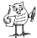Pair work
- As you have seen, in this project we are not only becoming music experts but also learning about different languages and cultures. Would you be able to tell us which languages and cultures have been mentioned in Worksheet 1?

- Look at the following word enigma and list the languages and different cultures we have been dealing with so far.

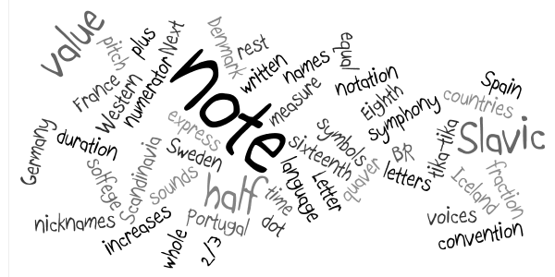

Group work
- Allegro, π, mezzo forte, ß, lied,…

- Do you know why these important music terms are in Italian?
- Can you think of languages and cultures that are important in the world of music? And in the world of math?
- Do you know any great musicians and mathematicians? Where do they come from?

 Discuss these questions in groups.

To answer this question, we encourage you to go online and do some research on the history of music and the history of math. Some key words you may want to use are: history of music / history of math / great musicians / Italian in music / etc.

Group work Whole class
-  You are now ready to prepare a short oral presentation of your findings. Here are some expressions you may want to use. While each group is presenting, your teacher will make a mind map on the board with everybody's findings.

Some expressions for your oral presentation:
- …...... are important words in the world of music....
- We have found that ….. / We have learnt that... / We know that...
- (musician/mathematician) is famous for his/her …...... /(musician/mathematician) is famous because......
- (musician/mathematician) comes from …..
- Italian is important in the world of ….. because....
- Some examples of music/mathematics words in (language) are....
- The word ….. means …..

Group work
-  In some of the expert cards some languages and cultures are mentioned. In teams, take one of the languages you consider important in the world of music, and make a new expert card which contains new relations between music and/or math and the new language you have chosen.

You can choose English, but we encourage you to choose a different language (maybe one of the languages you found when you did some research for activity 2).

Group work
- What about your mother tongue? And what about other languages you know? Taking everything you have learnt in this first and second part of the project (Worksheet 1 and 2), think of how many of these new music and math concepts you can say in the languages you know. Make a word cloud like the one in activity 1, using all the languages you and your teammates know. You can use the online tool Worlde (www.wordle.com).

