A Symphony of Fractions

ORIOL PALLARES MONGE
CARLOTA PETIT OLIVELLA

Oriol.Pallares@uab.cat
cpetit@xtec.cat

Universitat Autònoma de Barcelona
IES Salvador Espriu
Barcelona, Spain.

- Target Group: Secondary education (12-14)
- Subject: Math and Music
- Aims: At the end of the unit, most of the students will be competent to...
  - Explain relationships between music and math
  - Compare the language of music and math in different languages (L1, L2...)
  - Deduce what languages play an important role in the field of music
  - Explain how music is written
  - Compare how music is written and expressed in different cultures and in different languages
  - Cooperate in teams to learn about a shared topic
  - Synthesize written input to communicate it orally and in written form
  - Find language equivalences in one owns mother tongue
  - Use the ICT to create and write music
  - Integrate math knowledge when reading or writing music
  - Reflect on the connections between languages, math and artistic languages
  - Search for extended information on the Internet
  - Compose rhythms and tunes using math and music knowledge
  - Interact in L1 and FL to learn content and language

- Key Competencies

- Communication in L1
- Interact with other people and approach other cultures and languages.
- Communicate thoughts, feelings and facts orally
- Interpret and understand everyday life situations
- Code-switch between L1 and FL to learn content and language

- Communication in FL(s)
- Reflect on how to use the communicative resources specific of the subject (math and music).
- Interact with other people and approach other cultures and languages.
- Communicate thoughts, feelings and facts orally
- Interpret and understand everyday life situations
- Relate observations, explanations, thoughts...
- Synthesize information

- Mathematical competence and basic competences in science and technology
- Use and relate the tools and the forms of expression of mathematical thought
- Reason mathematically in order to produce and interpret different types of information.
- Interpret and put into practice processes of mathematical reasoning leading to solving the problems and questions in everyday situations.

- Learning to learn
- Gain, process and assimilate new knowledge and skills (intellectual, emotional and physical) as well as seek and make use of guidance.
- Apply study skills that include strategic thinking and cooperation and self-evaluation skills.
- Handle effectively an array of resources to transform information into personal knowledge.

- Digital competences
- Access and communicate information using different digital supports.
- Transform information into knowledge activating thinking skills in order to organize, relate, analyze, synthesize, make inferences and deduct at different levels of complexity.

- Interpersonal, intercultural and social and civic competences
- Respect others and value different ways of expressing oneself.

- Cultural expression
- Show interest and respect towards music as a means of expression.

- Timing of the overall activities: 3 class sessions + homework

- Resources and materials needed
  - Expert cards (for each team)
  - Access to a computer and to the Internet
  - Trial version of a music notation software
  - Free-hosting websites

Task 1: Becoming Music Experts

- Timing: 40 minutes
- Material required:
  - Worksheet 1: Music Jigsaw Reading
  - Expert cards
- Grouping: groups of 5
- Focus on content:
  - Learning to write music
  - The concept of duration
  - Systems for naming note values
  - Rests and dotted notes
  - Time signatures
  - Learning note values nicknames
  - The meaning of fractions in music
  - Triplets and syncopation
  - Expressing musical notes
  - The relationship between music and math

- Focus on language:
  - The language of music
  - Explaining how music is written
  - Specific vocabulary
  - Expressing music in words
  - Sharing knowledge about music

- Description of activities: Jigsaw Reading
See student's worksheet 1
- Document 1:
See student's worksheet 1 “Becoming Music Experts” and “Expert Cards”.
- Assessment
  - Classroom interaction (use voice recorders to record students' oral performance)
  - End of the activity oral QUIZ

Task 2: Language in the Worlds of Math and Music

- Timing: 55 minutes
- Material required:
  - Worksheet 1: Languages and Cultures in Tune
  - Website: www.wordle.net to make a word cloud
  - Cards (cardboard) to make expert cards
- Grouping: Pair work / Team work
- Focus on content:
  - The importance of languages in the world of music: differences and similarities
  - New relations between math and music

- Focus on language:
  - Music words and expressions in different languages
  - Expressing music and math concepts through words of different languages
  - Equivalences in different languages

- Description of activity 1: Word Clouds
See student's worksheet 1.
- Document 1:
See student's worksheet 1 “Languages and Cultures in Tune”
- Assessment
  - Class plenary to discuss questions 1 and 2
  - New expert cards (use of rubrics to assess cards)
  - Word clouds (use of rubrics to assess cards)

Task 3: Composing a Symphony of Fractions

- Timing: 55 minutes + homework

- Material required:
  - Worksheet 1
  - Trial version of a music notation software
  - Free-hosting website

- Grouping: Team work

- Focus on content:
  - Understanding fractions in music
  - Using math knowledge to compose music
  - Creating and performing rhythms an/or tunes
  - Writing music using a music notation software

- Focus on language:
  - Using a music notation software (in the CLIL language)
  - Music vocabulary
  - Creative writing (lyrics)

- Description of activity 3: : Composing a Symphony of Fractions
See student's worksheet 3.

- Document 1:
See student's worksheet 1 “Composing a Symphony of Fractions”

- Assessment
  - Classroom music performances (peer assessment)
  - Mp3 files with rhythms and tunes (peer assessment)
  - Here is an example of a rubric which can be used for peer assessment. Students, guided by the teacher, should finish this rubric by adding 2-3 more categories to be assessed.
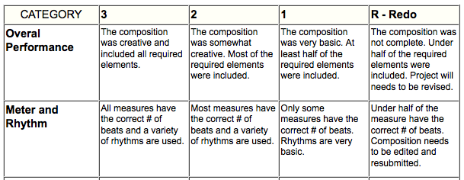

ANSWER KEY:
Activity 1:
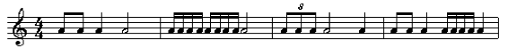
Any of the values can be also expressed as rests.

