A Symphony of Fractions
Oriol Pallarés and Carlota Petit
Task 1: Becoming Music Experts

Worksheet 1: Music Jigsaw Reading

Group work

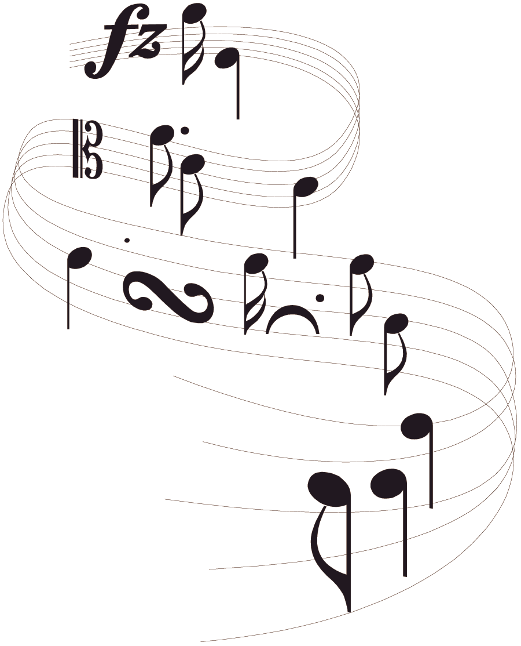
- In groups of five, assign yourselves a number from 1 to 5.
- Read the “expert card” that has your number. Try to understand it and memorize as much as you can.
- Make “expert” groups with the people from the other teams that studied the same expert cards. Once in your expert group, you will see that all of you have the same text.
-  You need to become real experts, so use as many strategies as you can to become more and more familiar with the content of the expert card: one of you explains, the others listen and help, ask each other questions, quiz each other...
-  When your teacher tells you to, work in pairs with someone from your “expert” group. Take turns explaining the text to each other without looking at it. The listener can look at the text and help the speaker.
- Now go back to your original team of four.
-  You will now have some time to share everything you learned with the other members of your team. You are now the only expert of your text in the team, so you have to explain what you have already practiced to the rest of your team mates.
- The objective is that all of you learn the information contained in all the expert cards.
- Your teacher will test you and your team to make sure that you have been working hard.
STUDENT 1: Expert card
HOW IS MUSIC WRITTEN?
Just as language is recorded with a set of letters that represent spoken sounds, music is recorded with a set of symbols that represent musical sounds. This system of symbols, called notation, tells musicians the pitch and the duration of each sound they are to play.

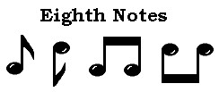
Duration
The longest note is the whole note. Next is the half note, then the quarter note, and so on, up to the sixty-fourth note. Notes with shorter values than the quarter note have flags, or “tails,” on their stems.
The whole note has the same time value as—or equal to—two half notes. A whole note also equals 4 quarter notes, 8 eighth notes, and so on, up to 64 sixty-fourth notes. When two or more eighth notes or shorter notes follow each other, they are often joined.
Breaking a whole note into equal shorter notes can be seen as fractioning it, just as the names of the shorter notes indicate.

Observing the diagram below, we can say that:

Whole note = half note + half note = quarter note + quarter note = etc.
w= h+ h= q+ q+ q+ q = e+e+e+e+e+e+e+e = etc.
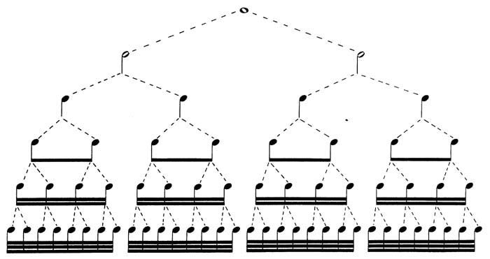
Whole note
Half note
Quarter note
Eighth note
Sixteenth note
Thirty-second note

1 =$1=\frac{1}{2}+\frac{1}{2}=\frac{1}{4}+\frac{1}{4}+\frac{1}{4}+\frac{1}{4}=...$

STUDENT 2: Expert card

Did you know...

…that there are two systems for naming note values in the English language. Here, the American names are listed first and the European names are listed in parentheses.

- Whole note (semibreve)
- Half note (minim)
- Quarter note (crotchet)
- Eighth note (quaver)
- Sixteenth note (semiquaver)
- Thirty-second note (demisemiquaver)
- Sixty-fourth note (hemidemisemiquaver)

Rests
When there is to be no sound, a rest is used. Rests have the same time value as notes of the same duration, ranging from a whole rest to a sixty-fourth rest.

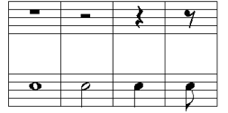

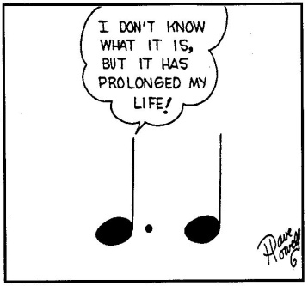
Dotted notes
A dot after a note increases its duration by one half. Thus a quarter note followed by a dot lasts one quarter note plus one eighth note. Duration is also increased by the tie, —a curved line connecting a note and the repetition of it. The tie makes the total duration of a note equal to that of the notes connected.
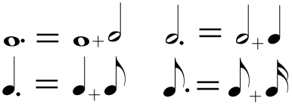
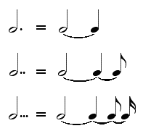

STUDENT 3: Expert card

Time signature

The time signature (also known as the “meter”) is a notational convention used in Western musical notation to specify how many beats are in each measure and what note value constitutes one beat.
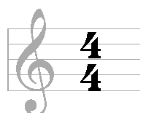
Most time signatures comprise two numbers, one above the other. Time signatures are written like a fraction
This time signature expresses that there are 4 beats in a measure and that the value of each beat is “1/4” of a whole note.

Did you know…?

…that note values have nicknames that we can use to say the rhythms with our voices. Each language has its own words.

Power | Result | Sign
q | ta | quarter note
N | ti-ti | 2 eighth notes
Q | sshh | quarter note rest
y | tika-tika | 4 sixteenth notes
H | too | half note
M | ti-tika | eight note and 2 sixteenth notes
M | tika-ti | 2 sixteenth notes and an eighth note
je | tum-ti | dotted quarter note and eighth note
eqe | syn-co-pa | eighth note, quarter note, eighth note
o | tim-ka | dotted eighth note, sixteenth note

STUDENT 4: Expert card

Did you know...

...that when you join three equal notes, we call this “a triplet” and its value is the same as the value of two of the notes? In other words, you play three notes in the normal time of two notes, but you need to play the three notes for the equal amount of time. Each note is 2/3 of the value of the triplet.
t = n
T= ss
So if t = n, we need to be careful when operating with notes. It is obviously not the same $\frac{3}{4}≠\frac{2}{4}$. Therefore, when we operate with triplets, we will need to take the value of the figure, but not the value of each of the notes that make the figure; or in math words, we will use 2 in the numerator instead of 3.

Did you know...

…that in music, when we play three notes one after the other, having the one in the middle twice the value of the other two, we say the rhythm is syncopated. The rhythm sounds abrupt because we are stressing a part of the rhythm that is not usually stressed.
eqe or qhq

Syncopation is used in many musical styles, if not all, and is fundamental in such styles as funk, ska, reggae, ragtime, rap, jump blues, jazz and often in heavy metal, and classical music.

STUDENT 5: Expert card

Did you know...

…that there are different ways singers / vocalists / musicians use to express musical notes?

- Letter names give a label to each note: C D E F G A B. These are the letter names used in English, Dutch, and possibly a few other languages.

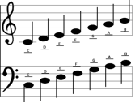

- However, Germany, Scandinavia (such as Iceland, Denmark, Sweden) and Slavic countries have another system: their C major scale is C D E F G A H. Their H corresponds to B in the English system.

- In some countries such as Spain, Portugal and France, solfege is always used instead of note names.

