Task 3: Composing a Symphony of Fractions

- Timing: 55 minutes + homework

- Material required:
  - Worksheet 1
  - Trial version of a music notation software
  - Free-hosting website

- Grouping: Team work

- Focus on content:
  - Understanding fractions in music
  - Using math knowledge to compose music
  - Creating and performing rhythms an/or tunes
  - Writing music using a music notation software

- Focus on language:
  - Using a music notation software (in the CLIL language)
  - Music vocabulary
  - Creative writing (lyrics)

- Description of activity 3: : Composing a Symphony of Fractions
See student's worksheet 3.

- Document 1:
See student's worksheet 1 “Composing a Symphony of Fractions”

- Assessment
  - Classroom music performances (peer assessment)
  - Mp3 files with rhythms and tunes (peer assessment)
  - Here is an example of a rubric which can be used for peer assessment. Students, guided by the teacher, should finish this rubric by adding 2-3 more categories to be assessed.
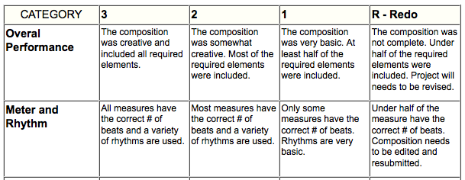

ANSWER KEY:
Activity 1:
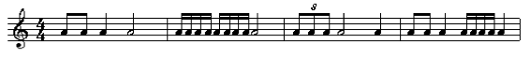
Any of the values can be also expressed as rests.

