

Worksheet 2: BODY PARTS

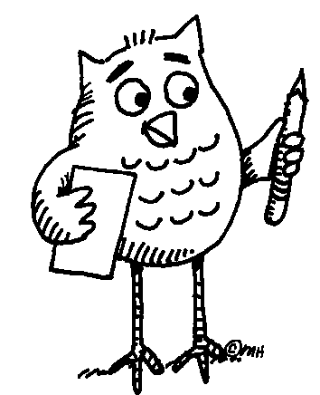 Task: Write down words that represent different parts of human hands and arms.
Make two columns:
English Your mother tongue 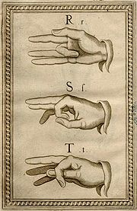
Manual alphabet (Bonet, 1620)
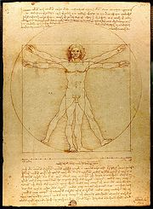
From: The Notebooks of Leonardo da Vinci (original edition 1883).
... Follow up activity for the whole class:
Can you teach your friends how to say the names of body parts in your language?

