Working with nature and scenery in fairy tales in cooperation with Geography, Science and Physical Education

Notes for the teacher
So far we have worked with characters in fairy tales. Now we will continue with the environment which you can come across in the tales.
The pupils can work individually, in pairs or in smaller groups.
Here you can work with teachers who teach Geography and/or Science
The pupils can study nature in their/their parents´ home country and compare it with nature in Sweden. They can compare the way people in Sweden look upon nature with how they/their parents look upon it.
How is nature portrayed in the fairy tales from the different countries?
Use a map of the world where you mark the countries the pupils, in your class, come from. What kind of nature do you have in your country? Is nature described in your favorite fairy tale?
Instructions:
- Look at the picture of the forest and describe it (Enclosure 1 or 3). Is it a scary forest or a nice and calm place to be? Use as many descriptive adjectives as you can. Use as many senses as possible:
- Hearing
- Sight
- Smell
- Taste
- Touch
What can you do in a forest? Give examples. (Working with verbs)
Here you can work with teachers who teach Physical Education
(The syllabus says: develop the ability to play, exercise and do sports)
Instructions:
- Design a game, which is based on your fairy tale, which you can play in the forest with the children from the kindergarten.
Design (Invent) your own sport.
Do you have forests like these in the country where you or your parents came from? Describe that nature.
Bring samples from the forest, such as stones, lava, insects and leaves and so on. (You can do that in Sweden, according to Swedish law.) Do you recognise any environments or/and monsters you have seen in movies?
Look at, whatever you have brought, in a microscope. Can you use what you see, in your fairy tale or in your game?

Homework:
Go home and ask your parents to describe or show you pictures of nature in their/your home country. Try to describe it by using the five senses. Write it down in your mother tongue and translate it into English. Draw a picture which you can show the class

Resources

Map of Sweden, Topography
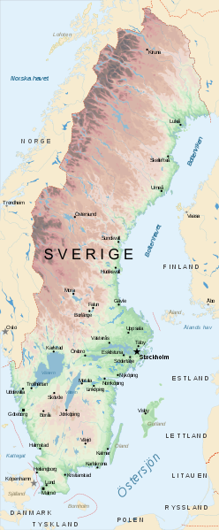
http://commons.wikimedia.org/wiki/File:Map_of_Sweden_Topography_(polar_stereographic)_Sv.svg

Map of the world

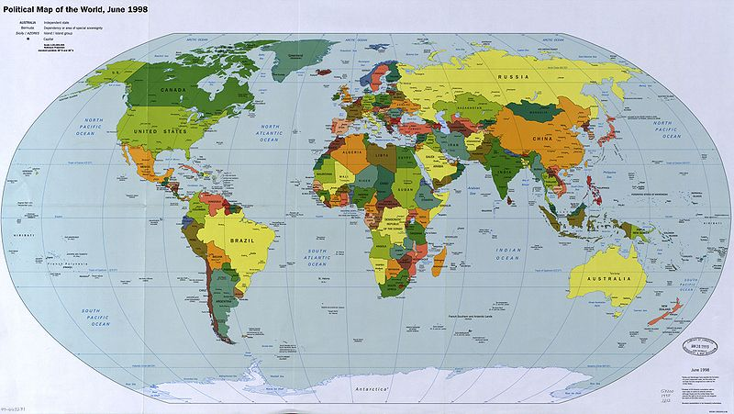
http://commons.wikimedia.org/wiki/File:Map_of_the_world_1998.jpg

