2. Europe
Grouping:  (whole class)

Worksheet 1
In which European countries are these languages official languages? Try this for 6 languages.

Language: _______________  Countries: ____________________  ____________________ | Language: _______________  Countries: ____________________  ____________________ | Language: _______________  Countries: ____________________  ____________________
Language: _______________  Countries: ____________________  ____________________ | Language: _______________  Countries: ____________________  ____________________ | Language: _______________  Countries: ____________________  ____________________
Can you find these countries on the map of Europe?
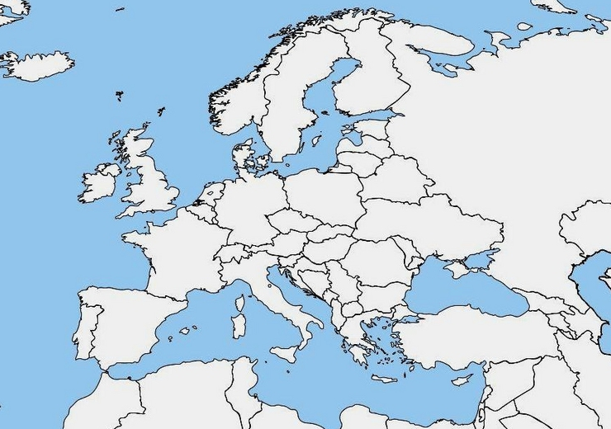
Afterwards you can check the atlas to see if you were right.

