

Worksheet 3: BODY PART COUNTING IN NEW GUINEA

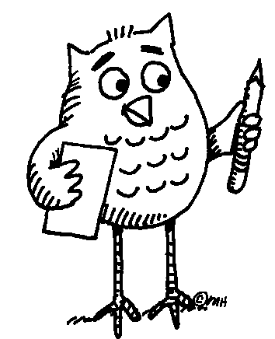 Task 1: Read the paragraph using the dictionary to clarify the meaning of unknown words or phrases. Find New Guinea on the map.
Nowhere in the world is the diversity of cultures and languages so marked as on the island of New Guinea. The number systems reflect this diversity. Saxe (1982) in Joseph (2000) describes the counting system of a province in Papua New Guinea in the following terms: starting with the thumb of a hand, counting proceeds along the fingers of that hand, so that 7 is the forearm along the upper periphery of the body, to the face, with 12 being the nearest ear to the hand that has been counted, to the nearest eye -13, the nose -14, the other eye -15, the other ear -16 and down along the other side of the body to the little finger on the other hand -27. Such a system of number representation has been used to describe a range of diverse activities, whether counting a set of objects, measuring the length of an object, or establishing the location of a house in relation to other houses on a path.
Adapted from: Joseph, G.G. The Crest of the Peacock, London: Penguin Books Ltd., 2000.

Task 2: Speculate which parts of the body represent numbers that are not mentioned in the text. You can speak in English or your mother tongue. After you agree, try to write the body parts in the two languages below.
6 20
8 21
9 22
10 23
11 24
17 25
18 26
19

