Trees: Linguistic and Cultural Aspects
For the student
Christoph SUTER

Trees: Linguistic and Cultural Aspects
Christoph SUTER
Title of task 1
Labelling parts of a tree; figurative senses of parts of a tree
Learner worksheets

Worksheet 1

/
- 1 Label the pictures with these terms: roots, trunk, crown, branches, leaves.
Rhizophora mangle (red mangrove) forest, Caeté estuary, Bragança, Pará, Brazil (http://de.wikipedia.org/w/index.php?title=Datei:Rhizophora-forest.jpg&filetimestamp=20060613214853)
Norway Spruce (http://en.wikipedia.org/wiki/File:Picea_abies.jpg)
Oak (http://upload.wikimedia.org/wikipedia/commons/d/df/Ljusterö_Bössarviken_01.jpg)

Bonsai: Dwarf Japanese Juniper (http://upload.wikimedia.org/wikipedia/commons/2/2d/Dwarf_Japanese_Juniper%2C_1975-2007.jpg)

Worksheet 2
-  Parts of a tree can also be used in a figurative sense in English. Look at these definitions going with the words root, trunk, branch, leaf, crown. Write the appropriate word next to its definition. Check with a partner.

- a large strong box with a lid used for storing things or for carrying them when you travel. __________
- a sheet of paper, especially in a book. __________
- a circular decoration that a king or queen wears on their head as a symbol of power, often decorated with jewels. __________
- the __________ of a number is another number that, when multiplied by itself a particular number of times, equals that number.
- a shop or office representing a large company or organization in a particular area. __________

- With your partner, use a monolingual dictionary (on paper or online) to make a list of other uses of these words in English.
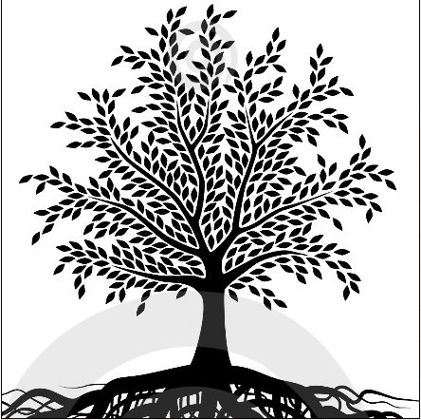
In class, read out uses of trunk - leaf - crown - root - branch and find out which part of the tree the definition is alluding to.
- What are parts of a tree called in your language? Ask members of your family or other people sharing your first language. Make a list, and collect other uses of these words.
- Write two or three figurative uses of parts of a tree used in your first language in English. Ask a classmate to point to the appropriate part of the tree on the picture.

Title of task 2: Connotations of trees in English and in learners‘ L1

Worksheet 3
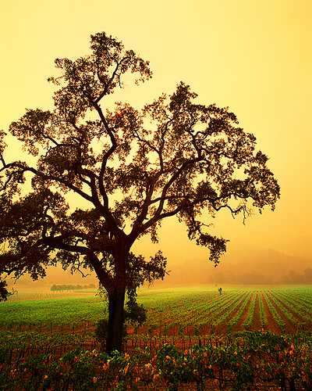
- What does a tree make you think of? Look at the picture and collect 5 to 10 words that you link to the word tree.
http://farm1.static.flickr.com/233/445631386_b4ea2896fc.jpg?v=1234922551
- In English, the word tree makes people think of the countryside, greenness, strength and longevity. Others may think of leafless trees connoting winter and hardship. Moreover, specific trees might make people think of certain things, the word oak, for instance, is often used in connection with words such as solid, royal, old.
What are speakers of your first language thinking of in connection with trees? Are there any specific trees in your first language‘s culture that are used in connection with other words? Ask these questions to three people of your family. Take notes of their answers and bring them to class (the notes, not the people ;-) ).
- Go to http://www.logosdictionary.org and type the name of a tree in your first language, then click on search. How many translations are being offered for your tree? Are some of them similar to the name in your first language? Try other trees. What can you find out?
- () Compare your findings in groups. In your group, design a poster with the outline of a tree and the information that you have collected.

Title of task 3: The forestal nutrient cycle in different climates

Worksheet 4
- Work with a partner. Look at the pictures. Compare the two systems. Use the language support.
Percentage of nutrient substance …
… in the tropical rainforest
… in a central European forest

45 % in living plants
5% in a layer of decomposing substance
50% in the soil

90% in living plants
3% in a layer of decomposing substance
7% in the soil

Language support
While in the rainforest there‘s … % of … in …, in a central European forest, there‘s …%.
In … there‘s only … % in …, but in … there‘s … % in….
There‘s twice as much nutrient substance … in … than in …

If you take away the living plants in a … forest, you take away … % of the nutrient substance.
- () The problem with cutting down tropical rainforest is that it isn‘t able to recover. Can you imagine why? Why is central European forest able to recover? Discuss in groups, then report to the class.
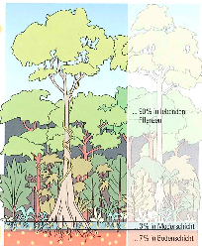
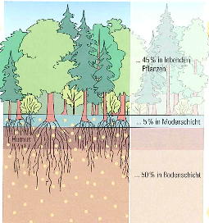

Title of task 4: The Baobab Tree: exploring the multiple functions of a tree in an ecologic system

Worksheet 5

- Brainstorm what a tree is good for : What benefits can you think of, for humans or animals? Make a list and exchange ideas in class.
- You are going to learn about a characteristic tree in the African savannah landscape. This tree is used in many ways by animals and humans. Its name is the baobab tree. Research the internet to find out about this tree. You may start with one of these web sites: http://www.baobab-solutions.com/the_baobab.htm
http://www.yozuna.com/baobab
Imagine specific people and animals living near a baobab tree. On sheets of paper write down the description of a person or the name of an animal and its profit from the baobab tree, e.g. Cheetah – Enjoys the shade under the baobab when it’s hot. / Little girls – Like to play hide and seek in and around the baobab.
Arrange your sheets of paper on a poster with a picture of a baobab tree.
Read and compare your posters in class.

Collocations Activity 2: Corpus research with the Cobuild Corpus.
Illustrations Activity 3: Lehrmittelverlag des Kantons Zürich: Die Erde (copyright?)

http://www.baobab-solutions.com/the_baobab.htm
http://www.yozuna.com/baobab

