The oceans in the world

Learner worksheet 1
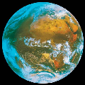
- Fill in the chart below after discussing the items with your friends and your teacher (use the language you know best / your teacher will help you if necessary)
What we know about the ocean | What we want to Learn  About the ocean
-  -  - (..) | -  -  - (...)
- Answer the following question after discussing it with your friends and your teacher (use the language you know best/ your teacher will help you if necessary)
Why does the water of the sea move?
…………………………………………………………………
………………………………………………………………….

