Measuring things using our body.

Worksheet 2.
Grouping: 
- Match the picture to the unit of measurement to the definition
Picture | Unit of measurement | Definition
a. 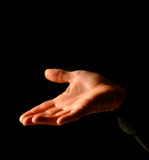 | Fathom | 1. The length of a man's foot
b. 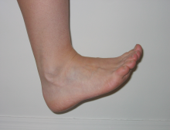 | Span | 2. Old English word fæðm meaning embracing arms or a pair of outstretched arms (used to measure depth of water).
c.  | Handbreadth | 3. The breadth of a male human hand (used for height of a horse for example)
d. 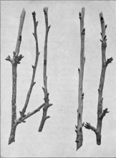 | Foot | 4. From the word for a straight branch or rod
e. | Cubit | 5. The Egyptian hieroglyph for the unit shows the symbol of a forearm subdivided into 7 'palms' of 4 'digits'
f. 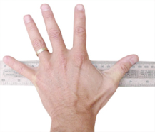 | Ell | 6. The width of a human hand
g. 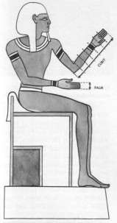 | Yard | 7. From Proto-Indo-European *el- "elbow, forearm.The length of a man's arm.

